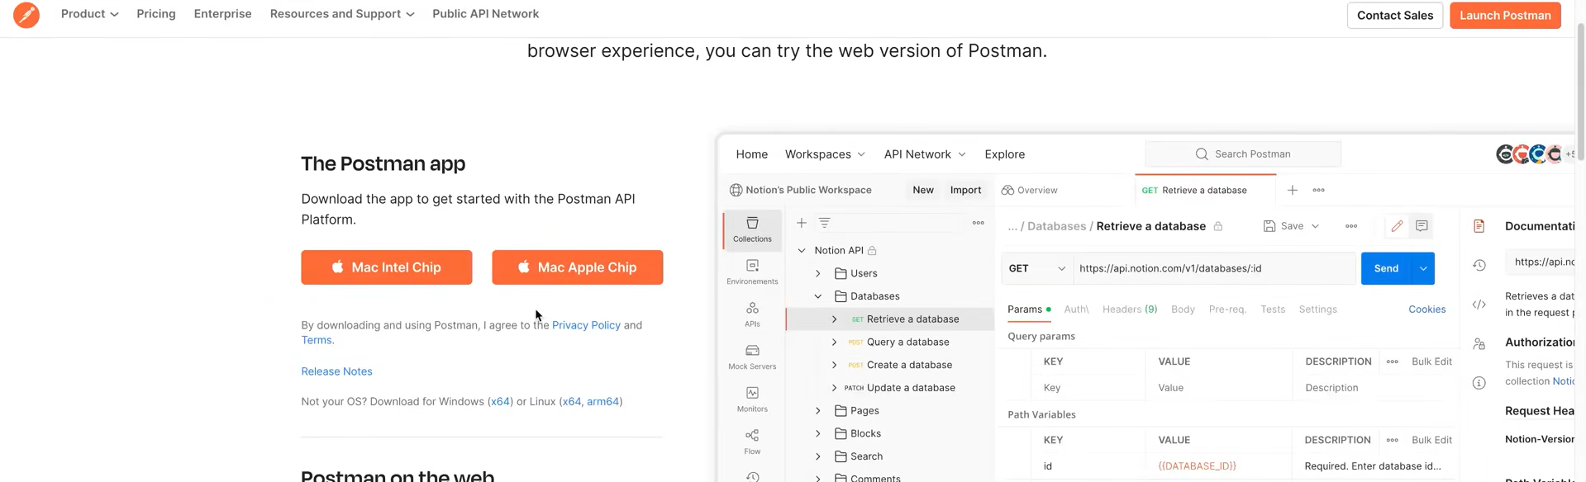

Postman-API client which allows us to send requests and receive responses from various API endpoints.

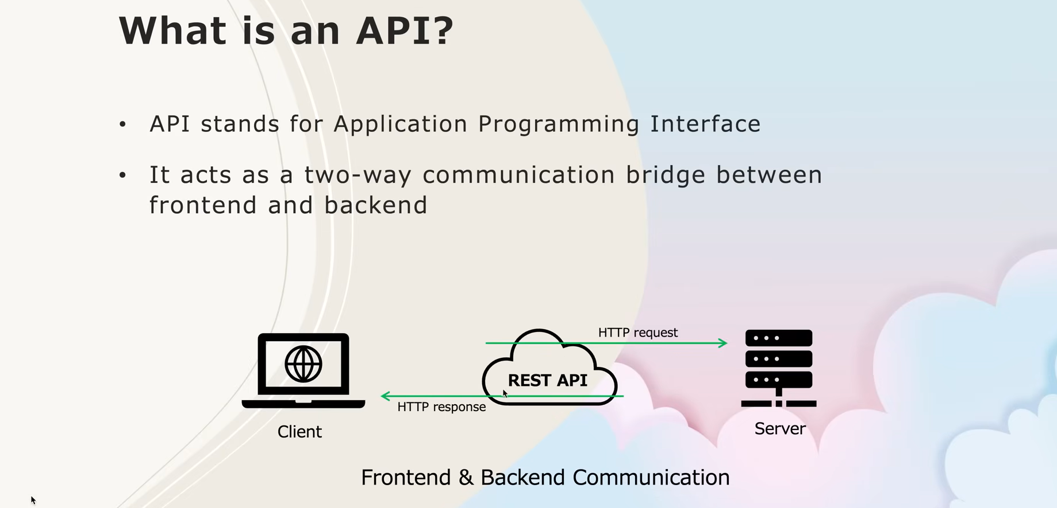

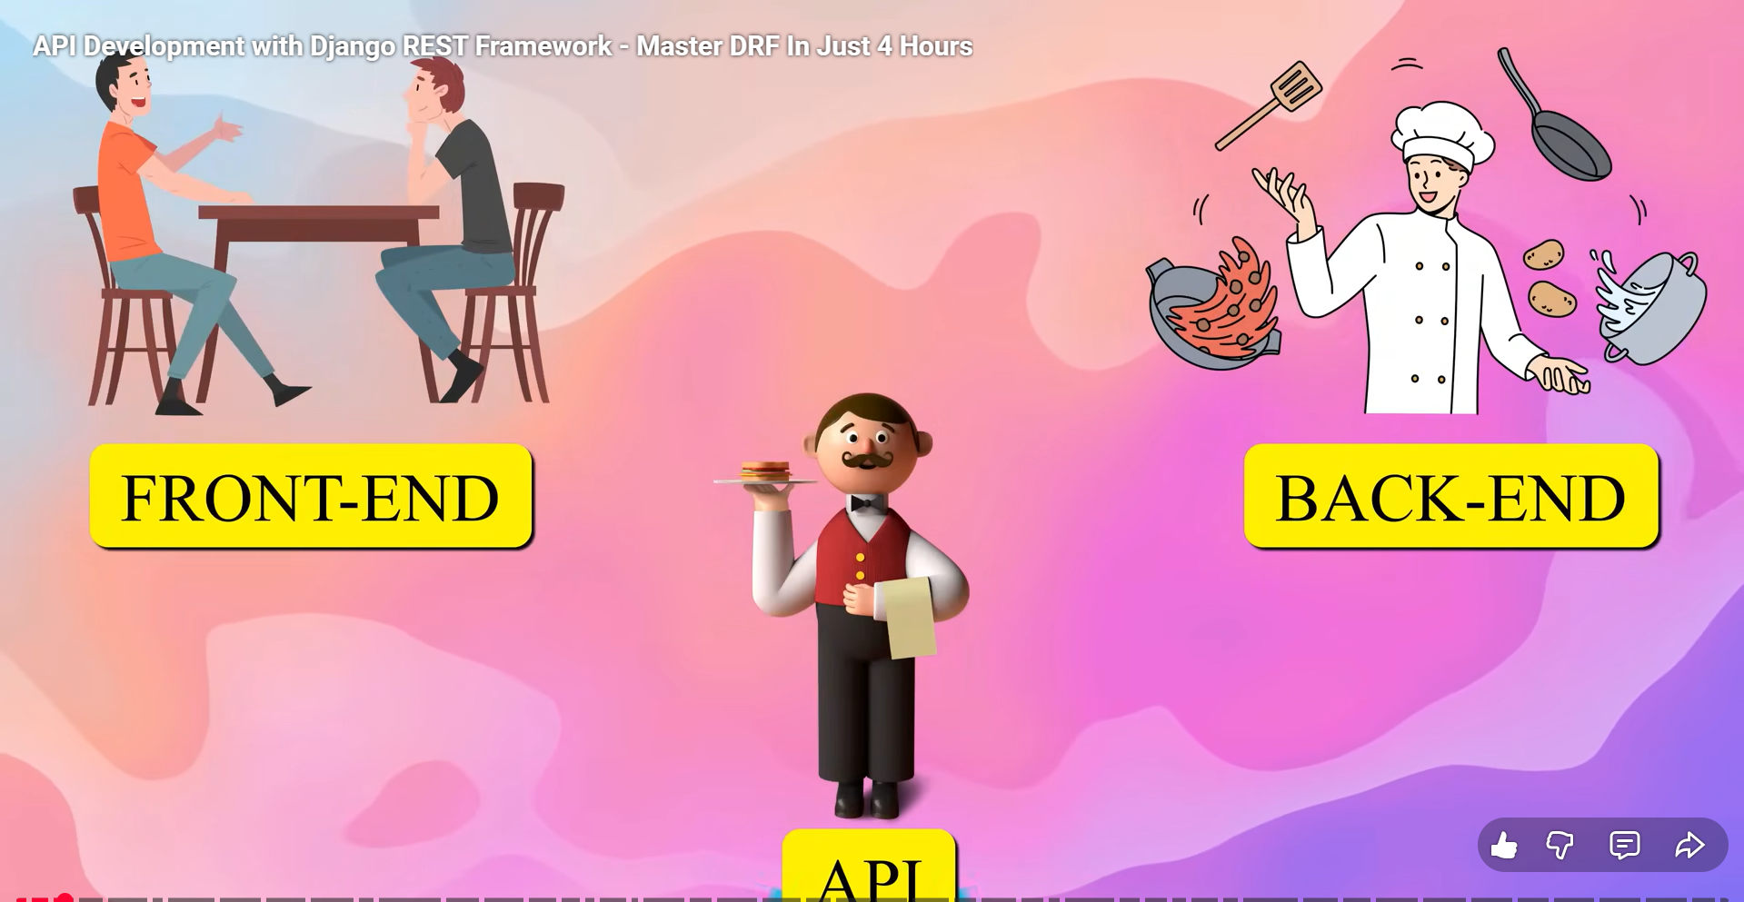

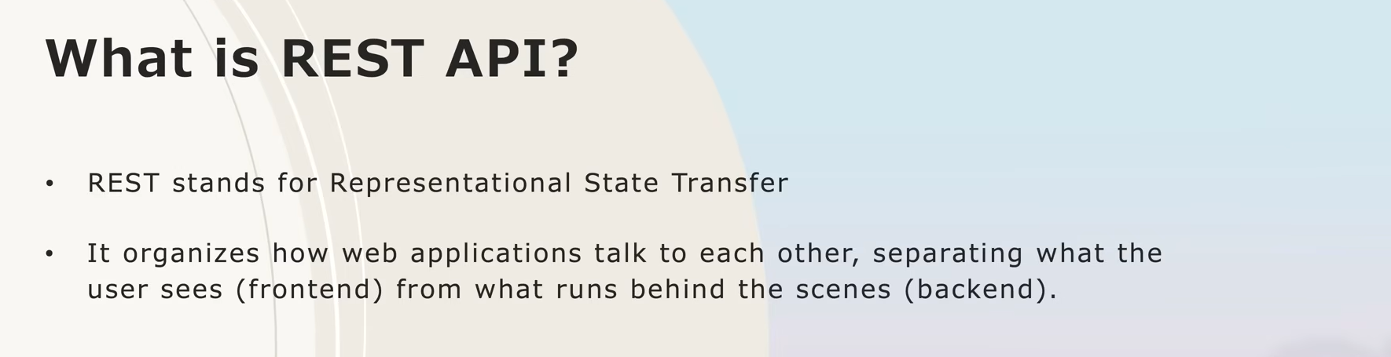

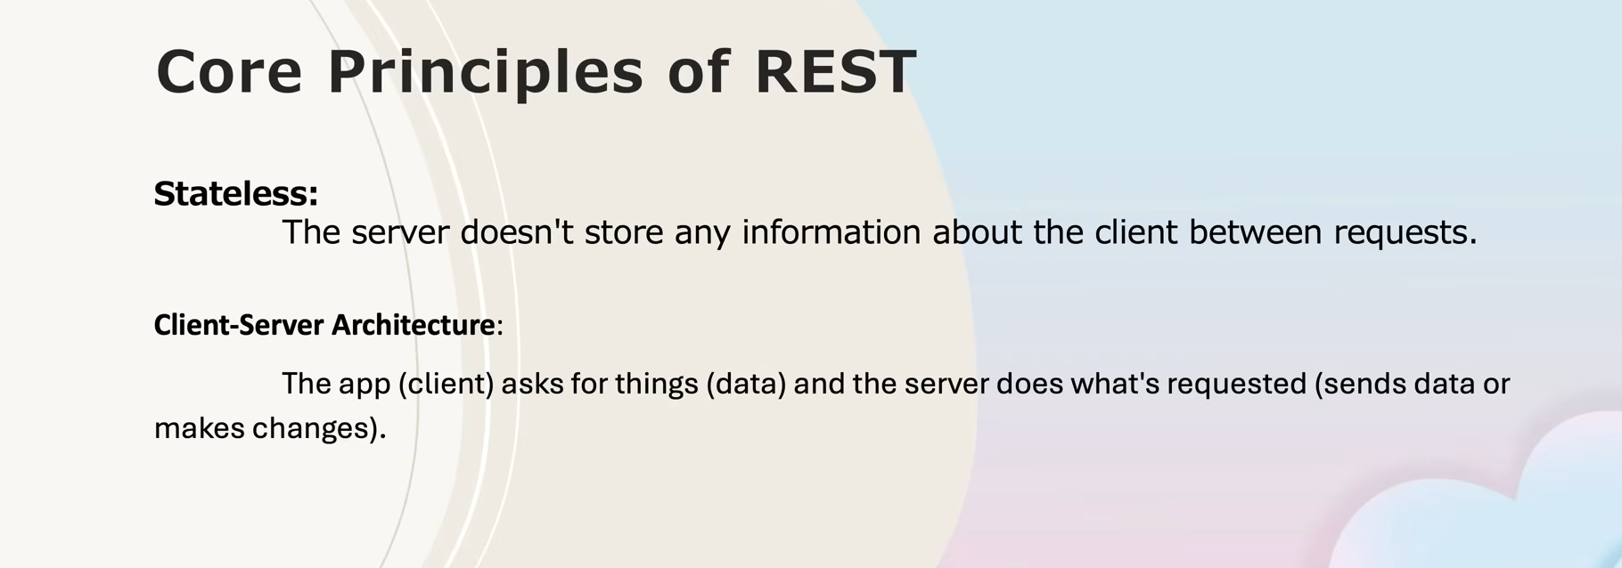

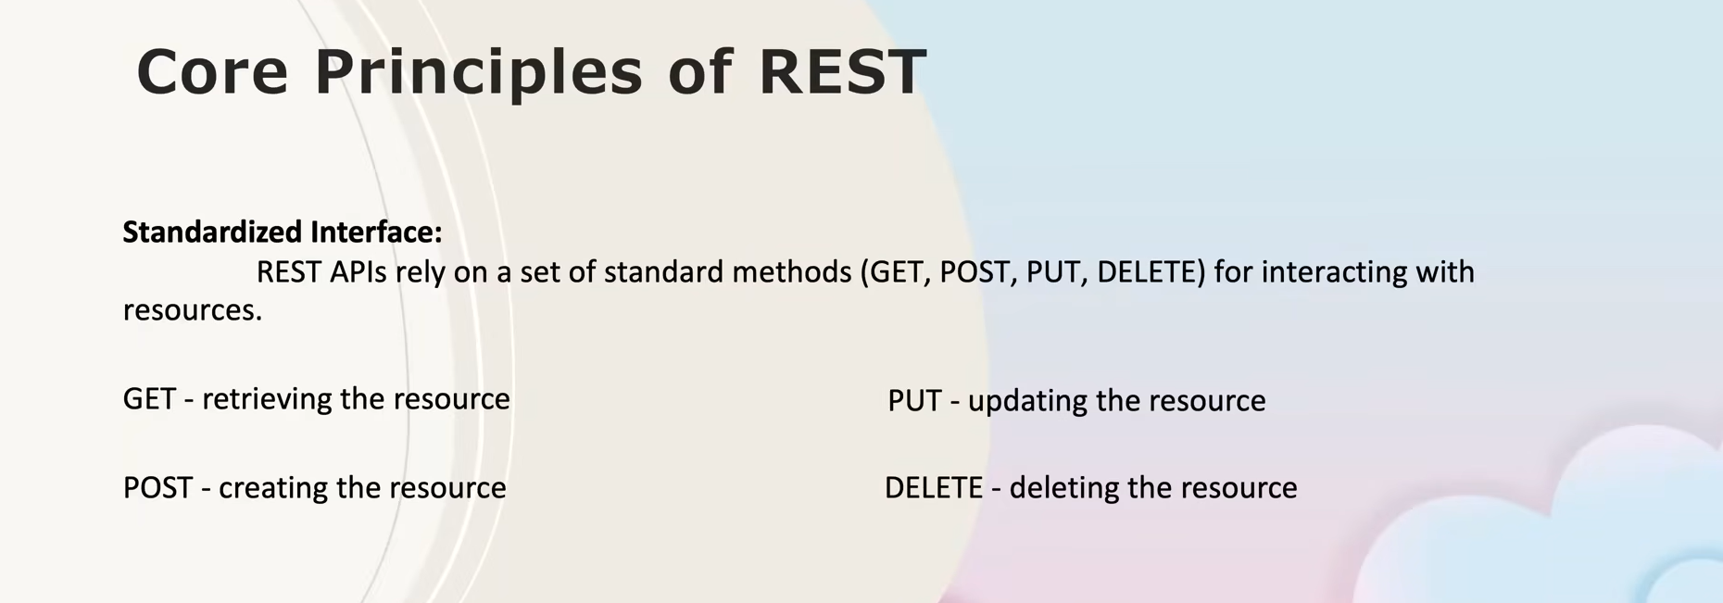

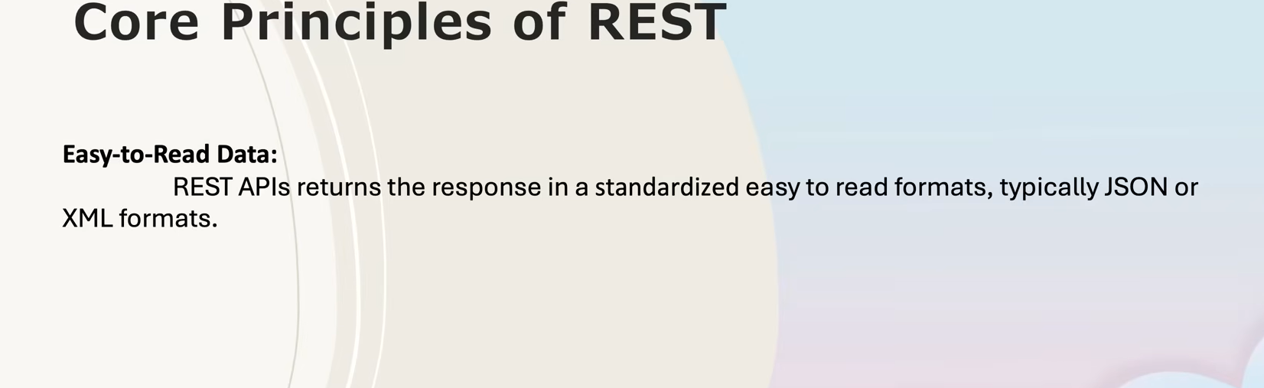

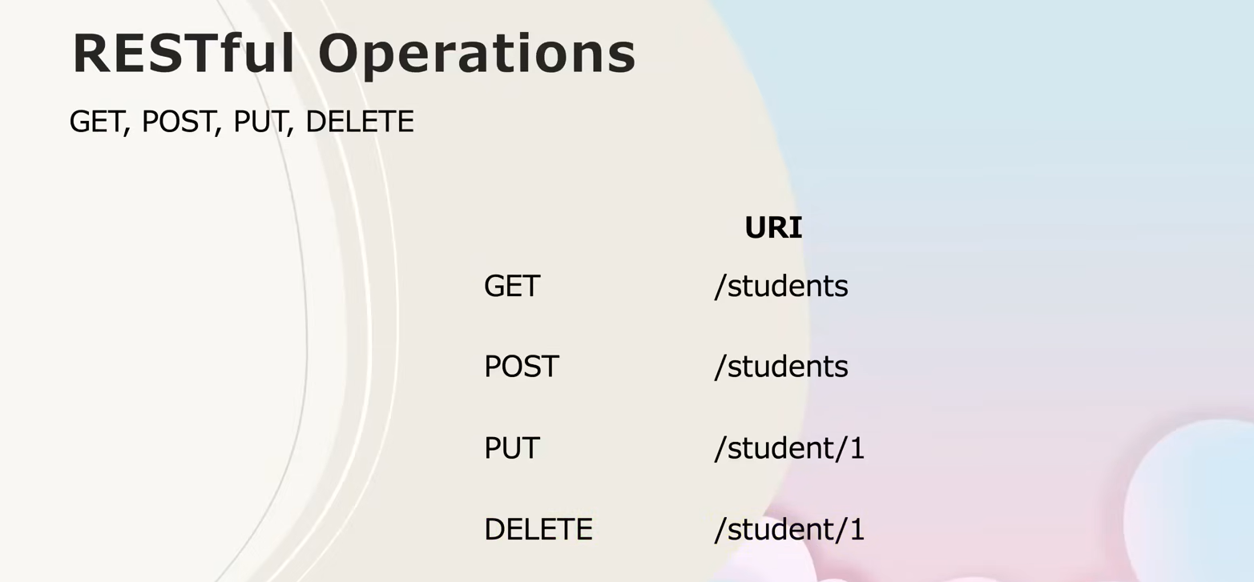

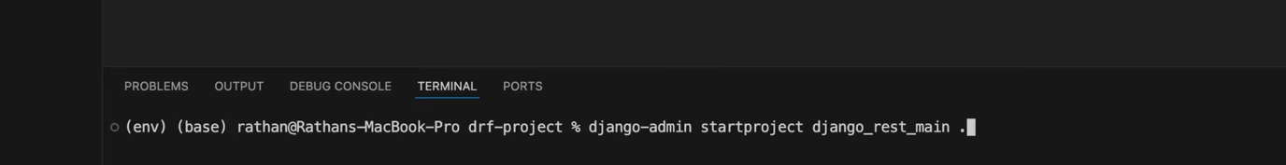



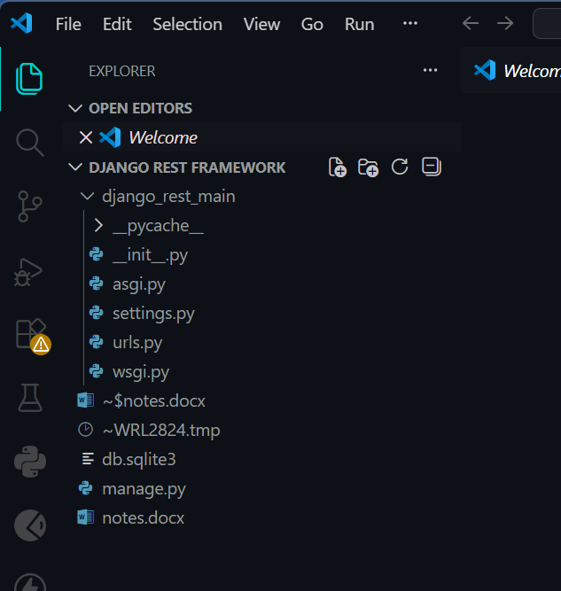

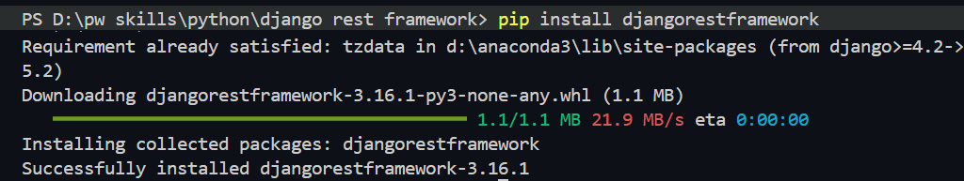

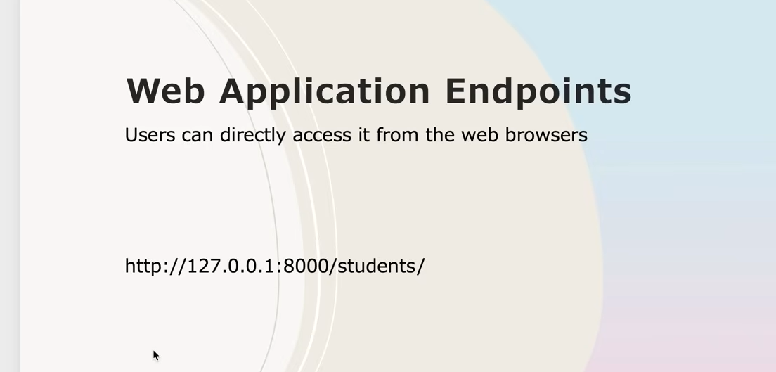

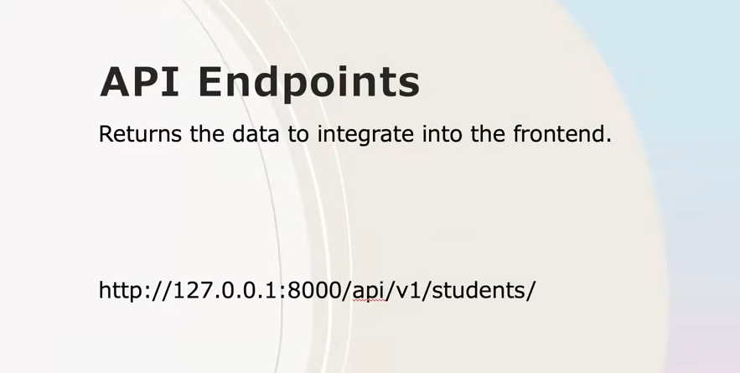



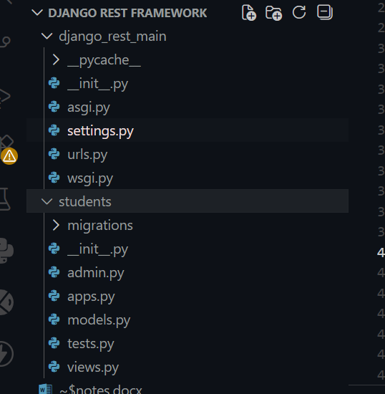

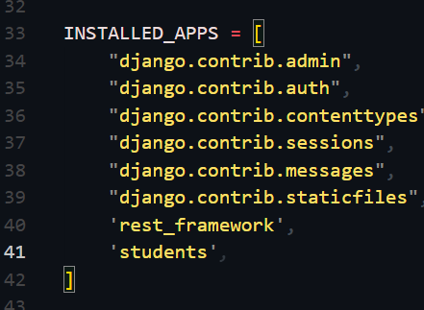

1)Web application endpoints

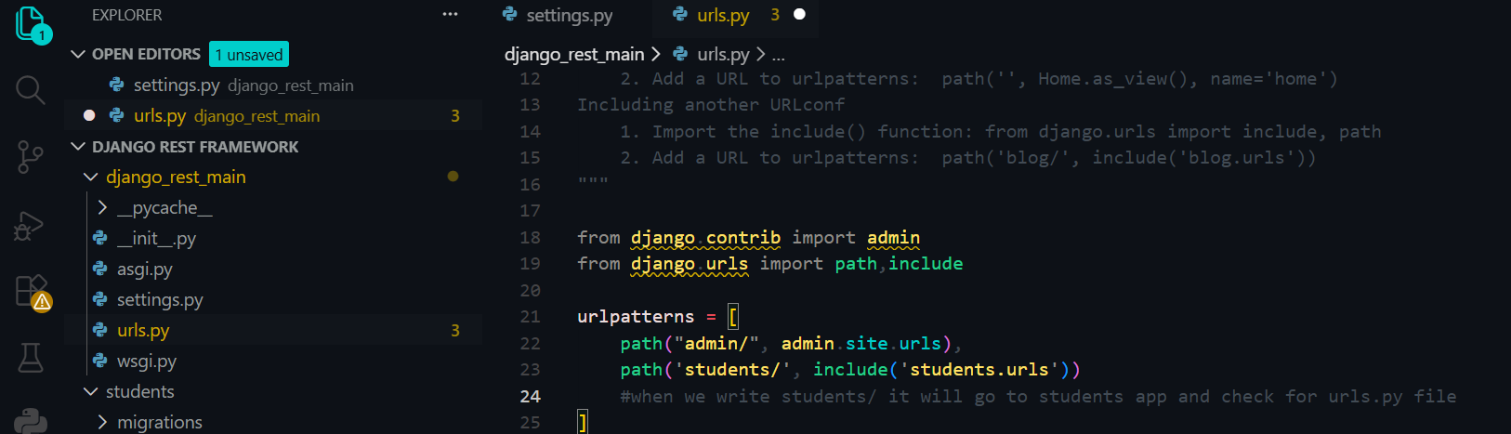

Then create .urls file in students folder

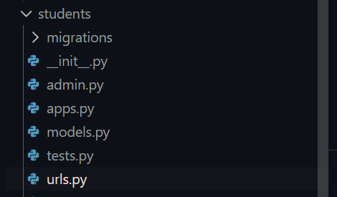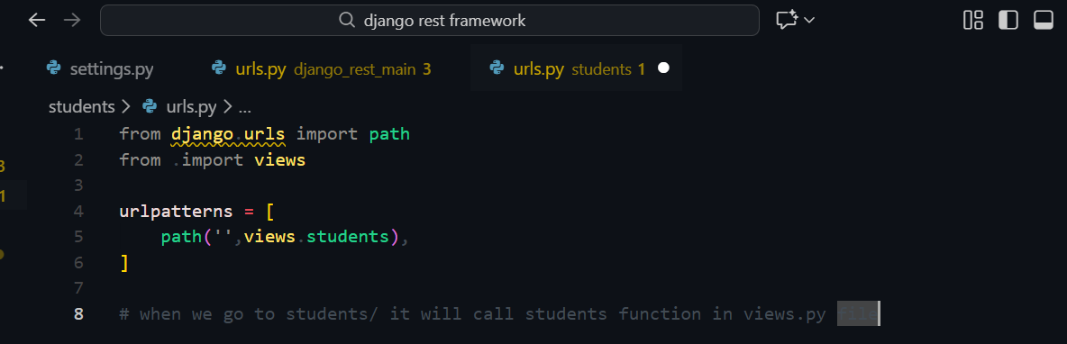

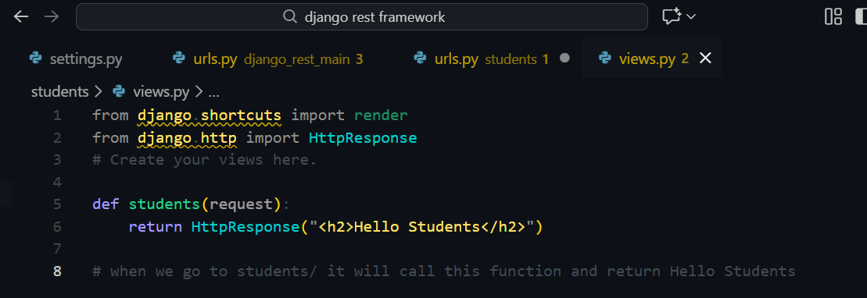

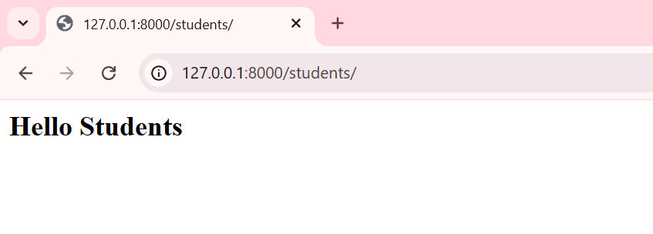

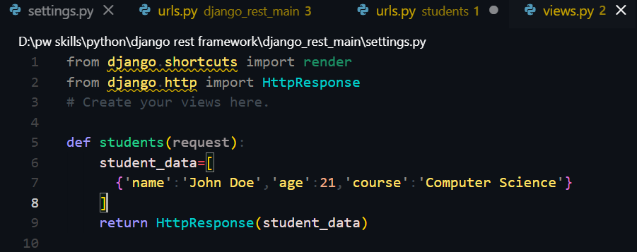

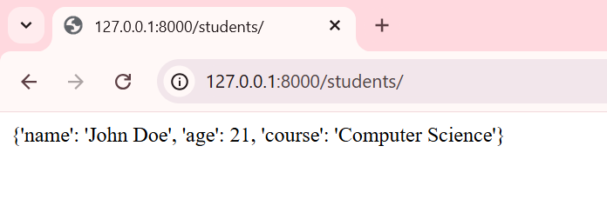

2)API endpoint

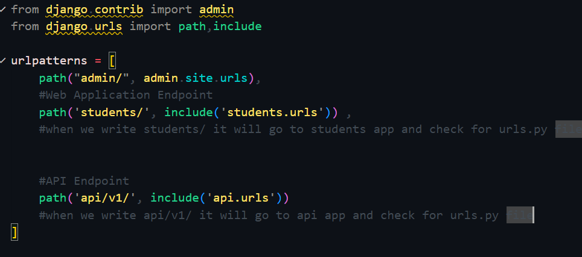

I also created a new app ‘api’ too!



**Always remember when u create any new app , don’t forget to add it in installed_apps in settings.py.

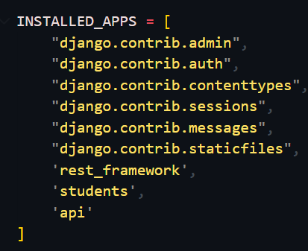

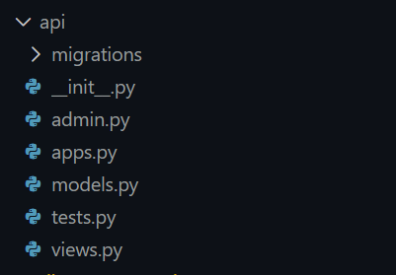

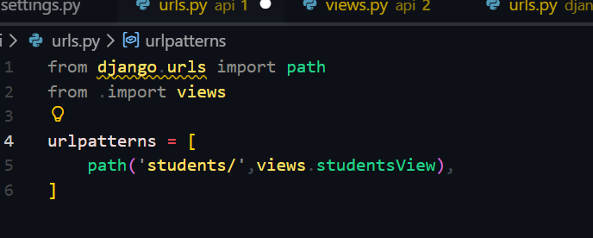

The data in api is returned in JSON format so we will use JsonResponse.

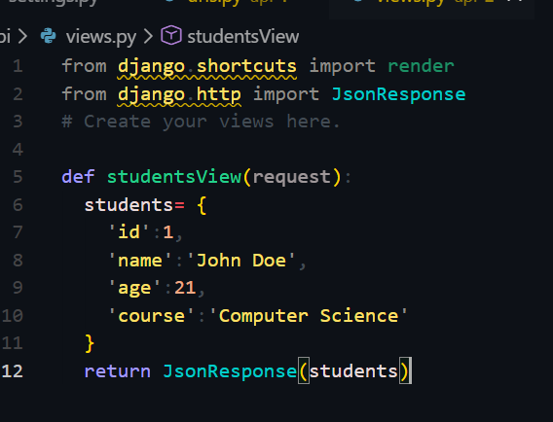

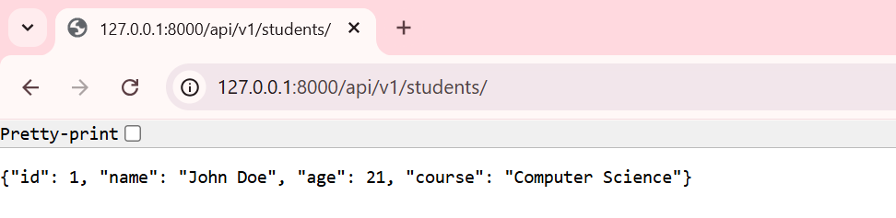

Great question 👍  
This is **very important** for your internship, so I’ll explain it **very simply**, then connect it to **what you’re doing right now**.

**🔹 What is an API Endpoint? (Very Simple)**

An **API endpoint** is just:

**A URL where data can be requested or sent.**

That’s it.

**🔹 In Normal Website (HTML world)**

Example:

http://example.com/home

* Browser requests a **web page**
* Server returns **HTML**
* User sees a page

**🔹 In API World (Data world)**

Example:

http://127.0.0.1:8000/api/v1/students/

* App / tool requests **data**
* Server returns **JSON**
* Used by Power BI, mobile apps, dashboards, automation, etc.

👉 **This URL is an API endpoint**

**🔹 Your Exact Example (From Your Code)**

**In django_rest_main/urls.py**

path('api/v1/', include('api.urls'))

**In api/urls.py**

urlpatterns = [

path('students/', views.studentsView),

]

**Final API endpoint becomes:**

http://127.0.0.1:8000/api/v1/students/

📌 **Breakdown**

* api/ → tells this is for API
* v1/ → API version (very common in companies)
* students/ → resource name

**🔹 What Happens When You Open the Endpoint?**

You visit:

http://127.0.0.1:8000/api/v1/students/

Django:

1. Matches the URL
2. Calls studentsView()
3. Returns JSON using JsonResponse

{

"id": 1,

"name": "John Doe",

"age": 21,

"course": "Computer Science"

}

✅ That URL = **API endpoint**

**🔹 Why APIs & Endpoints are IMPORTANT (Real Internship Use)**

In real companies:

| **Consumer** | **Uses Endpoint** |
| --- | --- |
| Power BI | Fetch data |
| Mobile App | Show data |
| Frontend (React) | Display UI |
| Automation Scripts | Pull data |
| ML Models | Get training data |

👉 **One backend, many consumers**

**🔹 API Endpoint vs Web Page (1-line difference)**

| **Web Page** | **API Endpoint** |
| --- | --- |
| Returns HTML | Returns JSON |
| For humans | For software |
| Browser focused | Data focused |

**🔹 Why Versioning (v1) Matters**

Companies do:

/api/v1/

/api/v2/

So old apps don’t break when new features are added.

**🔹 How This Fits Your Internship**

You are learning:

* Django → Backend
* DRF → API creation
* PostgreSQL → Data source
* Power BI → Data consumer

👉 API endpoints act as the **bridge**

**✅ One-liner you can say confidently**

“An API endpoint is a URL that allows applications or tools to access structured data, usually in JSON format.”

So we learnt how to return JSON response using ‘student api endpint’

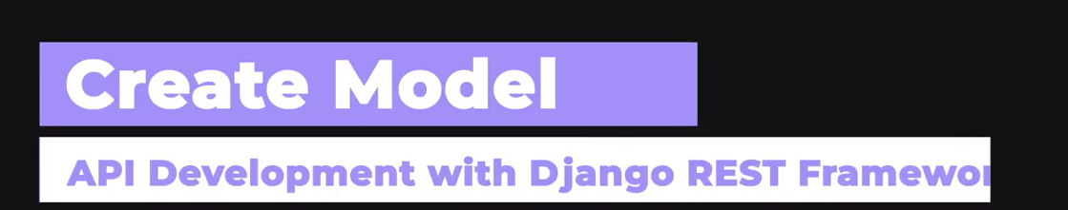

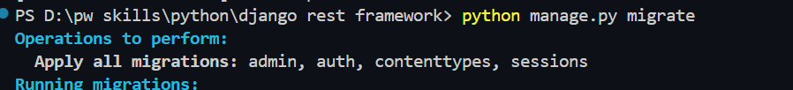

This wil create admin,auth,…. Tables

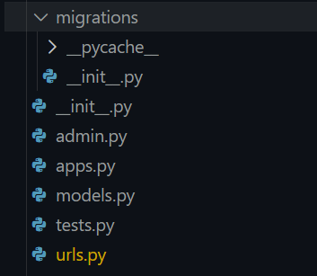

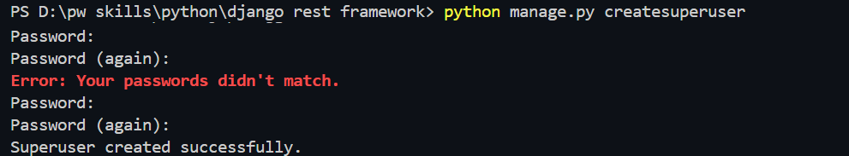

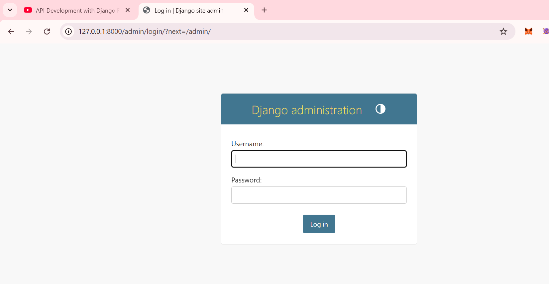

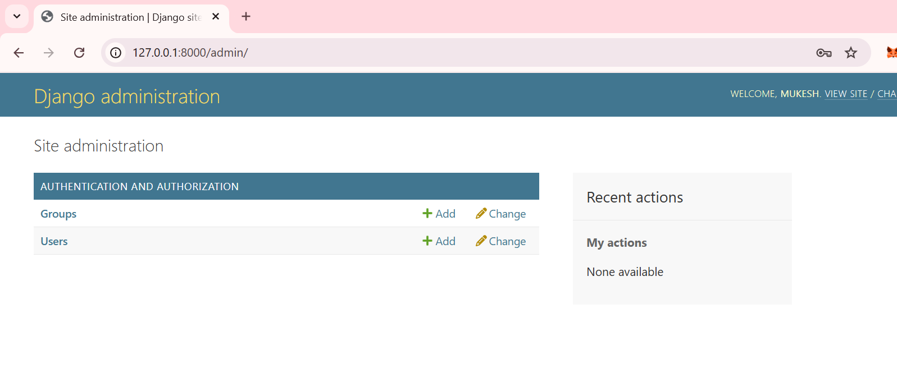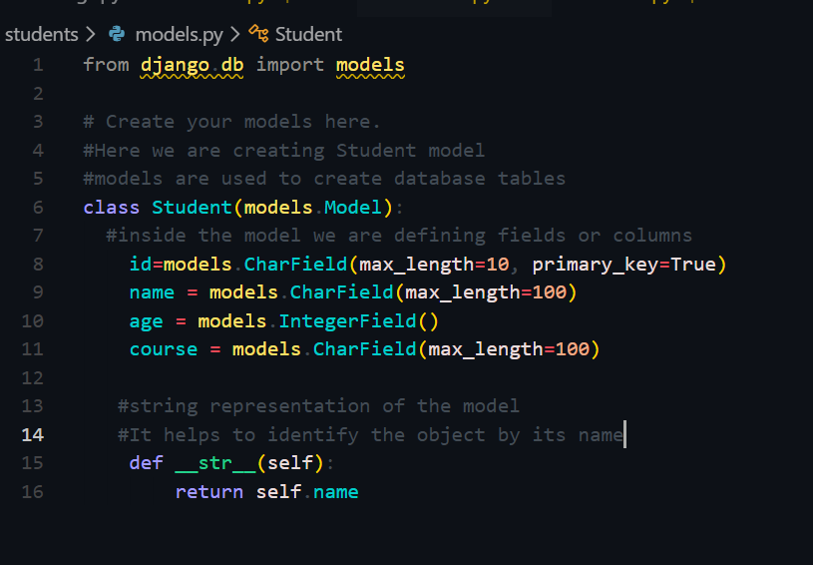

Then always remember t write this makemigratiions and migrations command to make changes (make model) and apply (add) the model or anyhting new to the sqlite3 database.

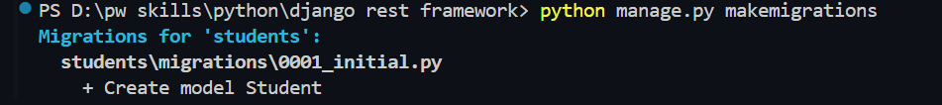

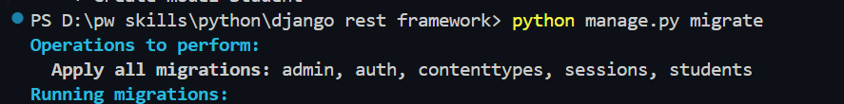

After doing this we need to register this model in admin.py only then it will be visible in Admin panel.

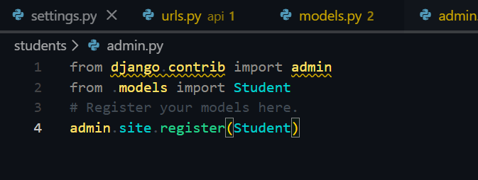

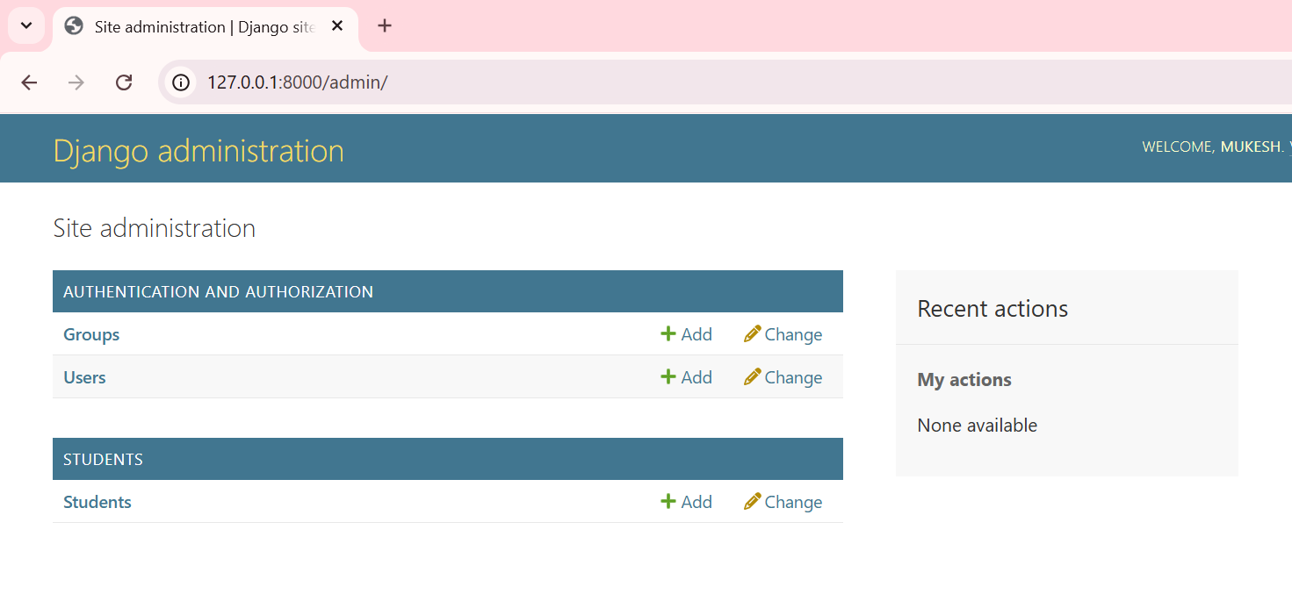

Now lets add some data in student model/table and then we will fetch this data via API endpoint that we had declared ealrier

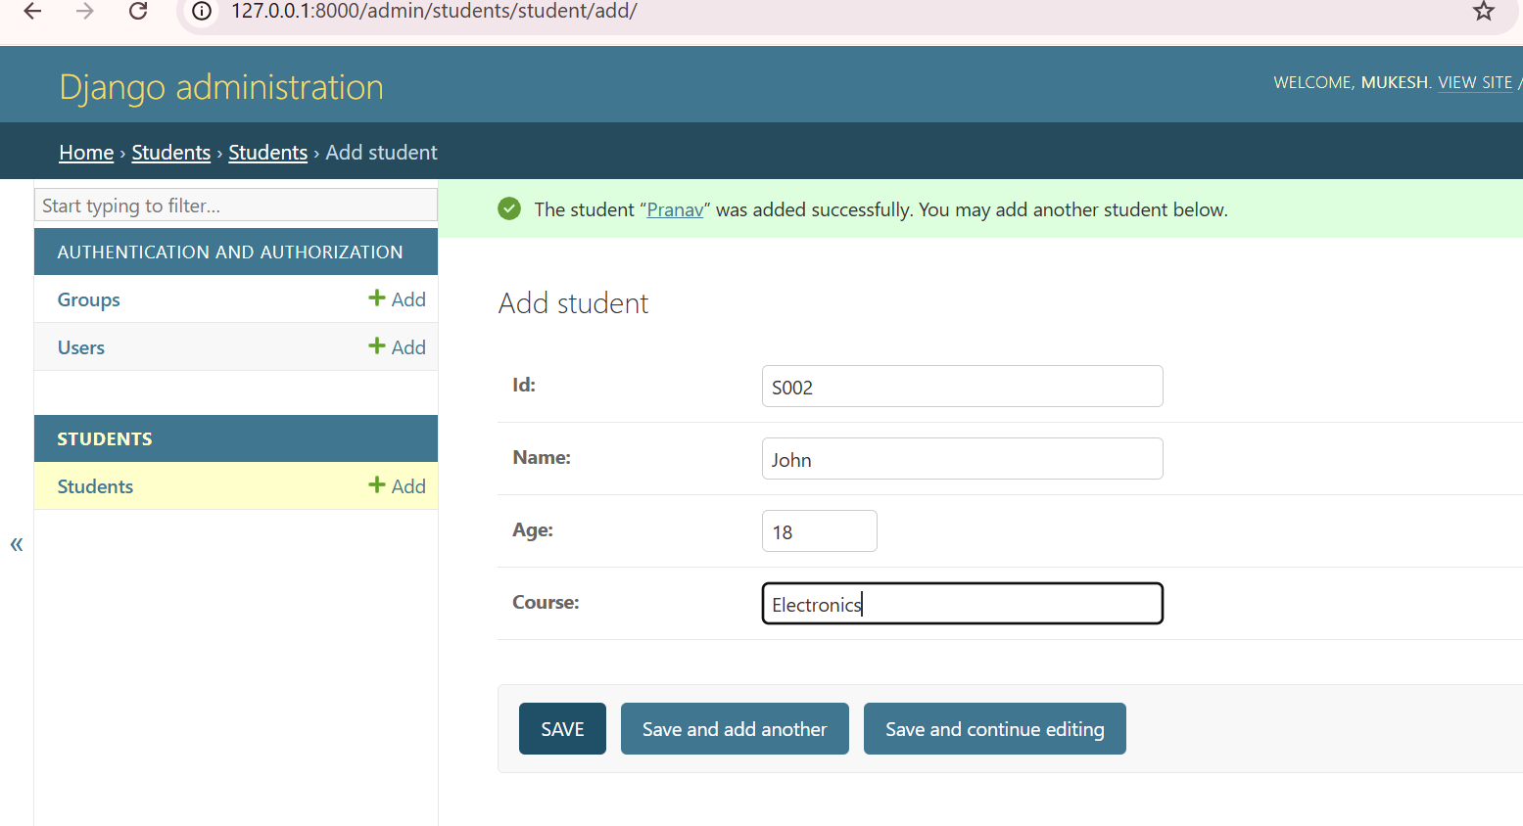

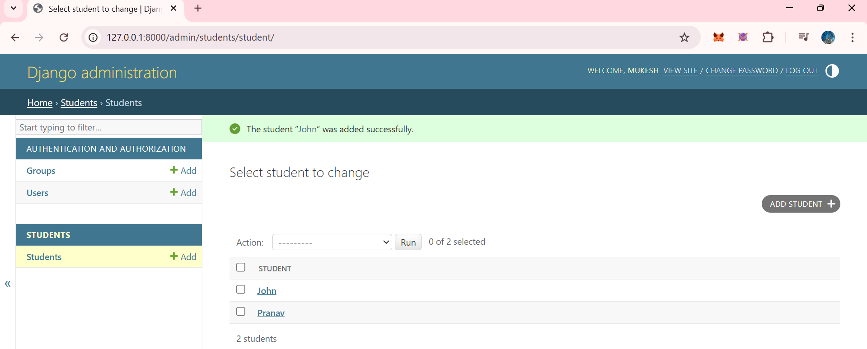

Now lets add this data model in views.py so that wr can retrieve the data lying in ‘students’ model via api endpoints

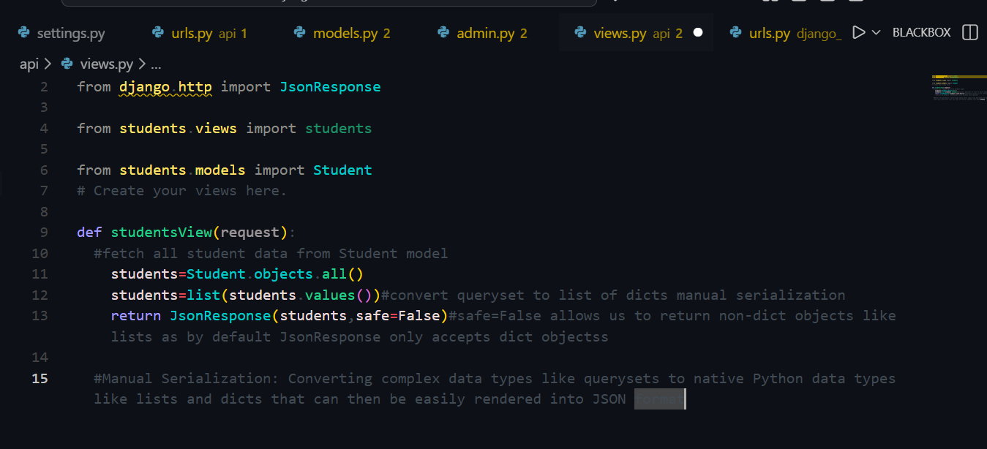

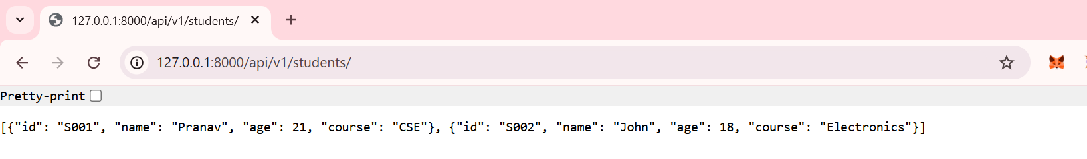

Let add new student and you whilce notice the data changes dynamically whnwevr you visit the api endpint.

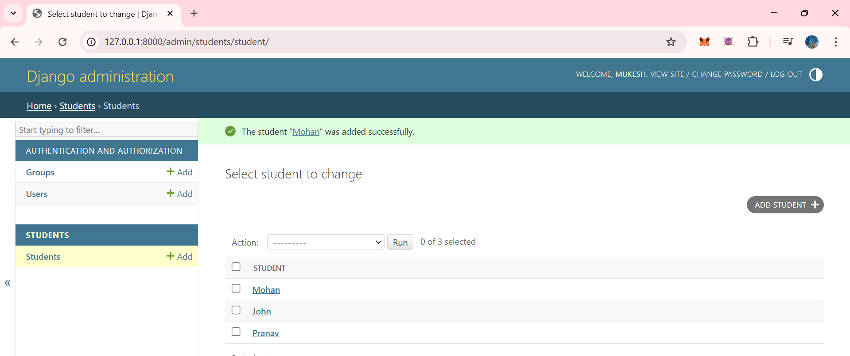

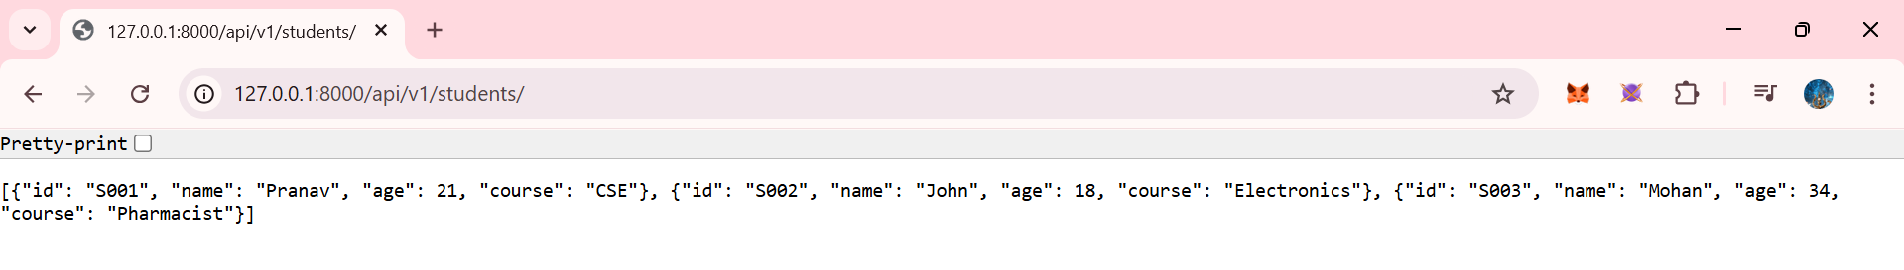

Perfect 👍  
Manual serialization is an **important concept**, and your notebook explanation should be **simple, clear, and exam/meeting-ready**.

I’ll explain it in a way you can **directly write in your notebook**.

**📘 Manual Serialization (Notebook-Ready Explanation)**

**🔹 What is Serialization?**

**Serialization** is the process of converting **Python objects (model data)** into a **JSON format** so that it can be sent through an API.

**🔹 What is *Manual* Serialization?**

**Manual serialization** means:

Converting Python data into JSON **by hand**, without using Django REST Framework serializers.

In this approach, we:

* Fetch data from database or define it in Python
* Manually create a dictionary
* Return it using JsonResponse

**🔹 Example of Manual Serialization**

from django.http import JsonResponse

def studentsView(request):

student = {

"id": 1,

"name": "John Doe",

"age": 21,

"course": "Computer Science"

}

return JsonResponse(student)

Here:

* Data is manually structured into a dictionary
* Django converts the dictionary into JSON
* JSON is returned via API endpoint

**🔹 Why is it called *manual*?**

Because:

* We explicitly decide every field
* We manually map values
* No automatic conversion from models

**🔹 When is Manual Serialization used?**

Manual serialization is useful:

* For learning API basics
* For small or static responses
* When no database model is involved
* For simple testing APIs

**🔹 Limitations of Manual Serialization**

* Not scalable for large datasets
* Repetitive code
* Difficult to maintain
* No validation support
* Not suitable for complex APIs

**🔹 Why Django REST Framework is preferred?**

Django REST Framework provides **Serializers** that:

* Automatically convert models to JSON
* Handle validation
* Support large datasets
* Reduce code

**🔹 Manual vs DRF Serialization (Short Table)**

| **Manual Serialization** | **DRF Serialization** |
| --- | --- |
| Hand-written dict | Auto conversion |
| Simple | Powerful |
| No validation | Built-in validation |
| Learning purpose | Production use |

**🔹 One-line Definition (Very Important)**

**Manual serialization is the process of manually converting Python data into JSON for API responses without using serializers.**

**🔹 How this connects to your internship**

You learn manual serialization first to:

* Understand API response structure
* Understand how JSON is formed
* Appreciate why DRF serializers are needed

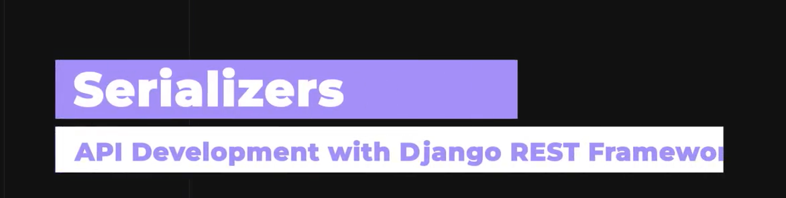

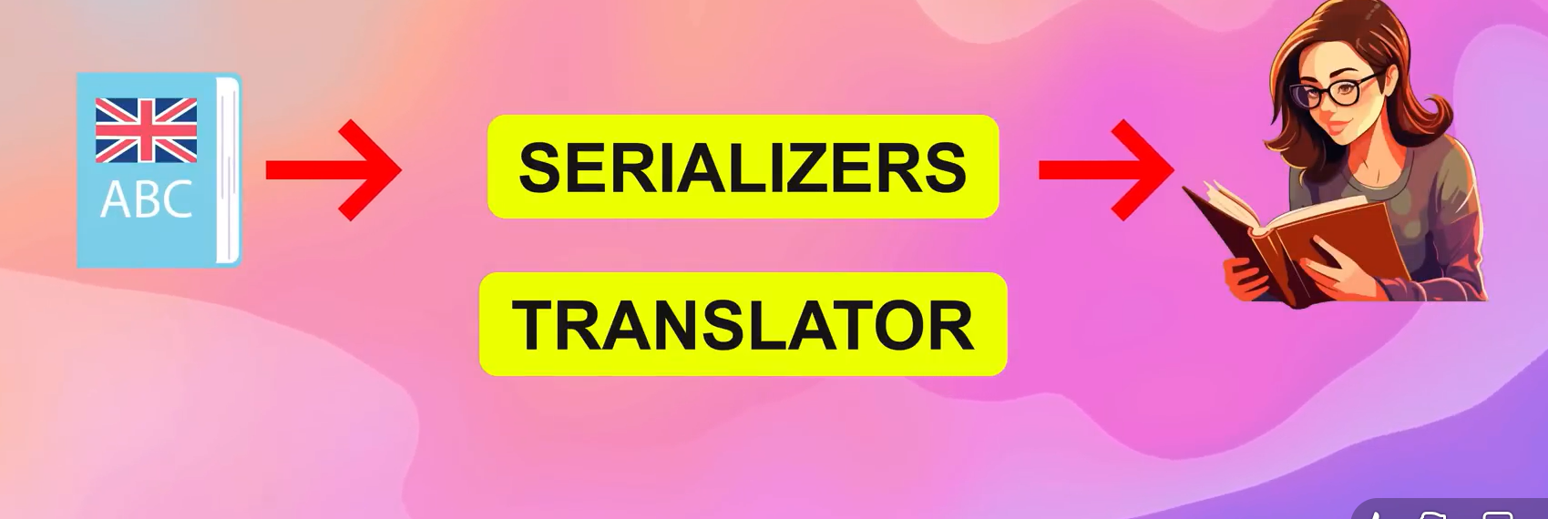

Serialzers are the translators of data which converts python or model objects into the JSON format.

**📘 Deserialization (Notebook-Ready Explanation)**

**🔹 What is Deserialization?**

**Deserialization** is the process of converting **JSON data received from a client** into **Python objects** so that it can be processed or stored in the database.

**🔹 Simple Definition (Very Important)**

**Deserialization is the process of converting incoming JSON data into Python objects or model instances.**

Now we will learn about the serializers that can be used to fetch the data in django.

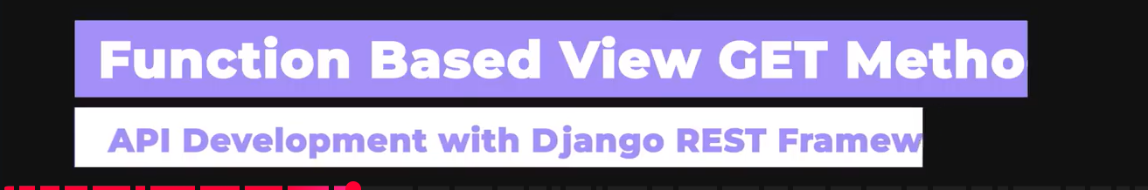

Create a new file Serializers.py

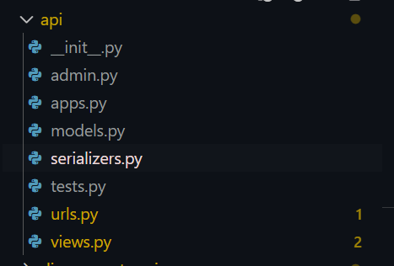

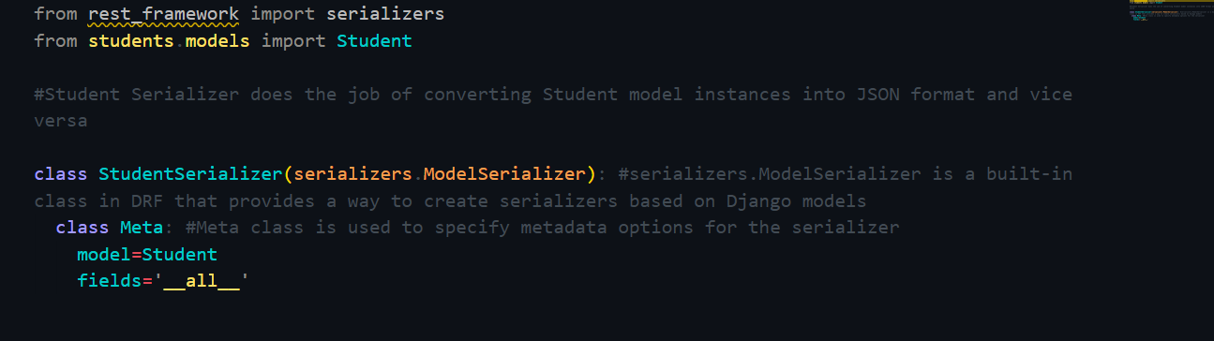

Perfect — this is **core Django REST Framework**, and your code is **100% correct** 👍  
I’ll explain it **line by line**, in **simple language**, so you can **write it in your notebook** and also **explain it in scrum/interview**.

**📘 What does this code do? (Big Picture)**

This code defines a **DRF ModelSerializer** that automatically converts **Student model objects ↔ JSON data**.

In short:

* **Model → JSON** (serialization)
* **JSON → Model** (deserialization)

**🔹 Line-by-line Explanation**

**1️⃣ Importing serializers from DRF**

from rest_framework import serializers

* Imports Django REST Framework’s serializer tools
* These tools help convert data between:
  + Python objects
  + JSON format

**2️⃣ Importing the Student model**

from students.models import Student

* Imports the **Student model**
* This model represents a **database table**

**3️⃣ Defining the Serializer class**

class StudentSerializer(serializers.ModelSerializer):

* You are creating a **custom serializer**
* ModelSerializer is a DRF class that:
  + Automatically maps model fields
  + Reduces boilerplate code
  + Handles validation

👉 This means:

“Create a serializer based on the Student model.”

**4️⃣ Meta class (VERY IMPORTANT)**

class Meta:

* Meta class stores **configuration details**
* It tells DRF:
  + Which model to use
  + Which fields to include

**5️⃣ Specifying the model**

model = Student

* Connects this serializer to the Student model
* DRF now knows:
  + What fields exist
  + Their data types
  + Validation rules

**6️⃣ Specifying fields**

fields = '__all__'

* Means:

“Include **all fields** from the Student model in the serializer.”

Example:  
If Student model has:

id, name, age, course

Then JSON will include:

{

"id": 1,

"name": "John",

"age": 21,

"course": "CS"

}

**🔄 What this Serializer does (VERY IMPORTANT)**

**✅ Serialization (Model → JSON)**

student = Student.objects.all()

serializer = StudentSerializer(student, many=True)

serializer.data

➡ Converts DB records into JSON

**✅ Deserialization (JSON → Model)**

serializer = StudentSerializer(data=request.data)

if serializer.is_valid():

serializer.save()

➡ Converts incoming JSON into model objects and saves to DB

**🔹 Why ModelSerializer is powerful**

Without ModelSerializer, you would need to:

* Define each field manually
* Write validation logic
* Write save logic

With it:

* Everything is automatic
* Clean & scalable
* Industry standard

**🔹 Manual vs ModelSerializer (Quick Table)**

| **Manual Serialization** | **ModelSerializer** |
| --- | --- |
| Hand-written dict | Auto-generated |
| No validation | Built-in validation |
| Not scalable | Production-ready |
| Learning only | Real projects |

**🔹 One-line Notebook Definition (WRITE THIS)**

**StudentSerializer is a ModelSerializer that converts Student model instances to JSON and validates JSON data to create or update Student records.**

**🔹 One-line Interview Answer**

“ModelSerializer automatically handles serialization and deserialization based on Django models.”

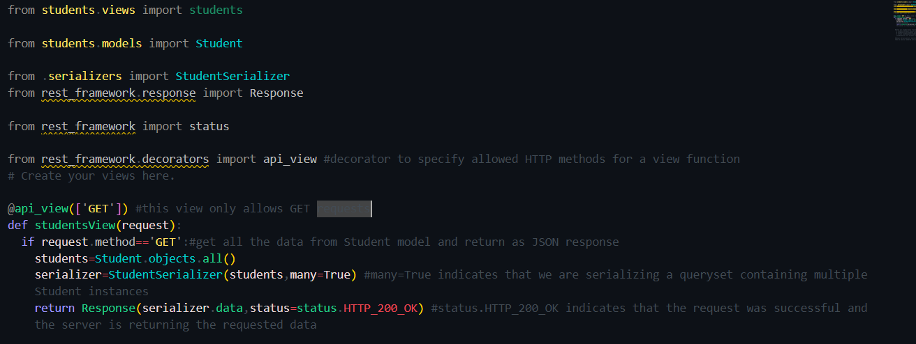

Great 👍  
You’ve just written your **first proper Django REST Framework API view**.  
I’ll explain this **cleanly, line-by-line**, and then give you **a notebook-ready explanation**.

**🔷 What this code does (in one line)**

This code creates a **GET API endpoint** that fetches all Student records from the database and returns them as **JSON**.

**🧩 Line-by-Line Explanation**

**1️⃣ Importing required modules**

from students.models import Student

* Imports the **Student model**
* This model represents your **database table**

from .serializers import StudentSerializer

* Imports the **StudentSerializer**
* Used to convert:
  + Model → JSON (serialization)
  + JSON → Model (deserialization)

from rest_framework.response import Response

* DRF’s version of HttpResponse
* Automatically:
  + Converts data to JSON
  + Sets correct headers
  + Works with status codes

from rest_framework import status

* Provides **HTTP status codes**
* Example:
  + HTTP_200_OK
  + HTTP_201_CREATED
  + HTTP_400_BAD_REQUEST

from rest_framework.decorators import api_view

* Converts a normal Django function into a **REST API view**
* Restricts which HTTP methods are allowed

**2️⃣ Declaring the API view**

@api_view(['GET'])

* This decorator means:

“This API only accepts GET requests.”

❌ POST, PUT, DELETE will be rejected automatically.

**3️⃣ Defining the API function**

def studentsView(request):

* This function will be called when:
  + Someone hits this API endpoint (URL)

**4️⃣ Fetching data from database**

students = Student.objects.all()

* Fetches **all student records** from the database
* Returns a **QuerySet** (list-like object)

**5️⃣ Serializing the data**

serializer = StudentSerializer(students, many=True)

* Converts queryset → JSON format
* many=True means:

“There are multiple student objects.”

📌 Without many=True, DRF will throw an error.

**6️⃣ Returning JSON response**

return Response(serializer.data, status=status.HTTP_200_OK)

* Sends serialized data as JSON
* HTTP status code = **200 OK**
* Browser / Postman / Swagger will receive clean JSON

**🔄 Flow of Execution (VERY IMPORTANT)**

Client (Browser / Postman)

↓

URL → studentsView()

↓

Student.objects.all()

↓

StudentSerializer

↓

JSON Response (200 OK)

**🧠 Notebook-Ready Explanation (WRITE THIS)**

studentsView is a function-based API view that handles GET requests. It retrieves all Student records from the database, serializes them using StudentSerializer, and returns the data as a JSON response with HTTP 200 OK status.

**📌 Key Concepts Used (Interview-Safe)**

| **Concept** | **Purpose** |
| --- | --- |
| @api_view | Defines allowed HTTP methods |
| Serializer | Converts model ↔ JSON |
| many=True | Handles multiple records |
| Response() | Returns API response |
| status.HTTP_200_OK | Success status code |

**🔥 Why this is REAL industry code**

This exact pattern is used in:

* Backend APIs
* Microservices
* Power BI data sources
* Swagger APIs
* Production analytics pipelines

You are **not learning dummy stuff**.

**🚀 What comes next (naturally)**

Next logical steps:

1. POST API (create student)
2. PUT API (update student)
3. DELETE API
4. Swagger UI
5. Power BI consuming this API

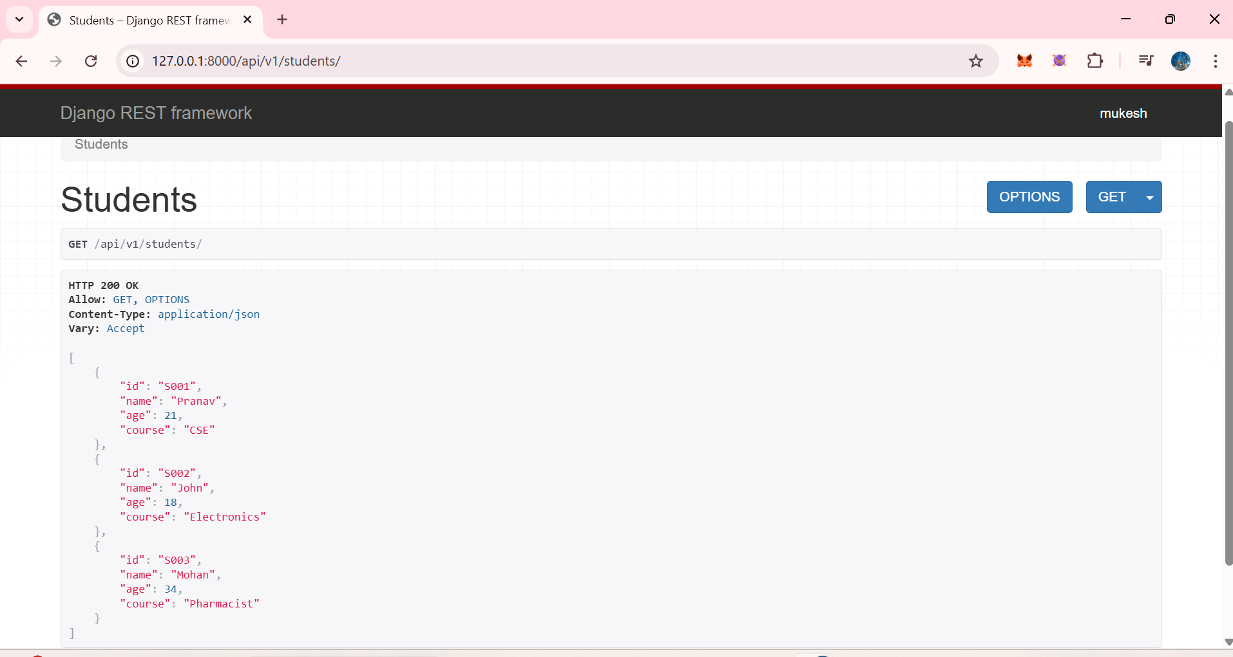

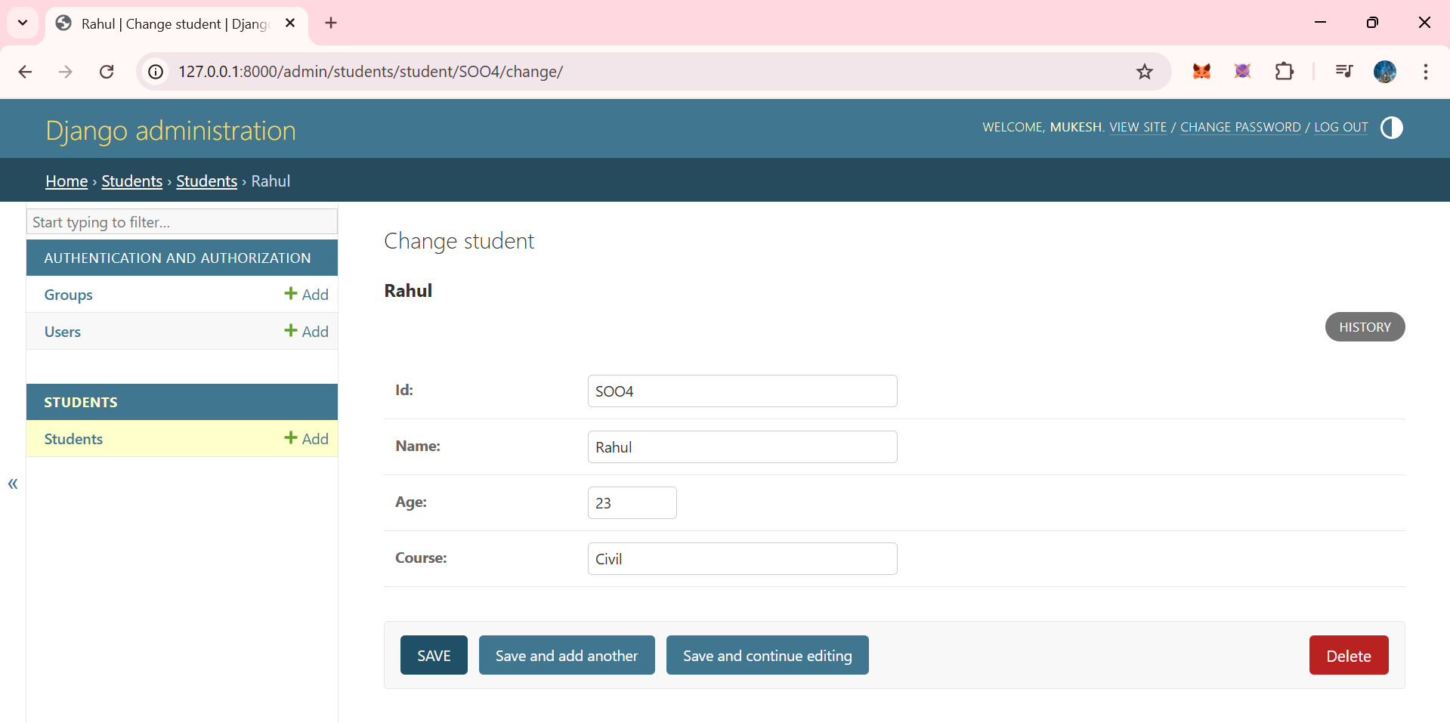

After we click on GET button we will see the 4th data RAHUL too..

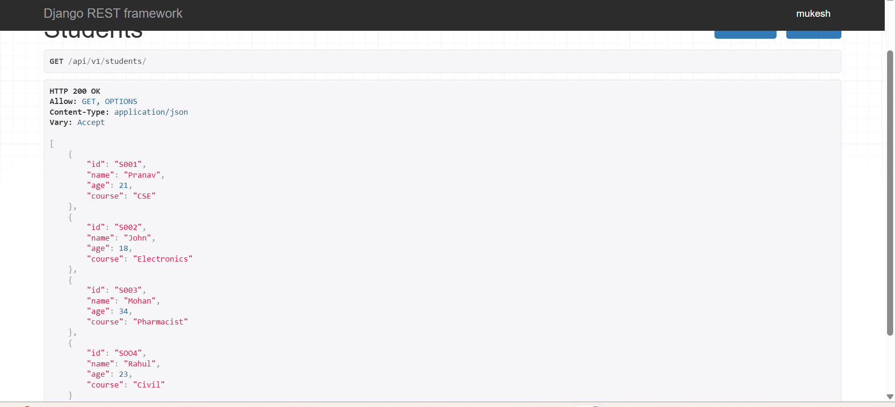

Now we wil see the POST data.





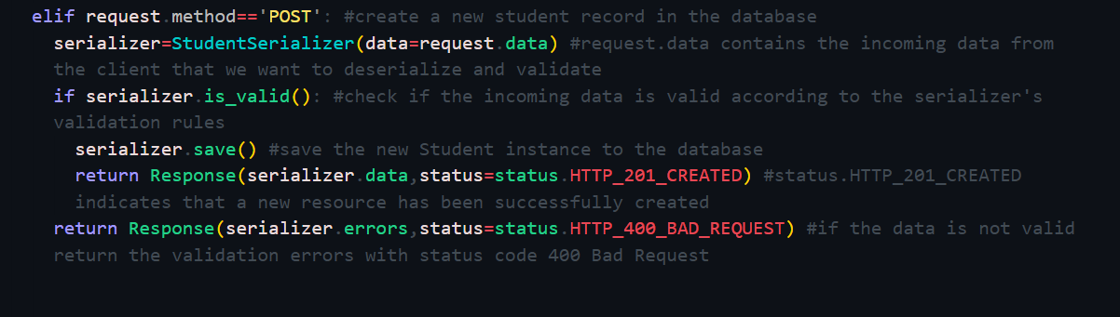

Great 👍  
This is an **important DRF milestone** you’ve reached. Let me explain this **slowly, clearly, and line-by-line**, so you can confidently write it in your notebook and also explain it in a scrum if asked.

**1️⃣ What is this code doing (big picture)**

This code creates **ONE API endpoint** that can handle **two HTTP methods**:

* **GET** → fetch student data
* **POST** → create (store) a new student in the database

This is called a **function-based API view** in Django REST Framework.

**2️⃣ This line (VERY IMPORTANT)**

@api_view(['GET', 'POST'])

**What it means:**

* This decorator tells DRF:

“This API endpoint only allows GET and POST requests”

If someone tries:

* PUT ❌
* DELETE ❌

They will get **405 Method Not Allowed**.

👉 Without @api_view, DRF features like request.data, proper JSON responses, etc. won’t work.

**3️⃣ POST request block (core logic)**

elif request.method == 'POST':

This block runs **only when client sends a POST request**, for example:

* From Postman
* From Swagger UI
* From frontend
* From Power BI / Python requests

**4️⃣ Serializer creation (DESERIALIZATION starts here)**

serializer = StudentSerializer(data=request.data)

**What is happening here?**

* request.data → incoming JSON data from client
* Example:

{

"student_id": "S004",

"name": "Alice",

"branch": "IT"

}

* Serializer converts **JSON → Python object**
* This process is called **DESERIALIZATION**

📌 **Important definition**:

Deserialization = converting incoming JSON data into Python objects so it can be validated and stored in the database.

**5️⃣ Validation step (VERY IMPORTANT)**

if serializer.is_valid():

**What happens here?**

* DRF checks:
  + Required fields present?
  + Data types correct?
  + Field constraints satisfied?

Example:

* name empty ❌
* age as string ❌

If validation fails → error messages returned.

**6️⃣ Saving data to database**

serializer.save()

**What this single line does:**

* Creates a **Student model instance**
* Inserts data into database table
* Equivalent to:

Student.objects.create(...)

📌 This is where **actual data storage happens**

**7️⃣ Success response (201 CREATED)**

return Response(

serializer.data,

status=status.HTTP_201_CREATED

)

**Meaning:**

* Data saved successfully ✅
* Return saved data as JSON
* HTTP **201** means:

“A new resource has been created”

This is **REST API best practice**.

**8️⃣ Error response (400 BAD REQUEST)**

return Response(

serializer.errors,

status=status.HTTP_400_BAD_REQUEST

)

**When does this run?**

* If serializer.is_valid() fails

Example response:

{

"name": ["This field is required."]

}

📌 Client knows exactly **what went wrong**

**9️⃣ Full flow in simple words (VERY INTERVIEW-FRIENDLY)**

Client sends POST request → JSON data → Serializer deserializes → validates data → saves to database → returns response with proper HTTP status code.

**🔑 One-line explanation you can write in notebook**

This code handles POST requests in DRF by deserializing incoming JSON data using a serializer, validating it, saving it to the database, and returning appropriate success or error responses with proper HTTP status codes.

**🔄 Relation to real projects (important for your internship)**

This exact logic is used when:

* Data comes from:
  + Frontend apps
  + Swagger
  + External APIs
  + Automation scripts
* Backend stores clean, validated data
* Dashboards (Power BI) later consume it

So yes — **this is REAL industry code** ✅

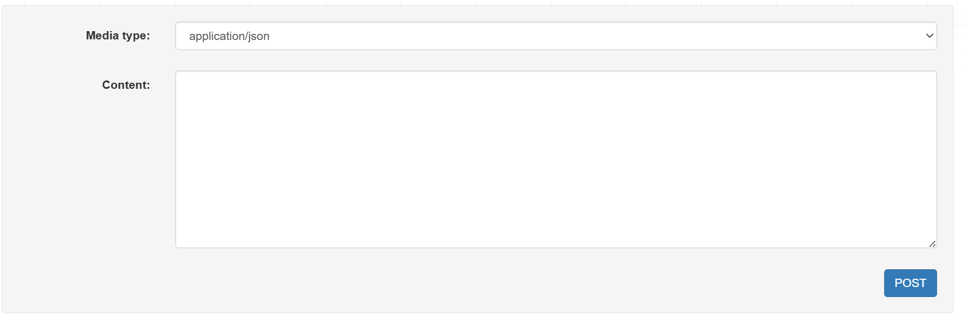

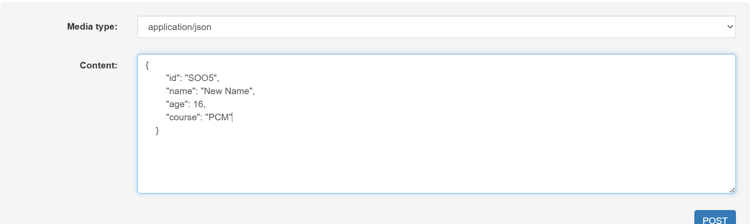

Clcik post

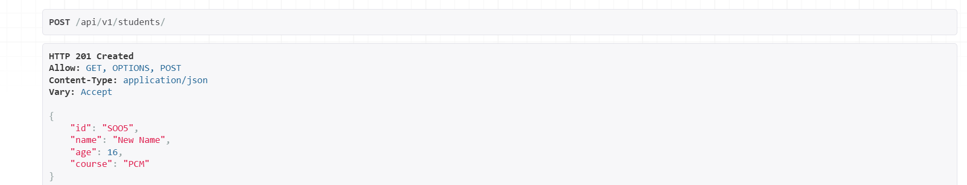

Now clcik get, you will see all the data and also newly added data

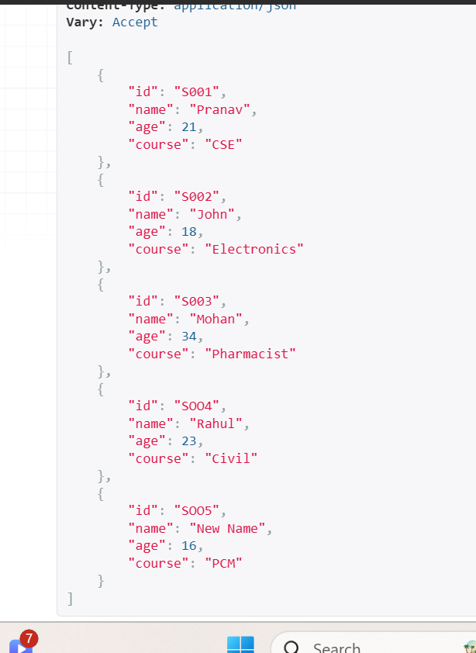



Now w will learn how to featch only a particualr student data instead of whole student data

I HAD DONE SMAL CHANGE IN MODELS.PY .. I removed student_id and let the django to autocreate its own id

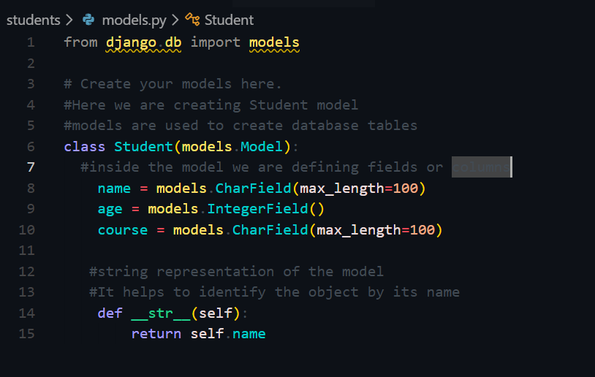

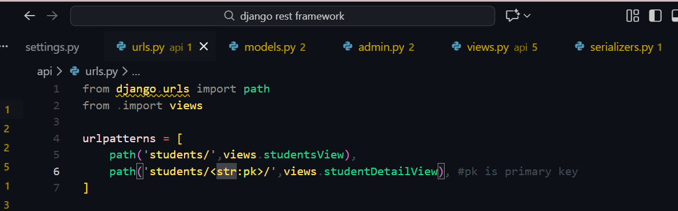

Then wrtie this code in views.py

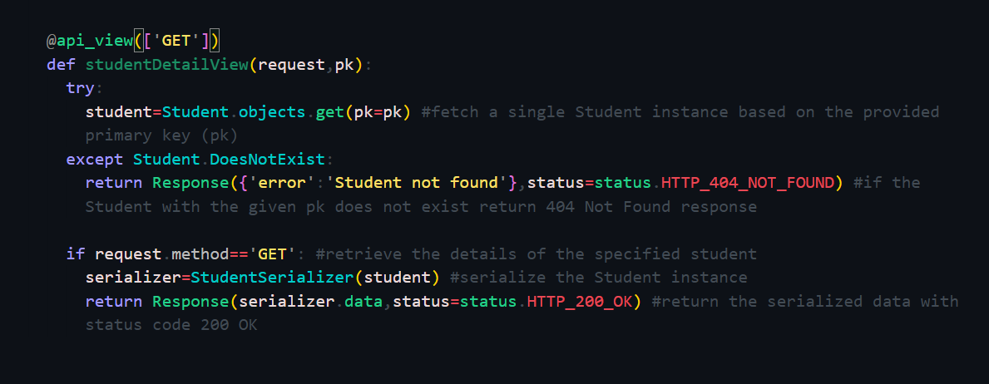

Perfect 👍  
Let’s **slowly and clearly** explain **only urls.py and views.py**, **NOT models**, exactly as used in your Django REST Framework project.

I’ll explain in **simple language**, **line by line**, so you can also **write it in your notebook**.

**1️⃣ api/urls.py – What this file does**

**📌 Purpose (in one line)**

urls.py decides **which function should run when a specific URL is requested**.

Think of it as a **traffic police** 🚦  
URL comes → it redirects traffic to the correct function.

**✅ Your code**

from django.urls import path

from . import views

**🔍 Explanation**

* path → used to define URL patterns
* views → imports views.py from the same folder (api app)

urlpatterns = [

path('students/', views.studentsView),

path('students/<int:pk>/', views.studentDetailView),

]

**🔍 Line-by-line meaning**

**1️⃣**

path('students/', views.studentsView)

* URL: /api/v1/students/
* Calls: studentsView
* Purpose: **Get ALL students**
* HTTP Method: GET

➡️ Example:

http://127.0.0.1:8000/api/v1/students/

**2️⃣**

path('students/<int:pk>/', views.studentDetailView)

* <int:pk> → dynamic value from URL
* pk = Primary Key (ID)
* Calls: studentDetailView
* Purpose: **Get ONE student by ID**

➡️ Example:

http://127.0.0.1:8000/api/v1/students/1/

**🧠 Important concept**

| **URL** | **What happens** |
| --- | --- |
| /students/ | Fetch all students |
| /students/1/ | Fetch student with ID = 1 |

**2️⃣ api/views.py – What this file does**

**📌 Purpose (in one line)**

views.py contains the **actual logic** of what data to return when a URL is hit.

**🔹 Imports (what they are for)**

from rest_framework.decorators import api_view

✔ Converts a normal Django function into a **REST API view**

from rest_framework.response import Response

✔ Used to return **JSON responses**

from rest_framework import status

✔ Provides HTTP status codes  
Example:

* 200 OK
* 404 NOT FOUND

from students.models import Student

from .serializers import StudentSerializer

✔ Used to:

* Fetch data from database
* Convert data → JSON

**🔹 First API: Get ALL students**

@api_view(['GET'])

def studentsView(request):

**🔍 Explanation**

* @api_view(['GET']) → allows only GET requests
* This function runs when /students/ is called

students = Student.objects.all()

* Fetches **all student records** from database

serializer = StudentSerializer(students, many=True)

* Converts Python objects → JSON
* many=True → because multiple records

return Response(serializer.data, status=status.HTTP_200_OK)

* Sends JSON data
* Status code: **200 OK**

**🔄 Flow (VERY IMPORTANT)**

URL → views.studentsView → DB → Serializer → JSON → Response

**🔹 Second API: Get ONE student by ID**

@api_view(['GET'])

def studentDetailView(request, pk):

* pk comes from URL (<int:pk>)

try:

student = Student.objects.get(pk=pk)

* Fetch student with given ID

except Student.DoesNotExist:

* If student not found → error

return Response(

{'error': 'Student not found'},

status=status.HTTP_404_NOT_FOUND

)

* Returns:

{

"error": "Student not found"

}

* Status: **404**

serializer = StudentSerializer(student)

* Convert single student → JSON

return Response(serializer.data, status=status.HTTP_200_OK)

* Success response

**🔁 Complete request flow (interview-ready)**

**Example:**

GET /api/v1/students/2/

**Flow:**

URL → urls.py → studentDetailView →

Database → Serializer → JSON → Response

**📝 Notebook-ready summary (you can write this)**

**urls.py**

urls.py maps URLs to view functions and decides which API function should execute for a given request.

**views.py**

views.py contains business logic. It handles HTTP requests, fetches data, serializes it into JSON, and returns responses using DRF.

We get student/1 id data.

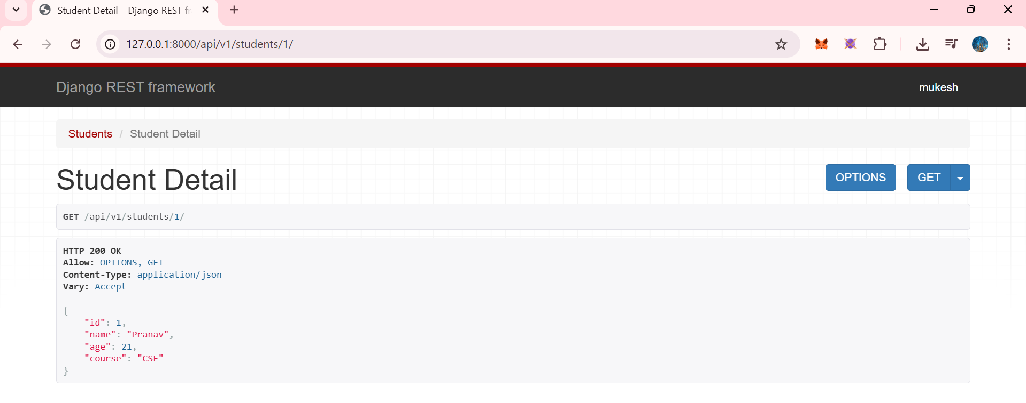



Now we will learn the ‘PUT’ mehtod which is used to update the resources.



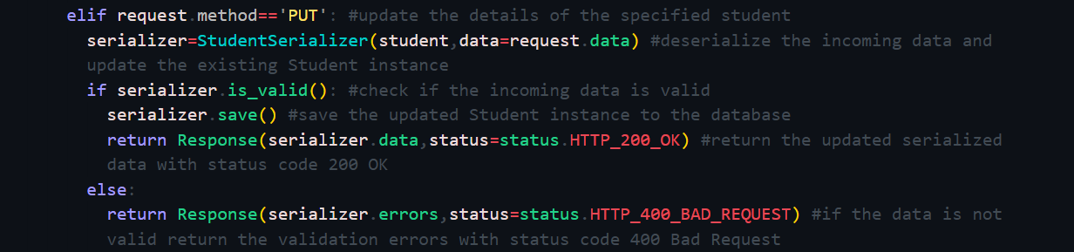

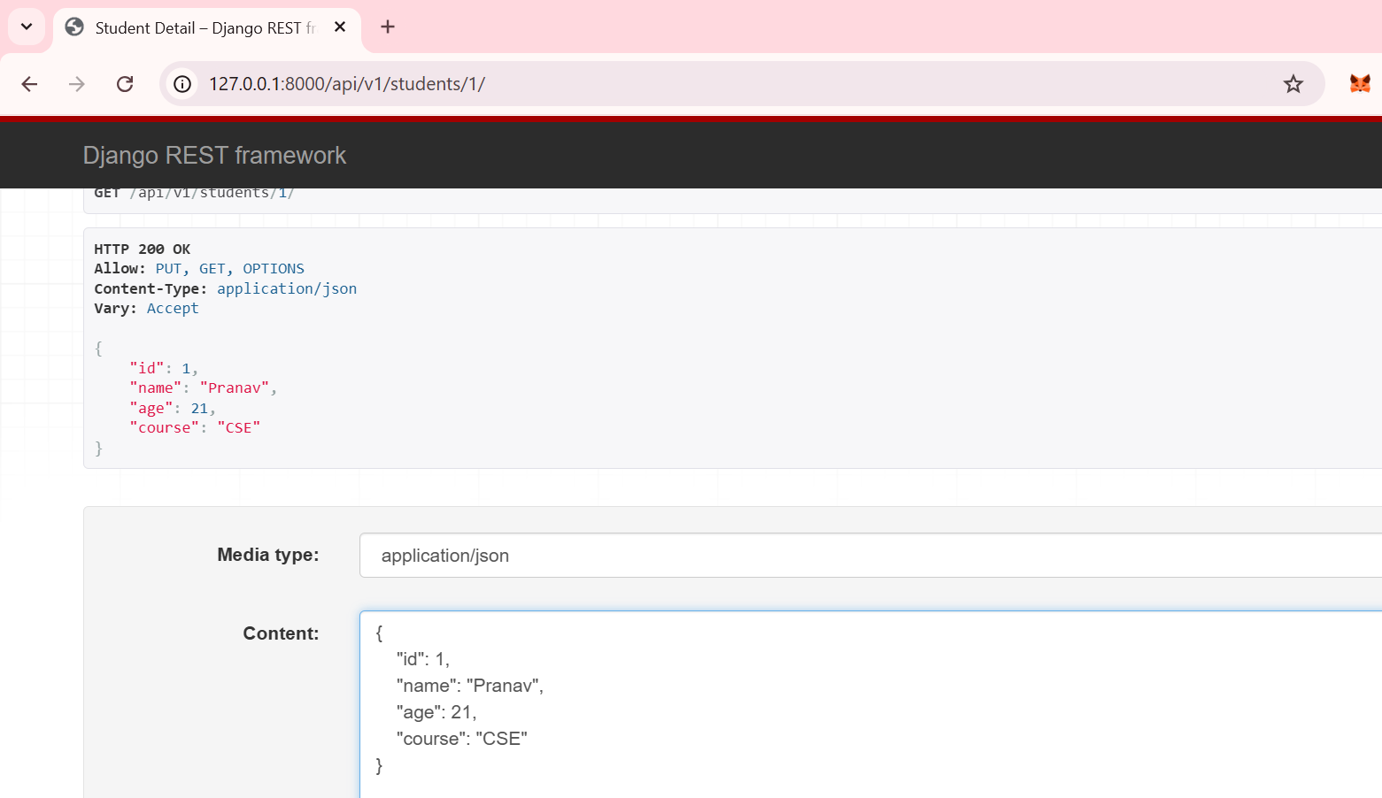

Lets change branch name of 1st id student.

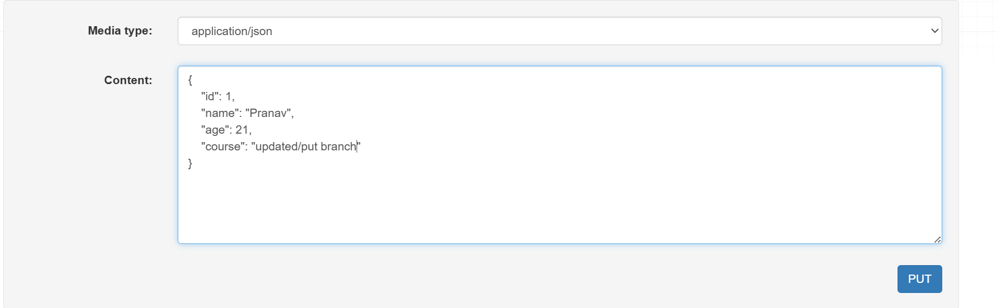

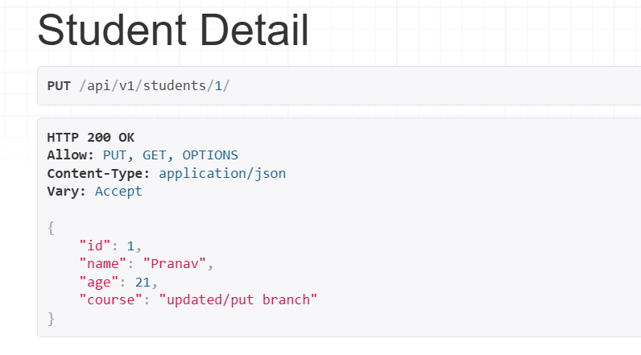

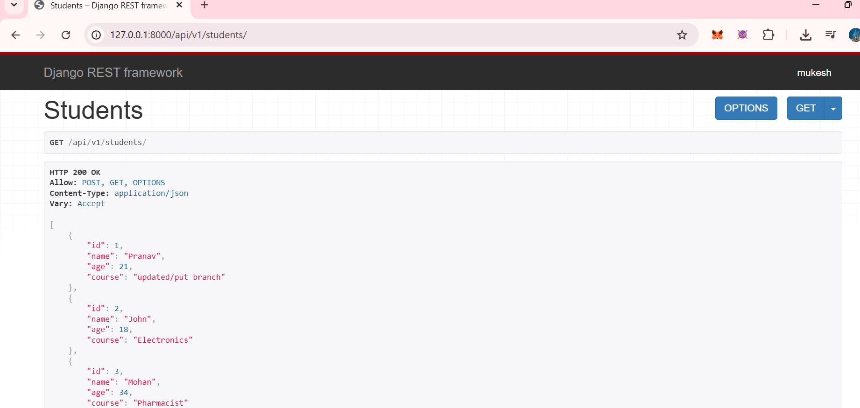



Now we will learn the DELETE method used to delete the resources,



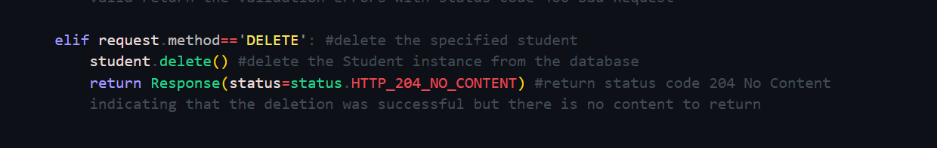

Now we got a delete button here

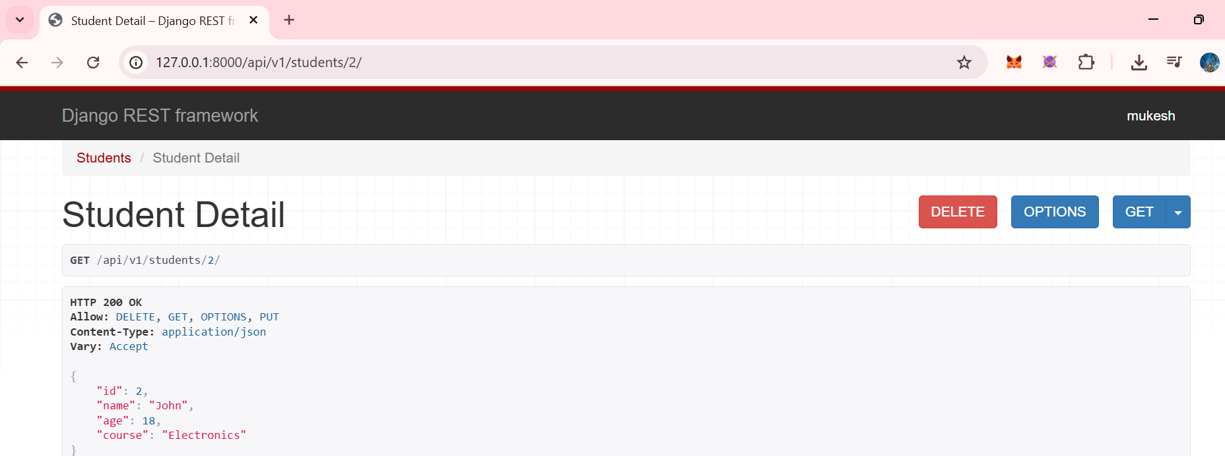

Lets delete the 2nd id student by clciking on DELETE button

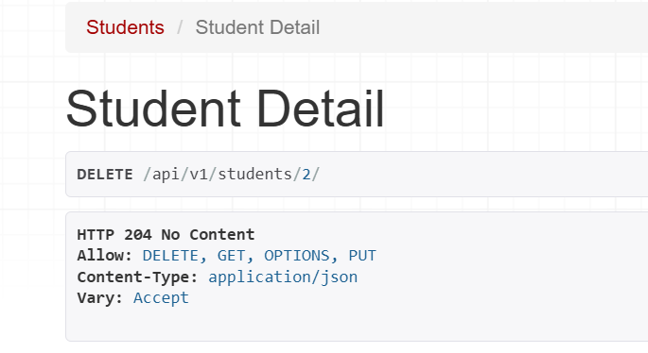

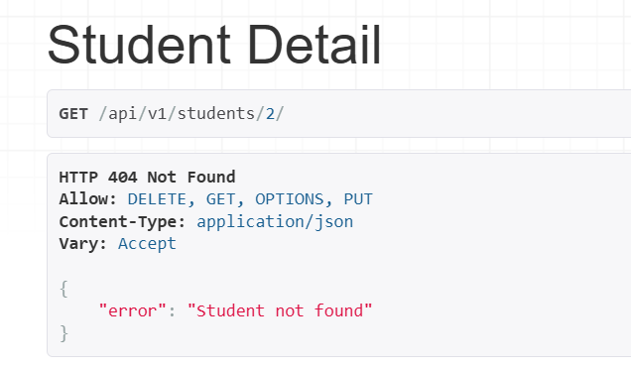

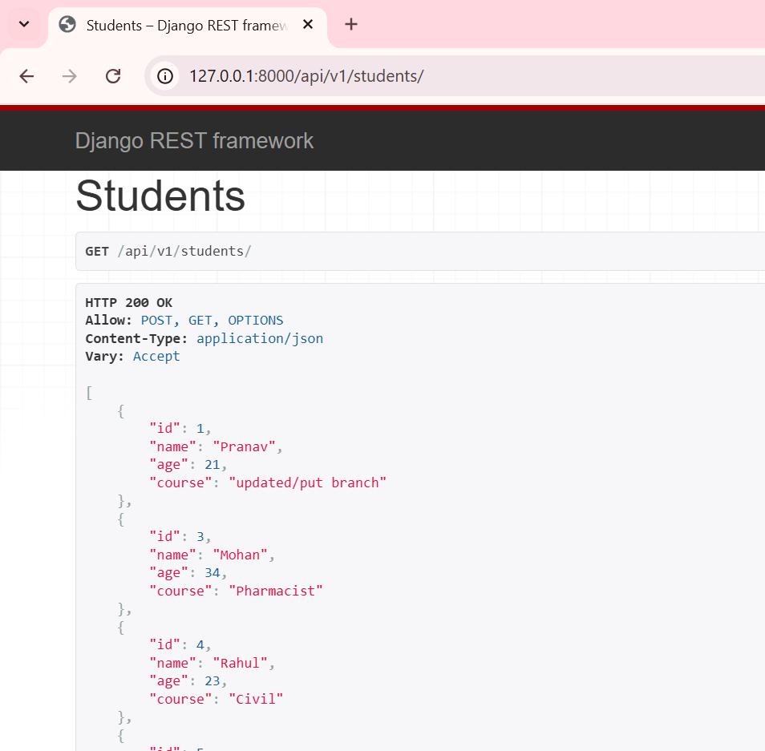

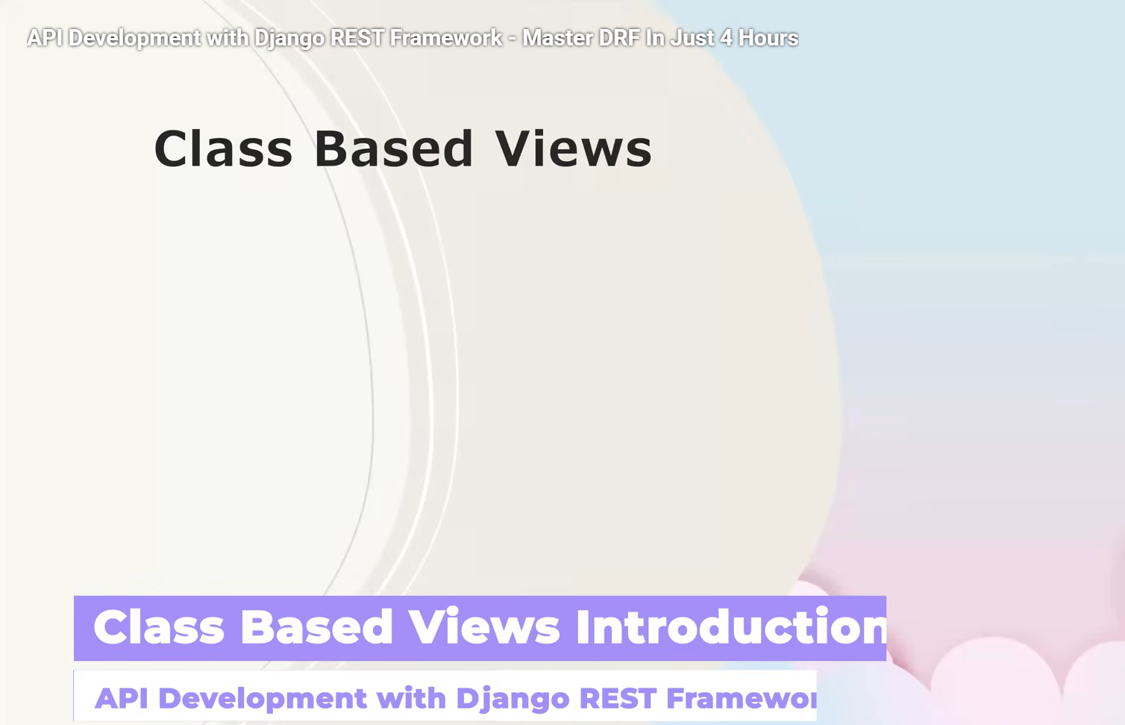

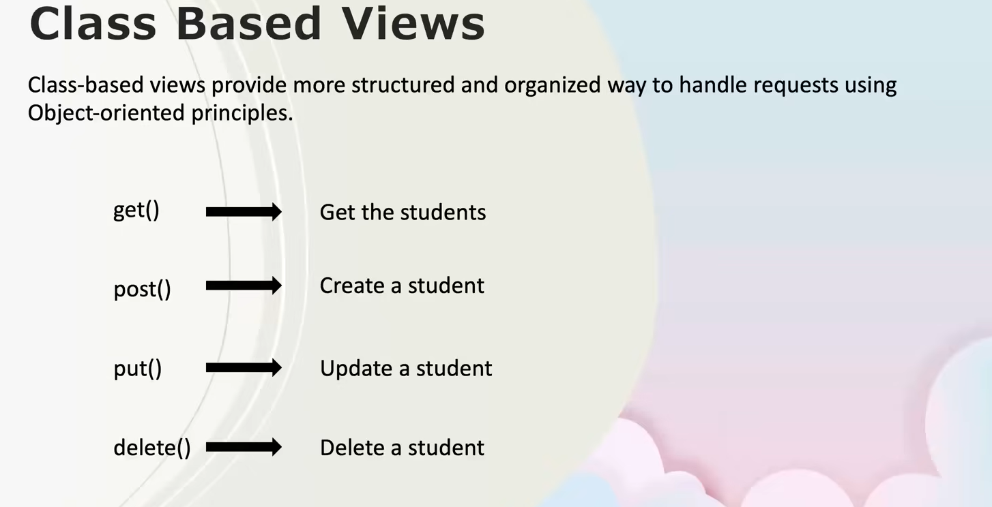

Class based views reduce the lines of code as It was in function based views and can re reused again and again.

Here are **clean, exam-ready + notebook-ready notes** on **Class-Based Views (CBVs) in Django REST Framework**, written in **simple language** 👇

**📌 Class-Based Views (CBVs) — Notes**

**🔹 What are Class-Based Views?**

Class-Based Views are a way to handle HTTP requests in Django/DRF using **Python classes instead of functions**.  
They use **Object-Oriented Programming (OOP)** concepts to make code **more structured, reusable, and maintainable**.

**🔹 Why use Class-Based Views?**

* Better **code organization**
* Less **repetition**
* Easy to extend and reuse logic
* Cleaner handling of **CRUD operations**
* Preferred in **real-world APIs**

**🔹 Mapping HTTP Methods to CRUD**

| **HTTP Method** | **CBV Method** | **CRUD Operation** | **Meaning** |
| --- | --- | --- | --- |
| GET | get() | Read | Fetch data |
| POST | post() | Create | Add new data |
| PUT | put() | Update | Update existing data |
| DELETE | delete() | Delete | Remove data |

✅ **Yes — GET, POST, PUT, DELETE are CRUD operations**  
(C → Create, R → Read, U → Update, D → Delete)

**🔹 Basic Structure of a Class-Based View**

from rest_framework.views import APIView

from rest_framework.response import Response

from rest_framework import status

class StudentView(APIView):

def get(self, request):

return Response({"message": "Get students"})

def post(self, request):

return Response({"message": "Create student"}, status=status.HTTP_201_CREATED)

**🔹 Key Points to Remember**

* Each HTTP method has its **own function**
* Cleaner than multiple if request.method == ...
* Uses APIView as base class
* Works well with **serializers**
* Common in **production-level APIs**

**🔹 CBVs vs Function-Based Views (FBVs)**

| **Feature** | **FBV** | **CBV** |
| --- | --- | --- |
| Structure | Simple | Organized |
| Reusability | Low | High |
| OOP support | ❌ | ✅ |
| Best for | Small APIs | Large APIs |

**🔹 Where CBVs are Used in Real Projects**

* REST APIs
* Backend for mobile apps
* Backend for React / Angular / Power BI
* Microservices

**🔹 Important Interview Line**

“Class-Based Views provide a structured, reusable, and scalable way to handle API requests using object-oriented principles.”

**🔹 What Comes After CBVs (Your Learning Path)**

You’re doing **perfectly in order** 👍  
Next topics after this:

1. ✅ Class-Based Views
2. 🔜 **Generic Views**
3. 🔜 **Mixins**
4. 🔜 **ViewSets**
5. 🔜 **Pagination & Filtering**

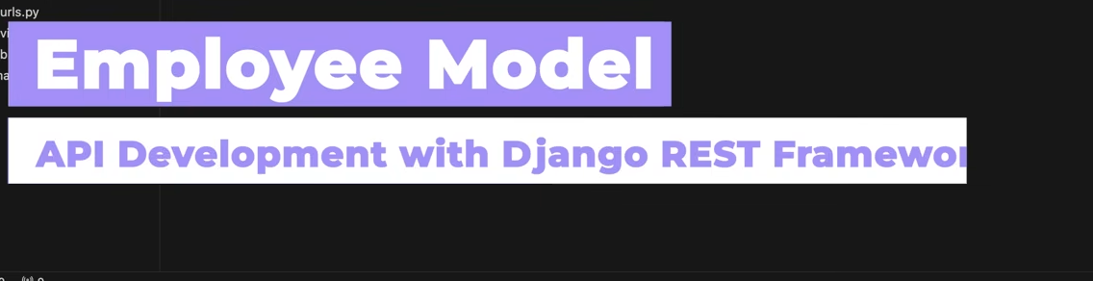

Now we will use emoloyee model for clas sbased views.

We will create a new employee map by python manage.py startapp employees,then add in settings

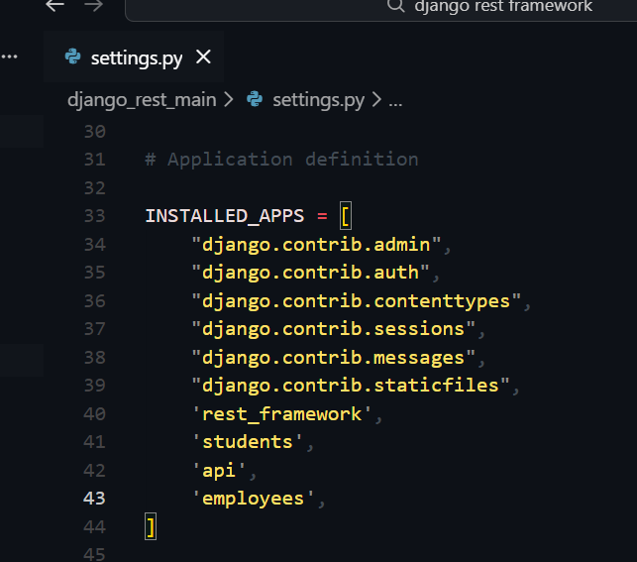

Then we create model in model.py

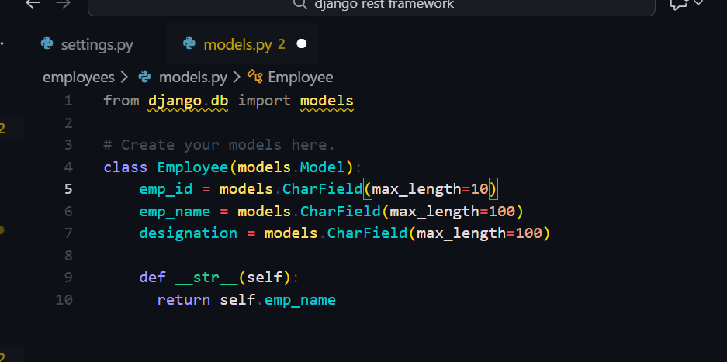

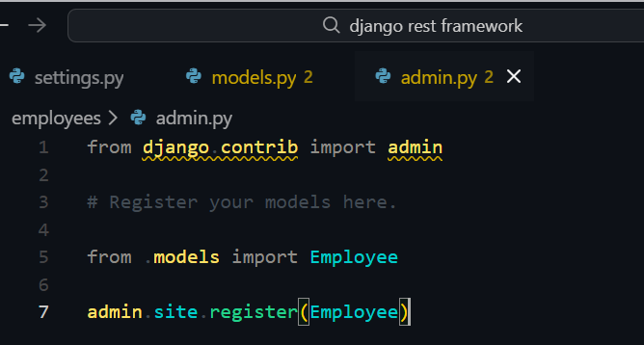

And then make migrations

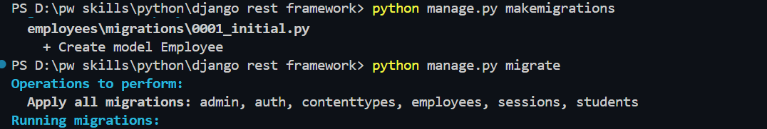

And then run the server and see in admin

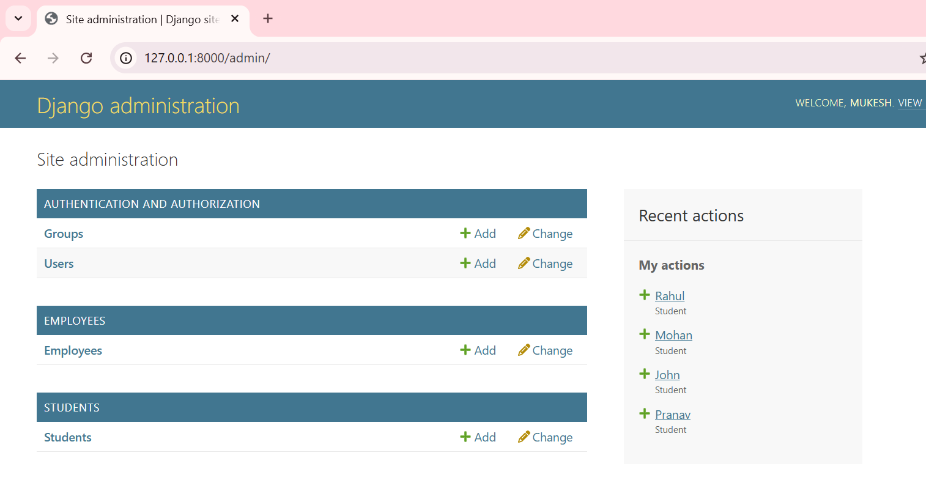

Lets add some employees

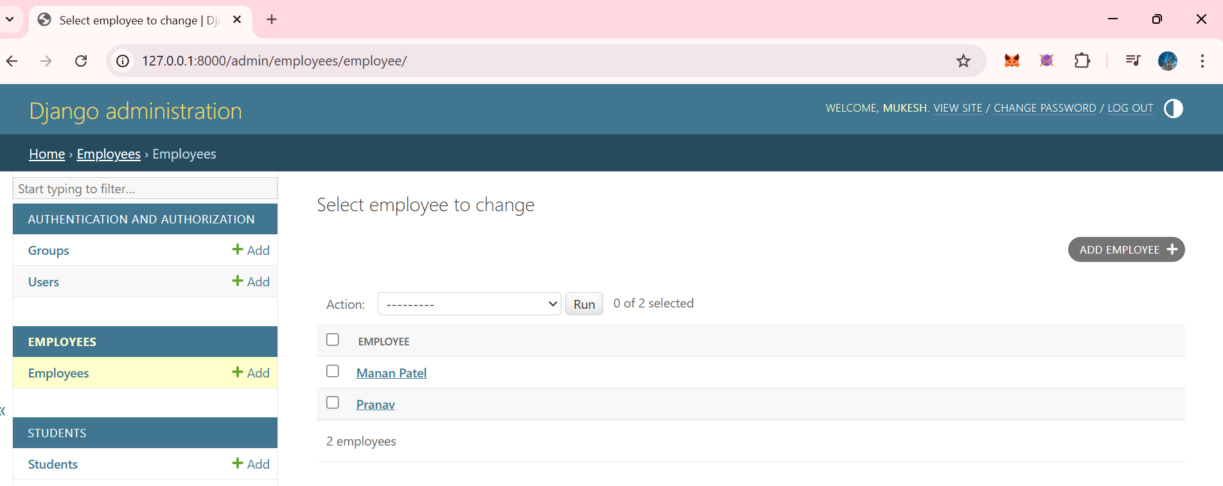

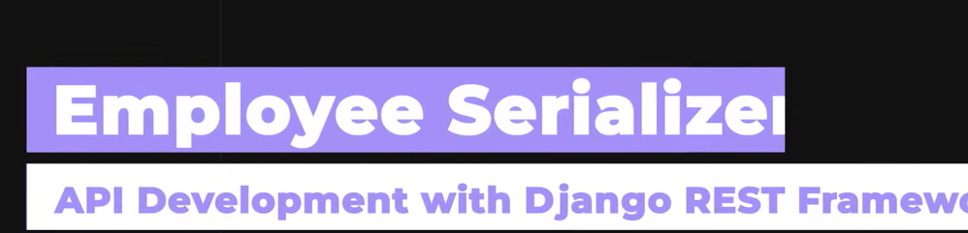

Now we will create a serializer.

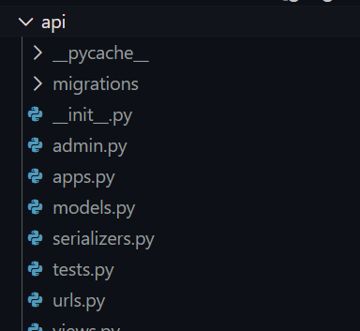

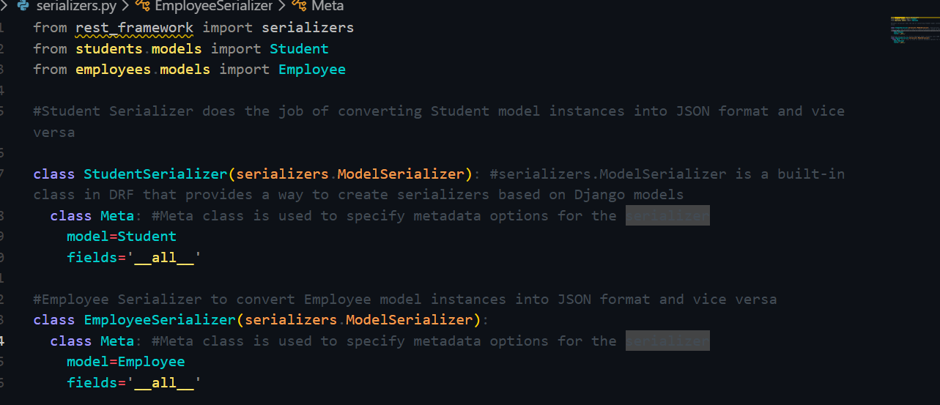

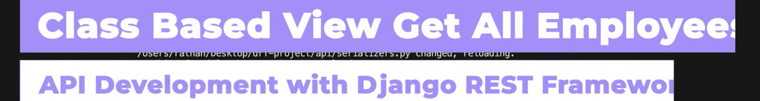

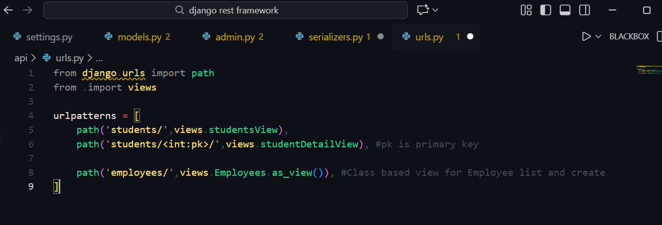

Now lets go in views and create class based views



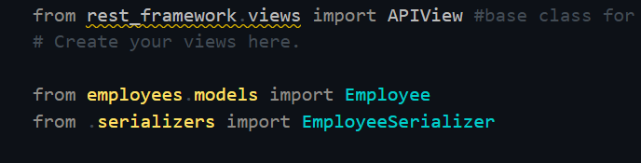

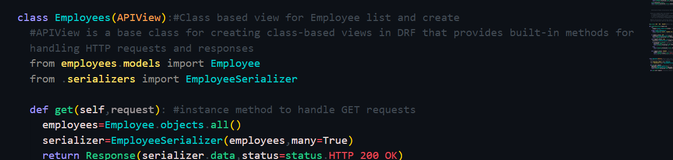

Instead of creating function based views which include (if.. , elif conditions) we created class based views with the help of base class APIView..

#APIView is a base class for creating class-based views in DRF that provides built-in methods for handling HTTP requests and responses

Here we will not need to write @api[‘GET’]… decorators. The APIView will take care of it on its own as it is a base class and has built in methods.

Then run server ,

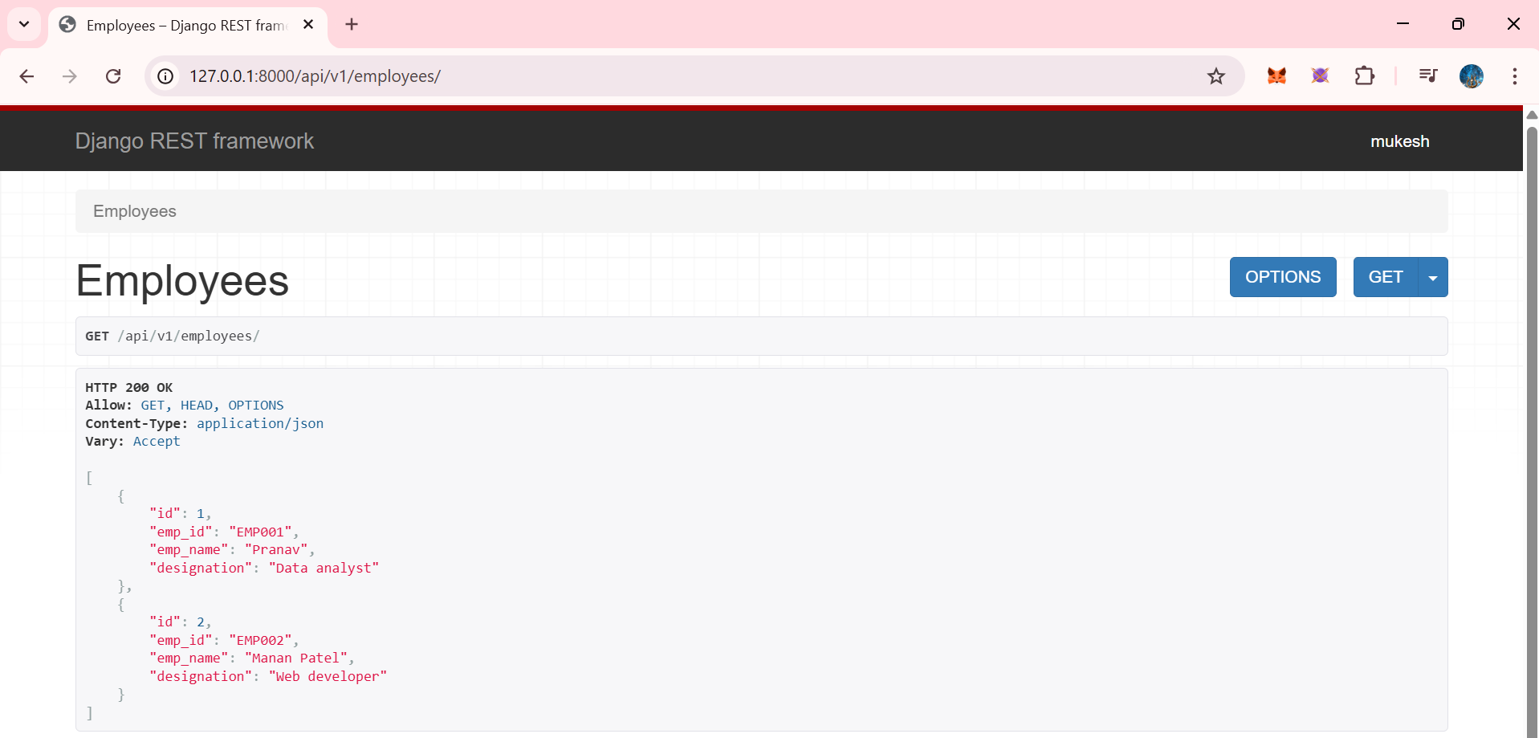

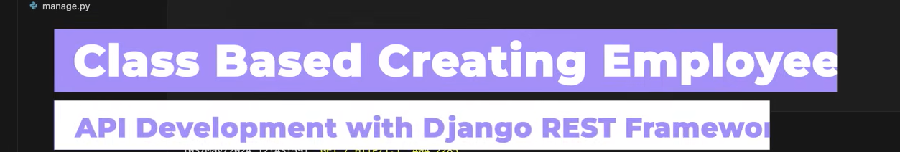

Now lets create a new Employee using POST method

Writ in same class

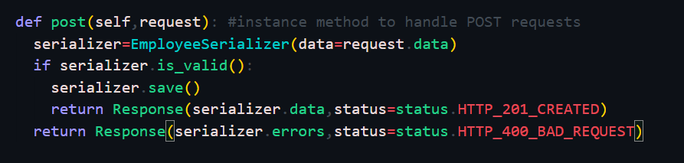

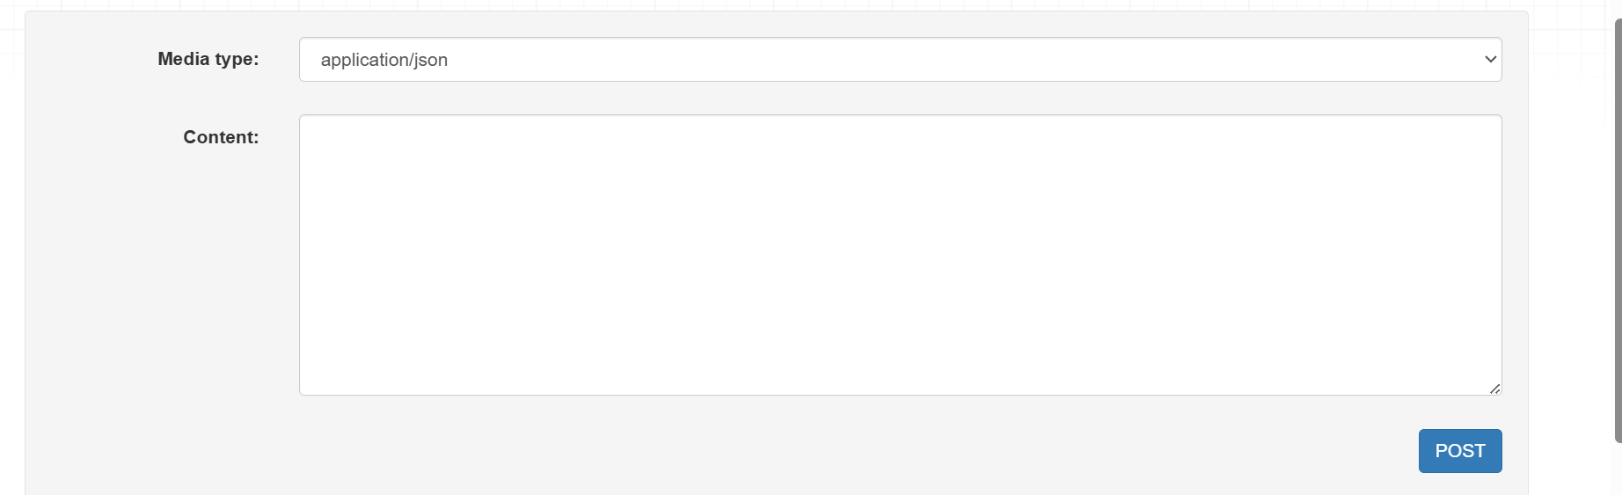

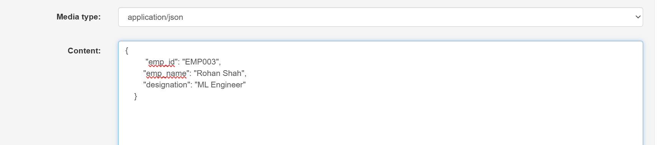

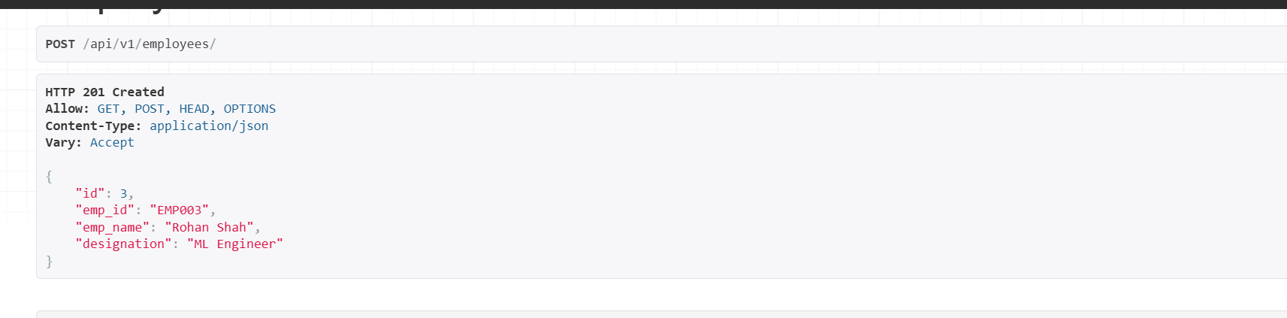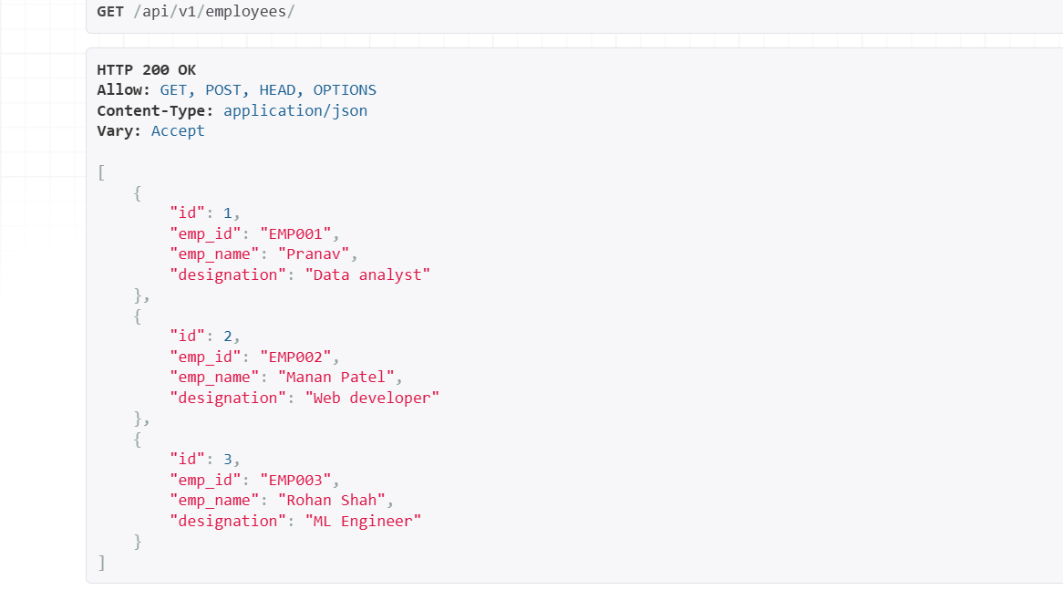

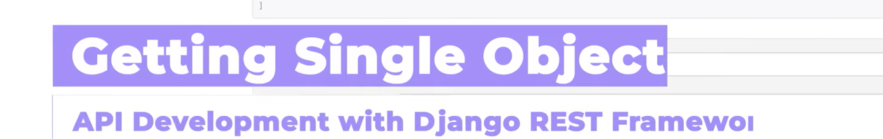

Now we will learn primary key based operations like getting ,updating or deleting a single/particular empolyee.

Now go in urls.py and add url path

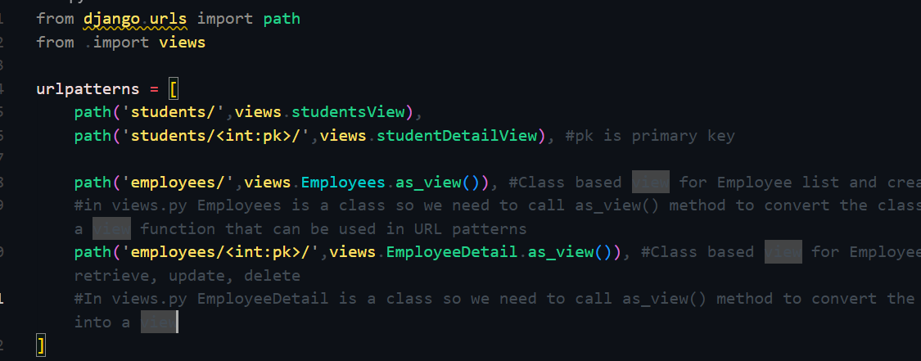

Now again go in views.py



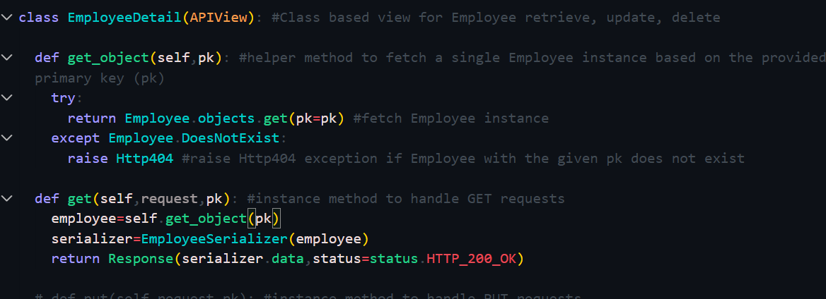

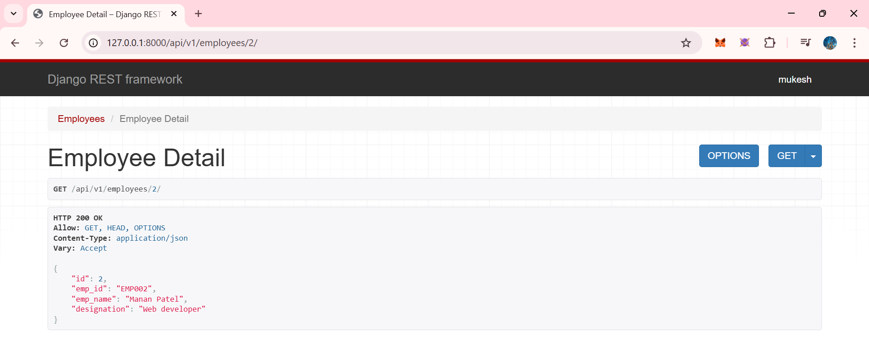

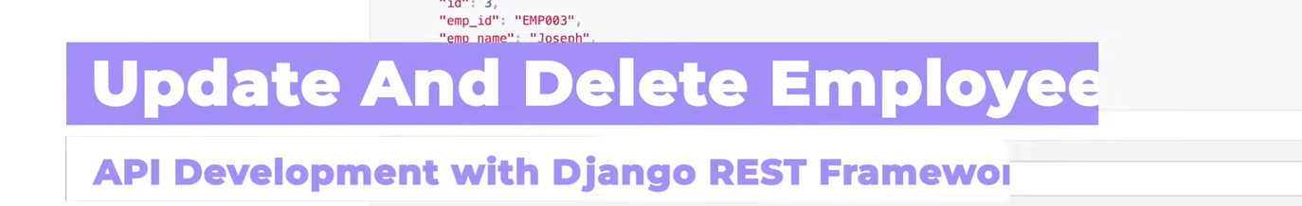

Now lets learn PUT,DELETE,

PUT

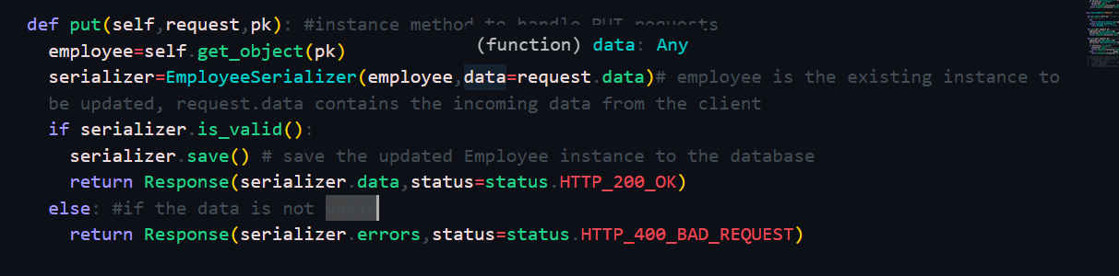

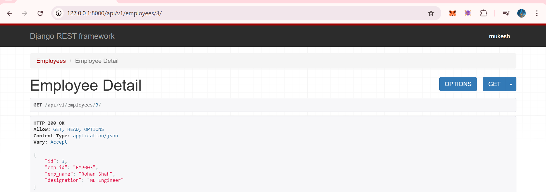

Lets change 3rd employee 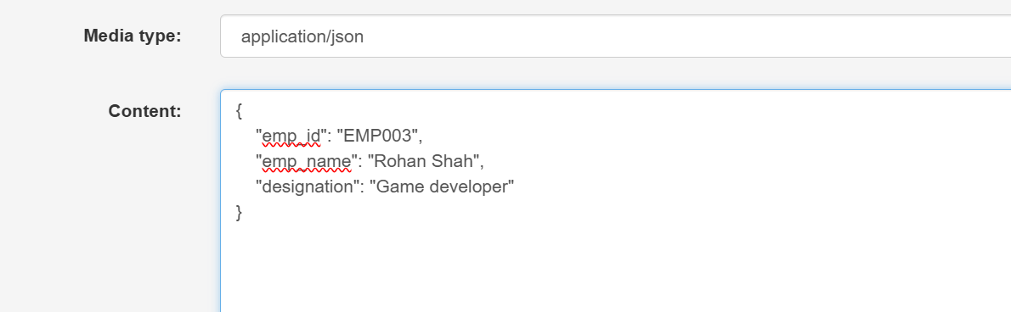

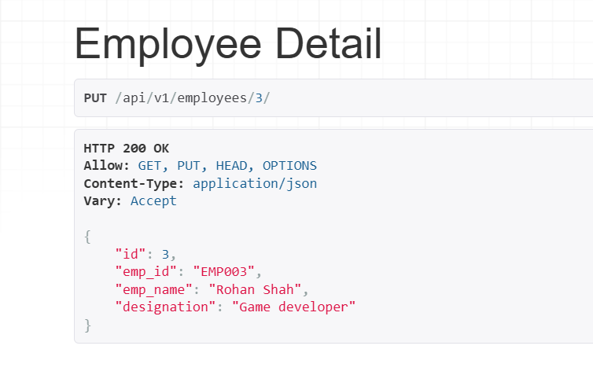

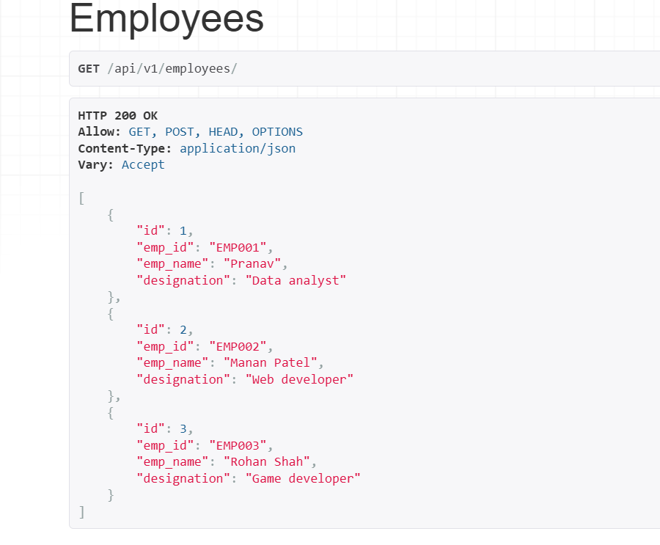

Now lets delete 3rd employee

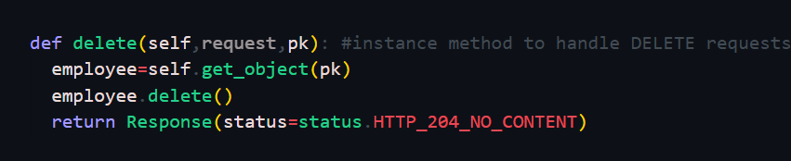

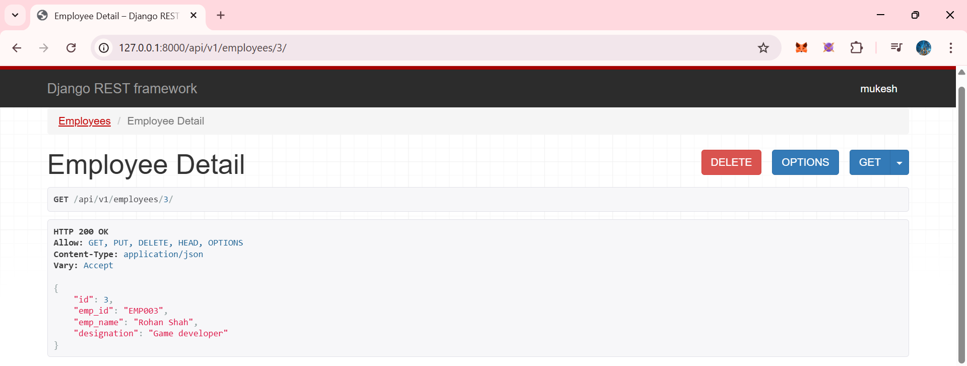

Lets clcik on delete button

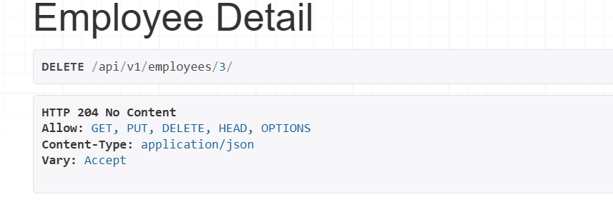

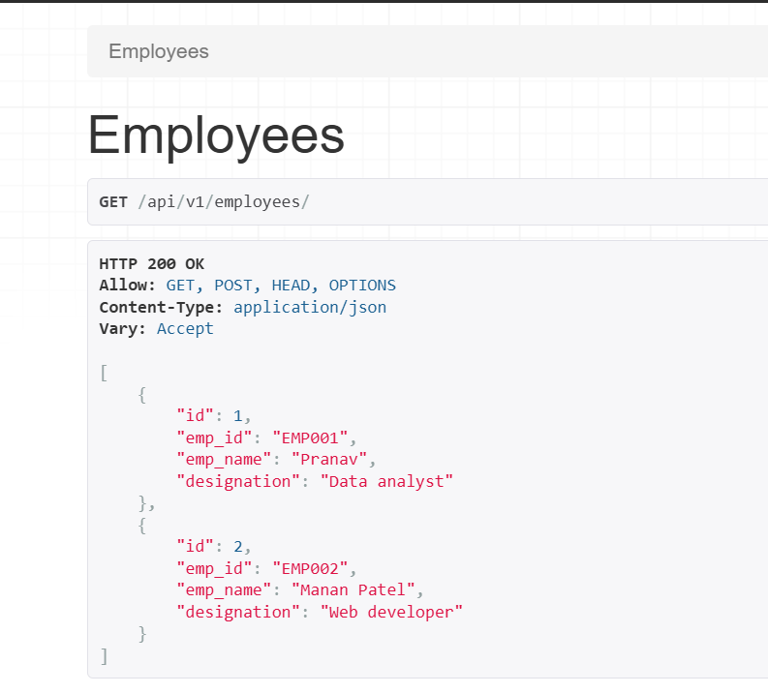

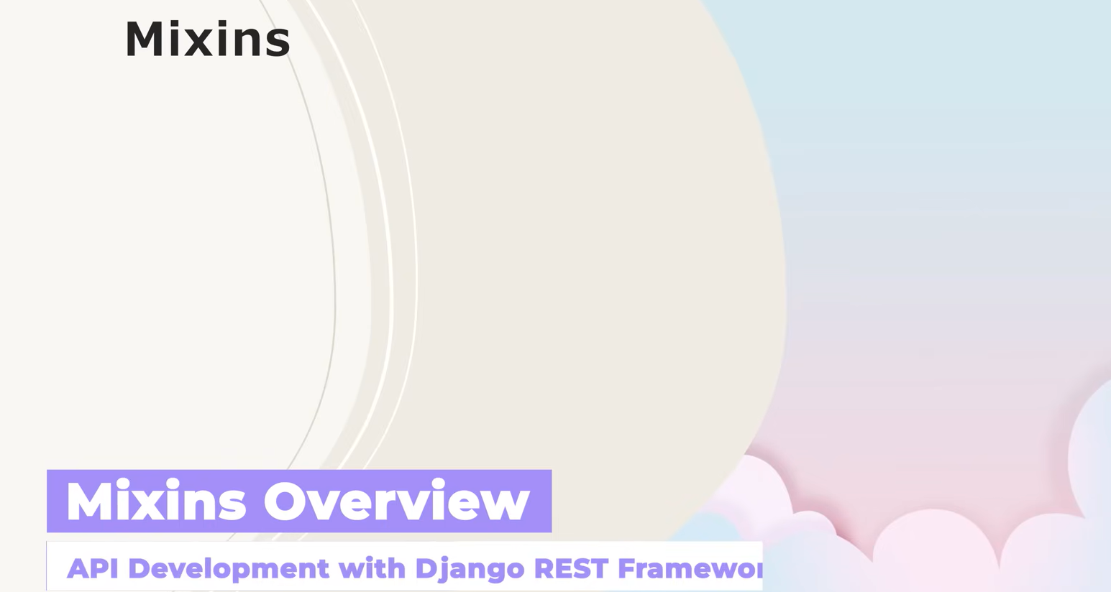

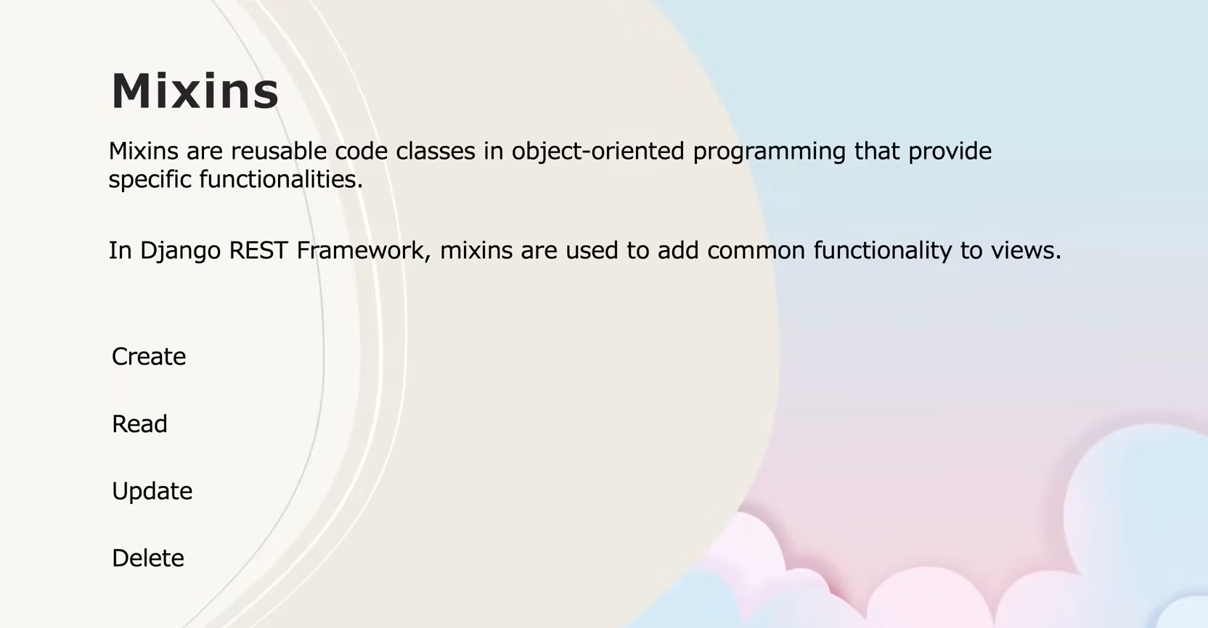

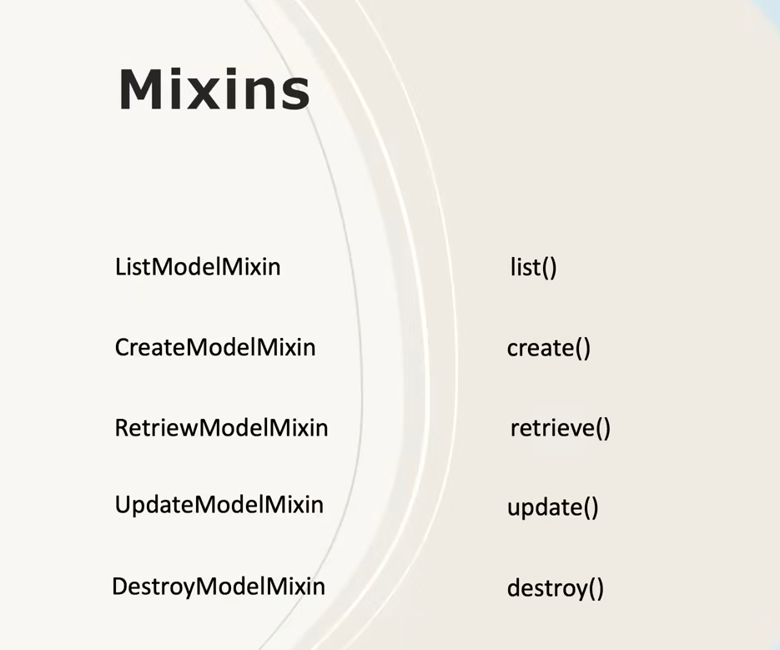

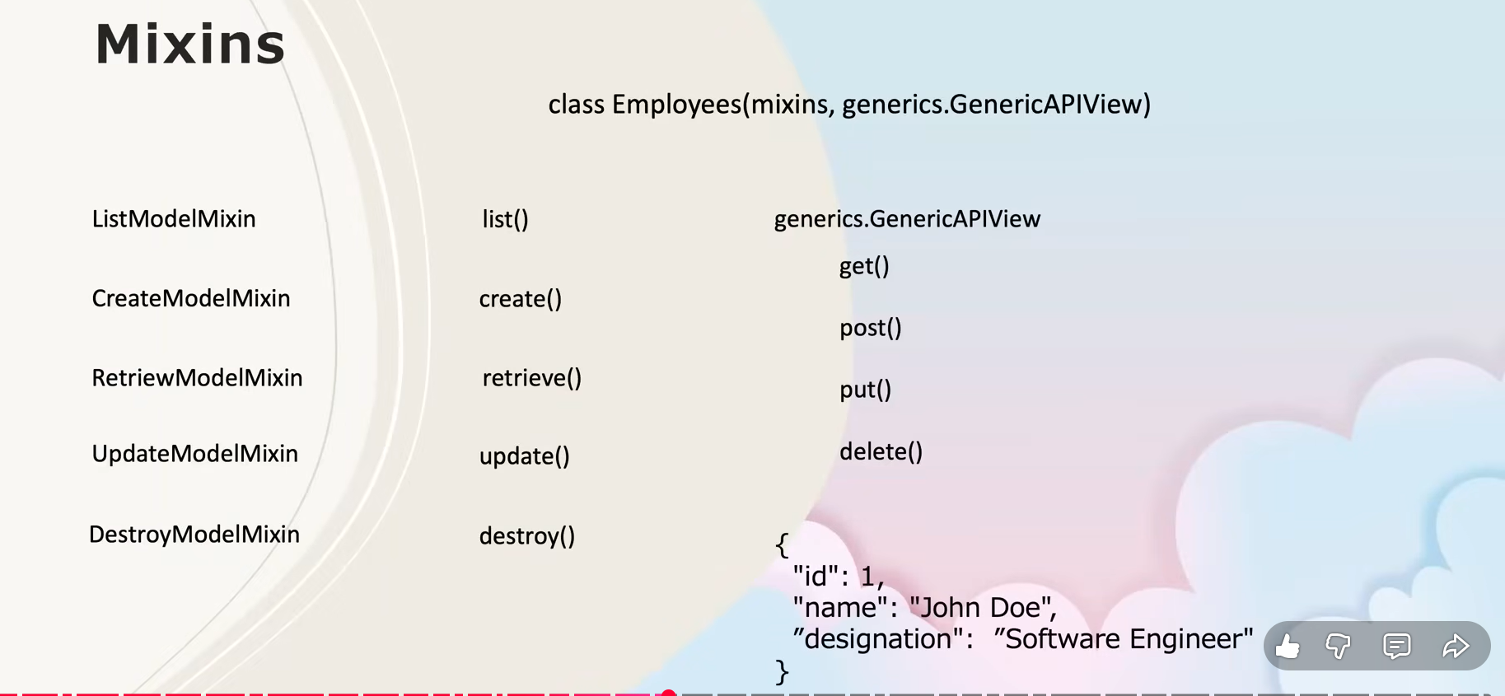

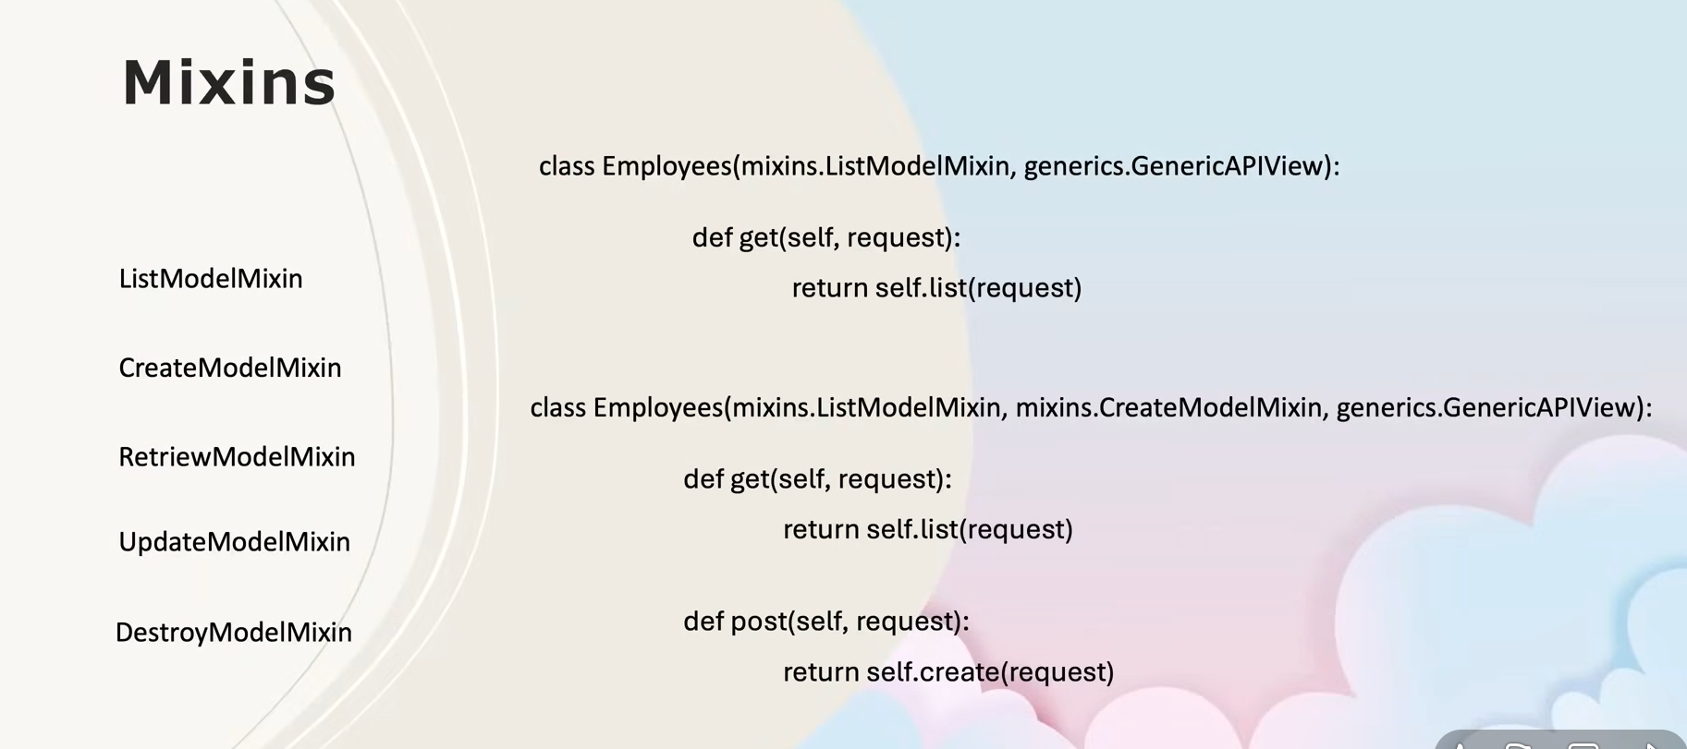

Great, you’re at a **very important and core DRF concept** now 👍  
Below are **clean, exam-ready + notebook-ready notes** for **Mixins in Django REST Framework**, exactly aligned with what your instructor is starting.

**📘 Django REST Framework – Mixins (Notes)**

**🔹 What are Mixins?**

**Mixins** are **reusable helper classes** provided by Django REST Framework that implement **common CRUD logic** (Create, Read, Update, Delete).

They are used **with Class-Based Views** to avoid writing the same code again and again.

👉 Mixins **do not work alone** — they must be combined with GenericAPIView.

**🔹 Why Mixins are Used?**

* Reduce **boilerplate code**
* Follow **DRY principle** (Don’t Repeat Yourself)
* Clean, readable, and structured API code
* Built-in handling of:
  + Querysets
  + Serializers
  + HTTP status codes

**🔹 CRUD Mapping with Mixins**

| **CRUD Operation** | **HTTP Method** | **DRF Mixin** | **Method Provided** |
| --- | --- | --- | --- |
| Create | POST | CreateModelMixin | create() |
| Read (List) | GET | ListModelMixin | list() |
| Read (Single) | GET | RetrieveModelMixin | retrieve() |
| Update | PUT / PATCH | UpdateModelMixin | update() |
| Delete | DELETE | DestroyModelMixin | destroy() |

**🔹 Commonly Used DRF Mixins**

from rest_framework import mixins

**1️⃣ ListModelMixin**

* Used to **fetch all records**
* Provides: list()

mixins.ListModelMixin

**2️⃣ CreateModelMixin**

* Used to **create a new record**
* Provides: create()

mixins.CreateModelMixin

**3️⃣ RetrieveModelMixin**

* Used to **get a single object by ID**
* Provides: retrieve()

mixins.RetrieveModelMixin

**4️⃣ UpdateModelMixin**

* Used to **update an existing object**
* Provides: update()

mixins.UpdateModelMixin

**5️⃣ DestroyModelMixin**

* Used to **delete an object**
* Provides: destroy()

mixins.DestroyModelMixin

**🔹 GenericAPIView (Very Important)**

GenericAPIView:

* Connects **mixins** with:
  + queryset
  + serializer_class
* Handles:
  + request parsing
  + object lookup (pk)
  + validation

👉 **Mixins cannot work without GenericAPIView**

**🔹 Example: List + Create API using Mixins**

from rest_framework import mixins, generics

from .models import Student

from .serializers import StudentSerializer

class StudentListCreateView(

mixins.ListModelMixin,

mixins.CreateModelMixin,

generics.GenericAPIView

):

queryset = Student.objects.all()

serializer_class = StudentSerializer

def get(self, request):

return self.list(request)

def post(self, request):

return self.create(request)

**What happens here?**

* GET → returns list of students
* POST → creates a new student
* Logic handled internally by mixins

**🔹 Example: Retrieve + Update + Delete API**

class StudentDetailView(

mixins.RetrieveModelMixin,

mixins.UpdateModelMixin,

mixins.DestroyModelMixin,

generics.GenericAPIView

):

queryset = Student.objects.all()

serializer_class = StudentSerializer

def get(self, request, pk):

return self.retrieve(request, pk=pk)

def put(self, request, pk):

return self.update(request, pk=pk)

def delete(self, request, pk):

return self.destroy(request, pk=pk)

**🔹 Relation Between CBVs, Mixins & Generics**

Function-Based Views (Manual)

↓

Class-Based Views

↓

Mixins + GenericAPIView

↓

Generic Views

↓

ViewSets (Highest abstraction)

**🔹 Important Interview / Scrum Lines**

You can confidently say:

“I am currently working with Django REST Framework and have completed Function-Based Views, Class-Based Views, and started Mixins with GenericAPIView for implementing CRUD operations.”

**🔹 Should You Worry If Mixins Feel Confusing?**

❌ No — **this is normal**

Mixins feel confusing initially because:

* They hide logic internally
* Less visible code than FBVs

👉 Once you see **Generic Views**, everything will click naturally.

**🔹 What’s Next After Mixins?**

Your learning order should be:

1. ✔ Function-Based Views
2. ✔ Class-Based Views
3. 🔄 Mixins
4. ⏭ **Generic Views**
5. ⏭ **ViewSets**
6. ⏭ Pagination & Filtering (optional but useful)





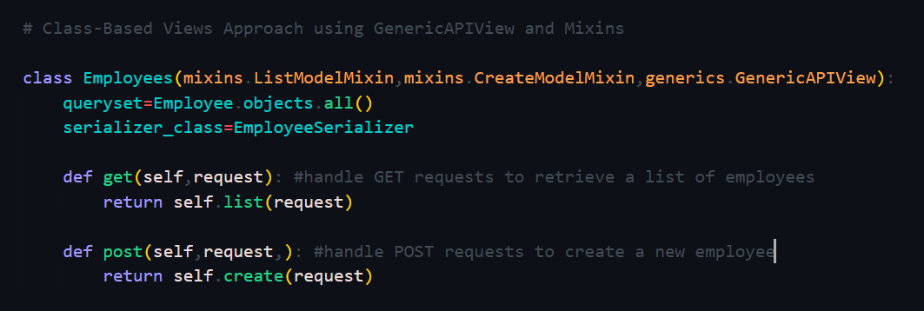

The GenericAPIView will taks care of data validation and HTTP responses as well as it’s status. Now we don;t need ot manually write response(status=status….)

Now see the below code takrn from ealiier example without mxins and genercs..

Now using genericAPIView it will automatically validate(is_valid()) and save the data and return response and status.

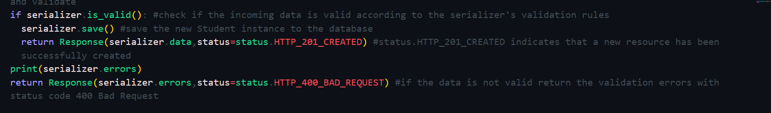

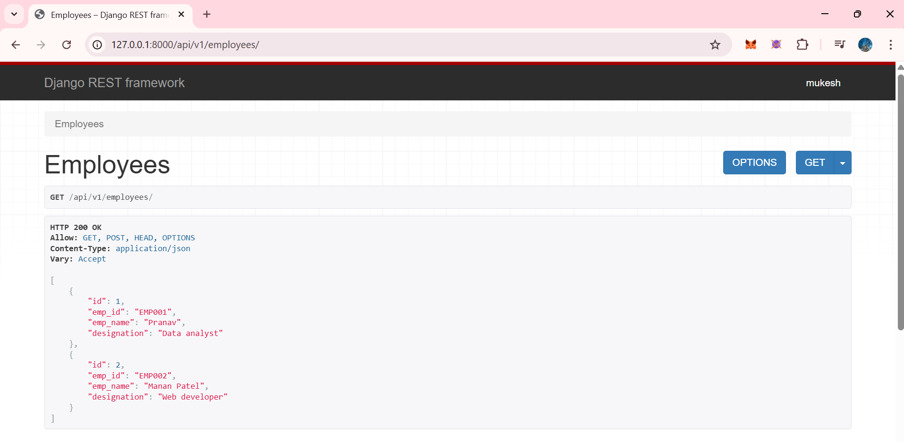

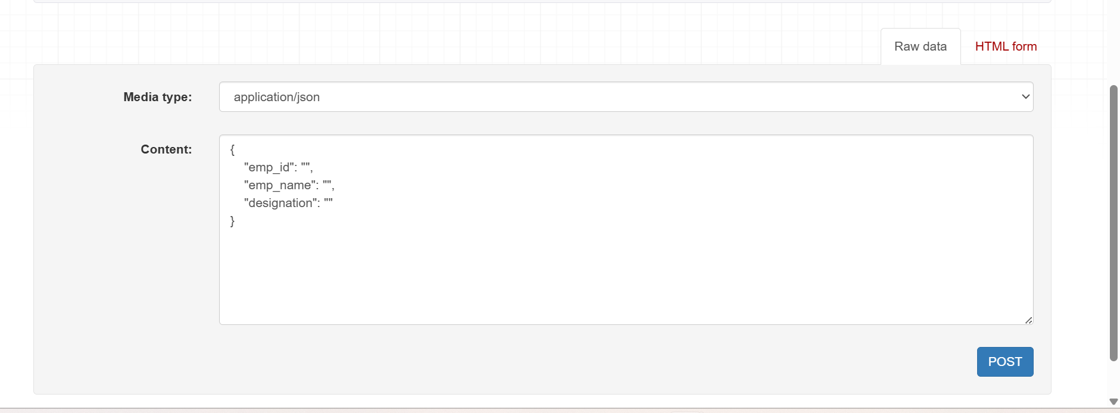

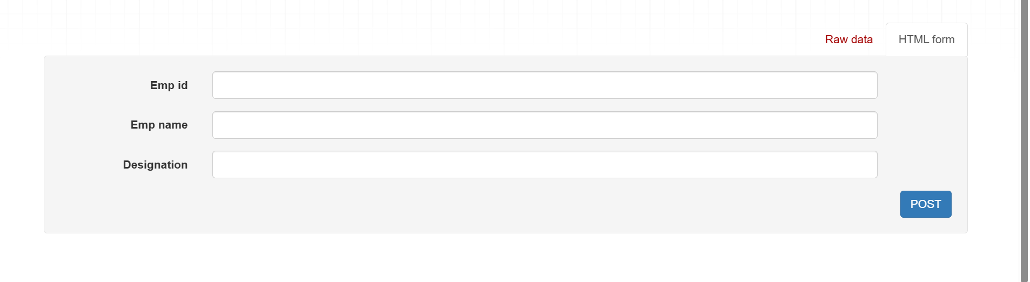

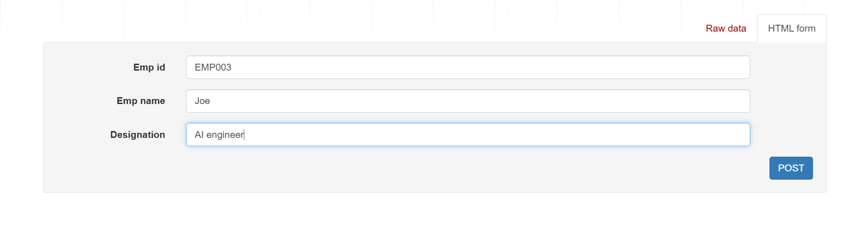

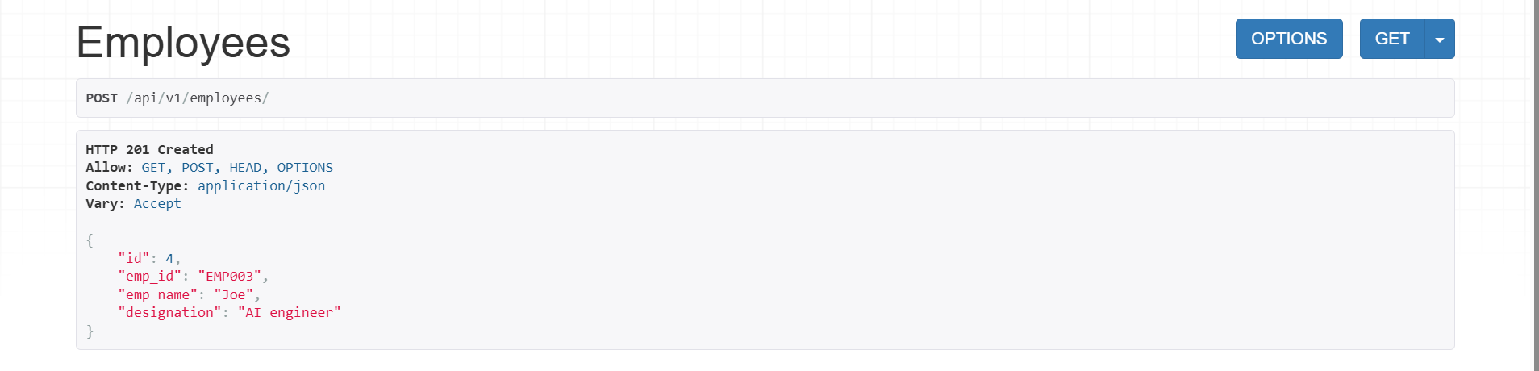

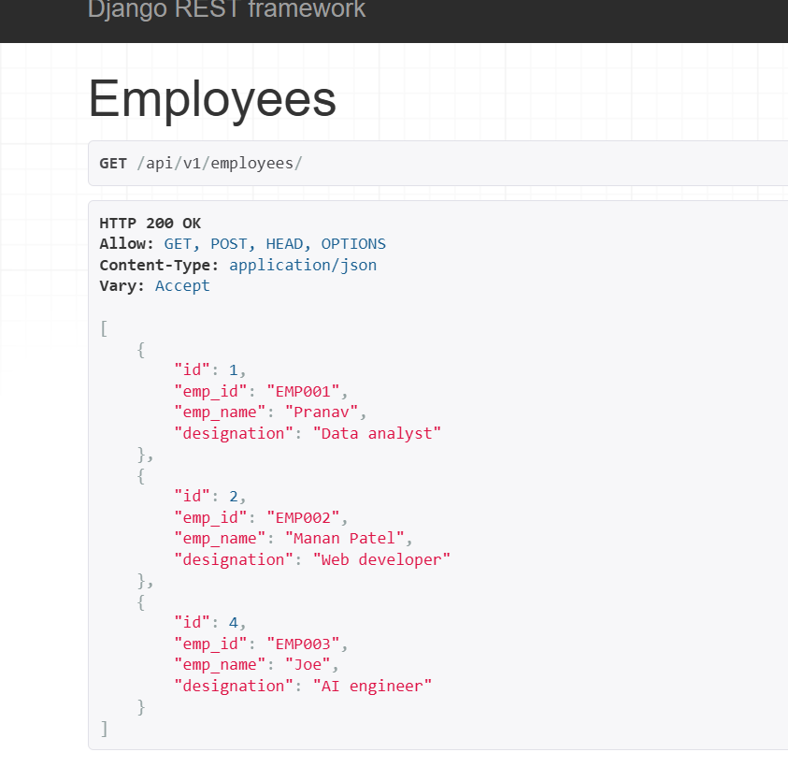

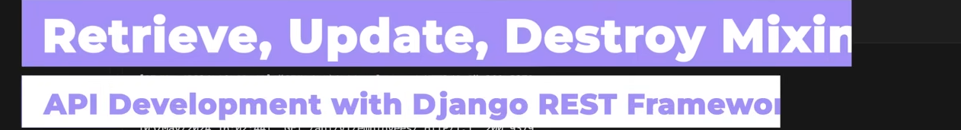

Now lets Retrieve a single employye id

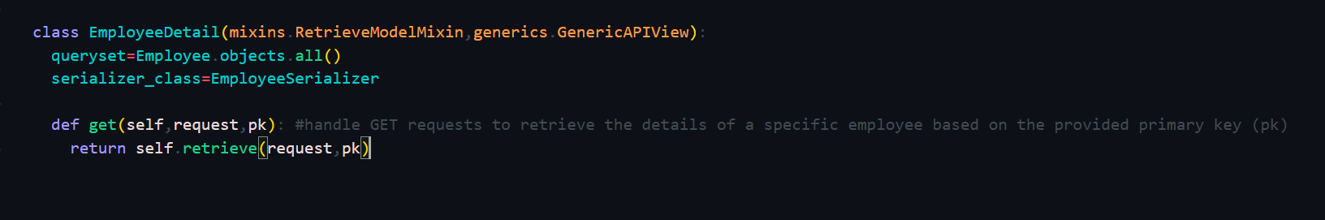

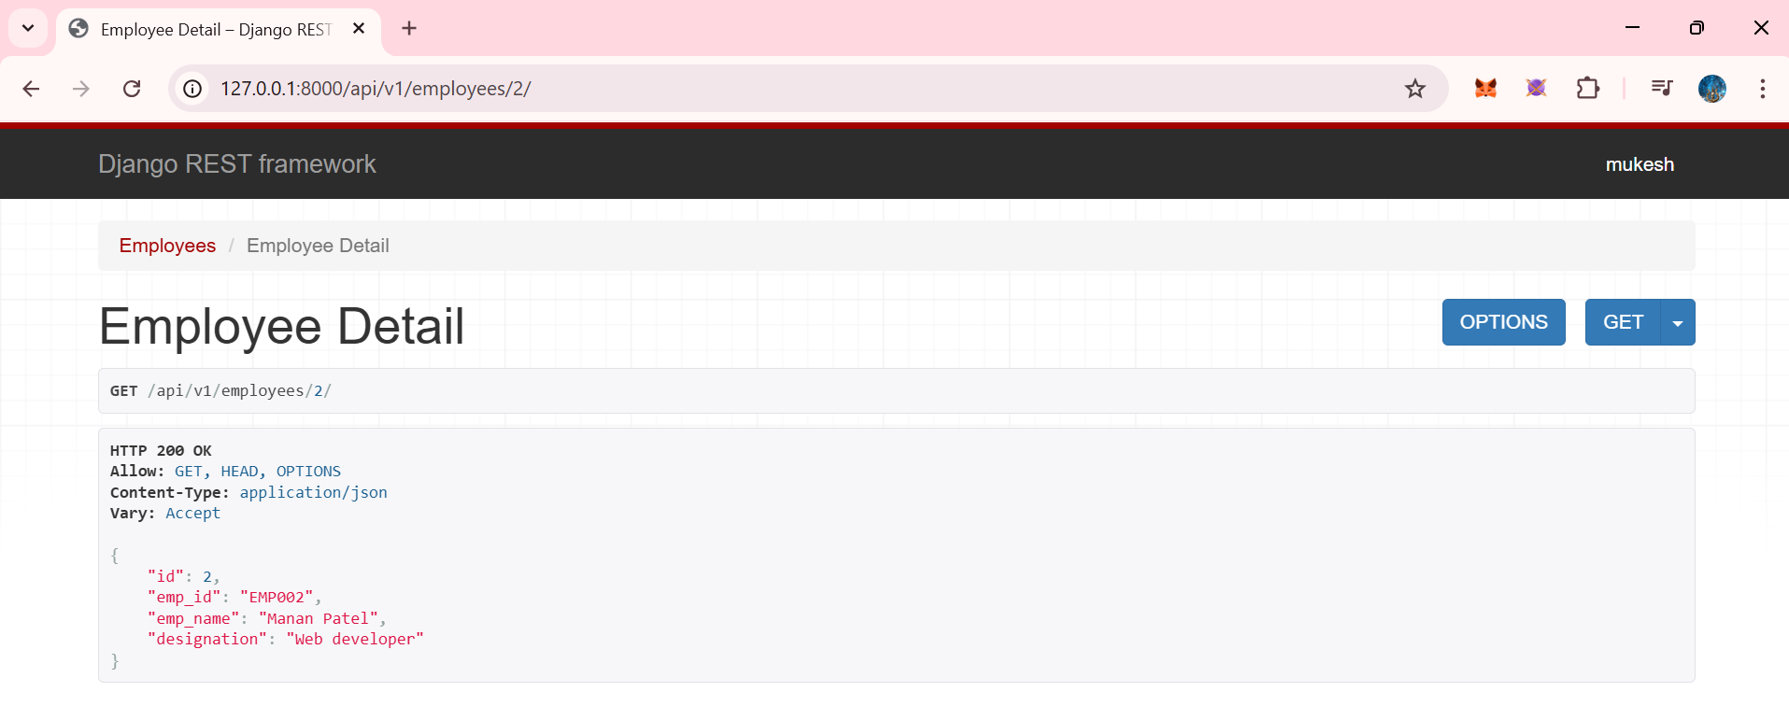

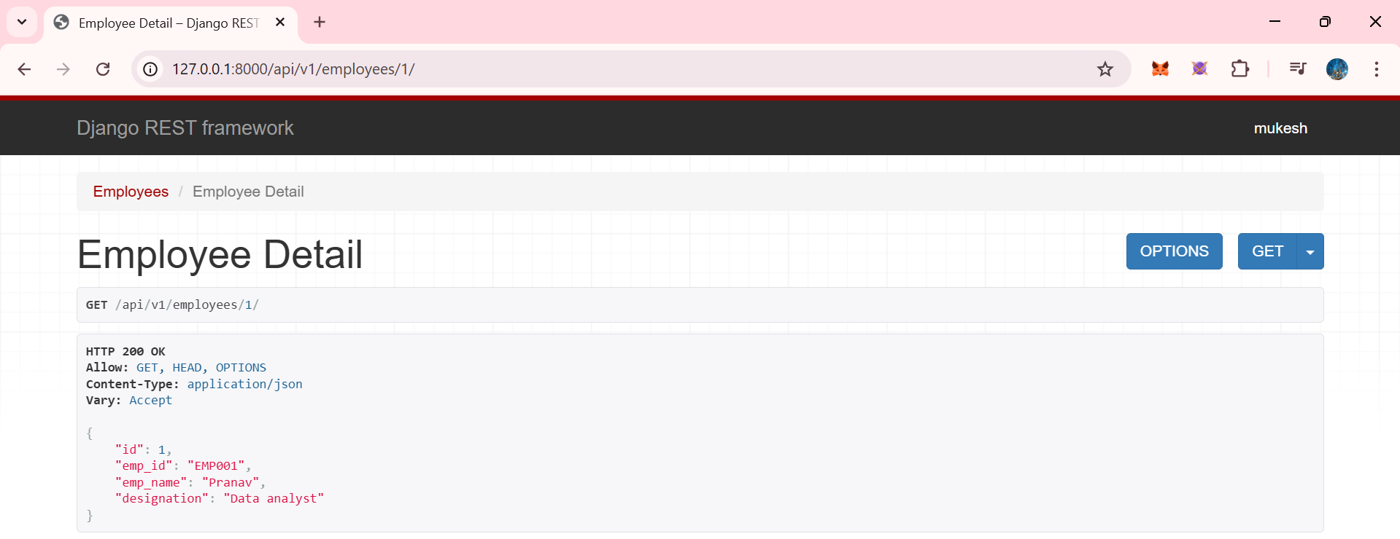

Now lets see PUT method to update the any employee info





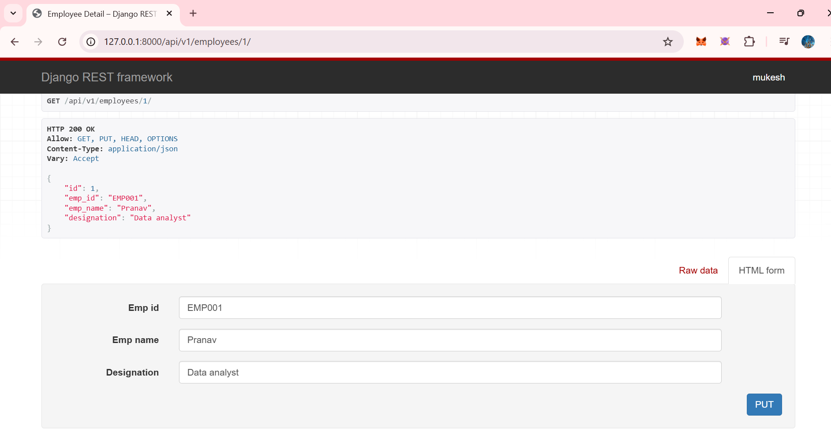

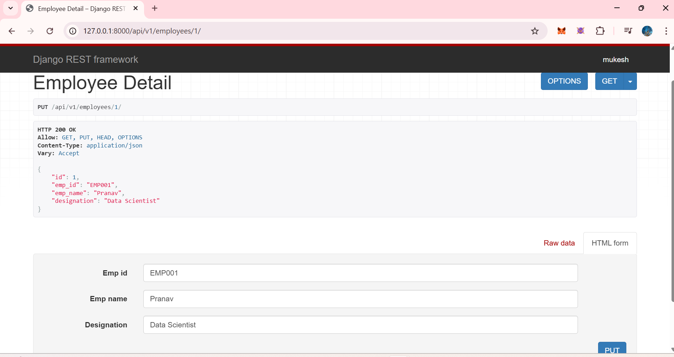

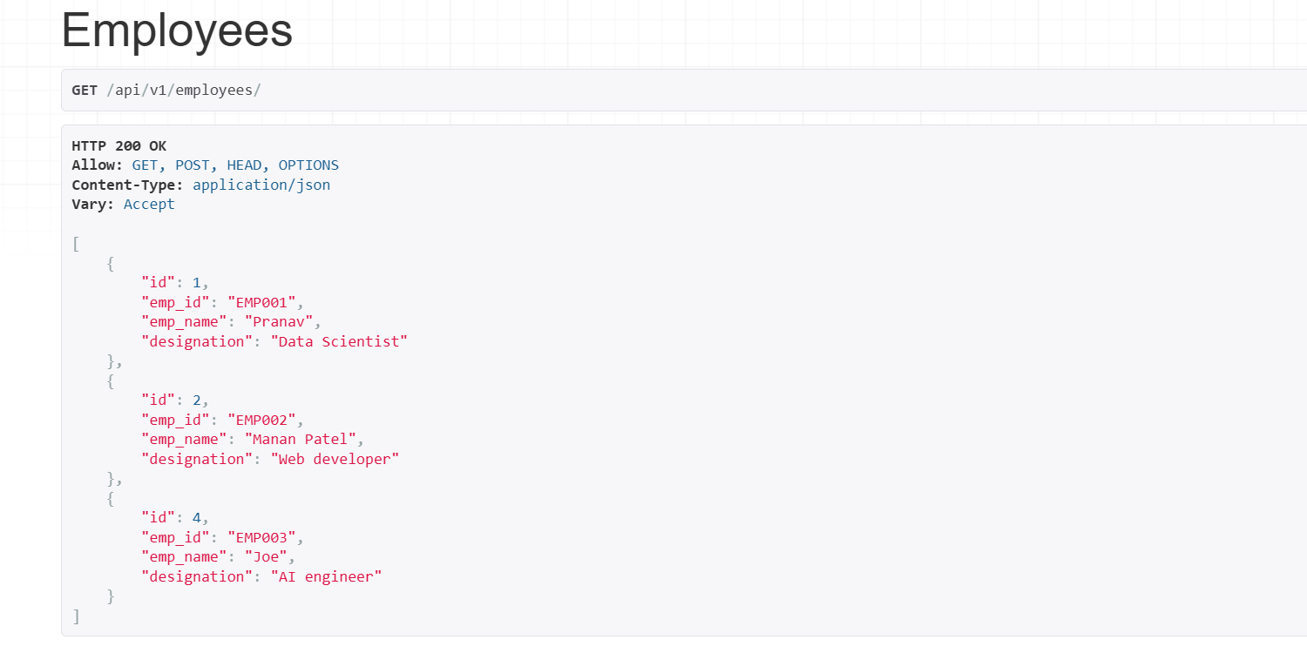

Now lets delete one eomployee

Wrtie in the same class 

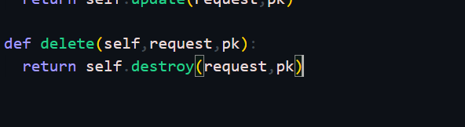

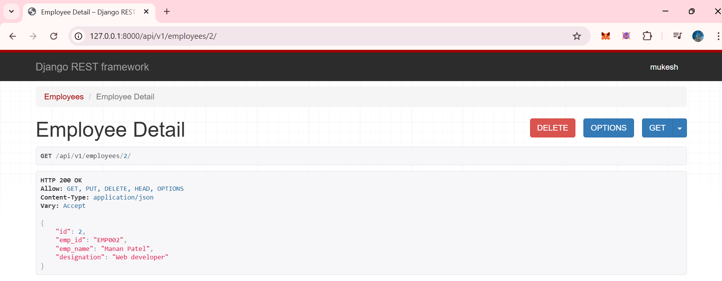

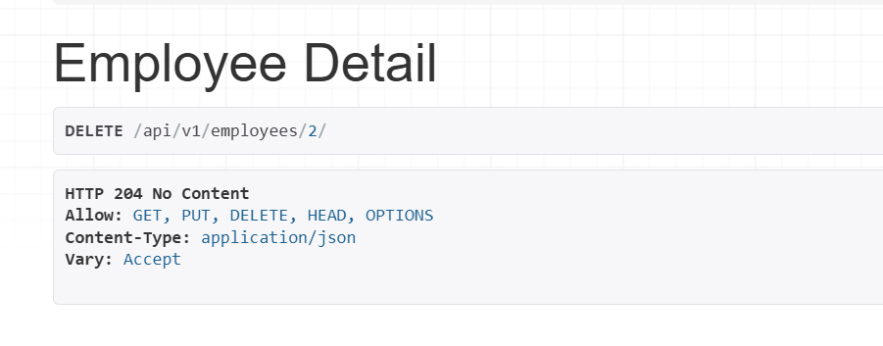

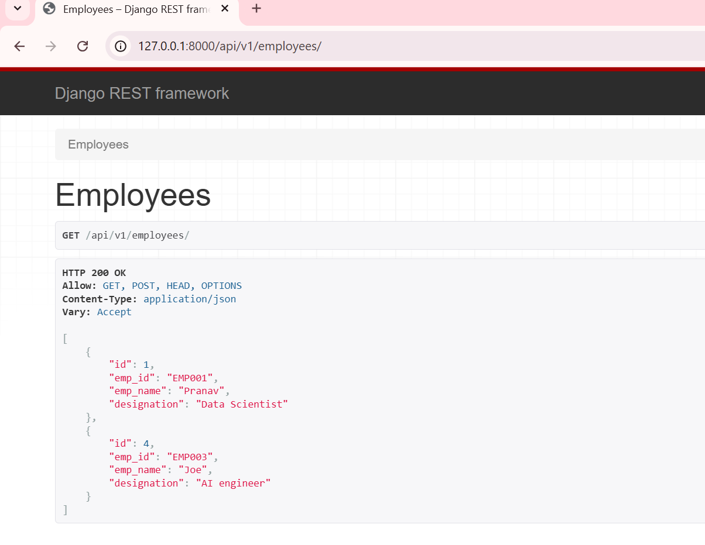

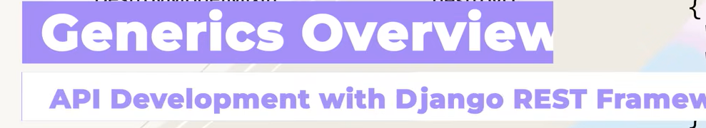

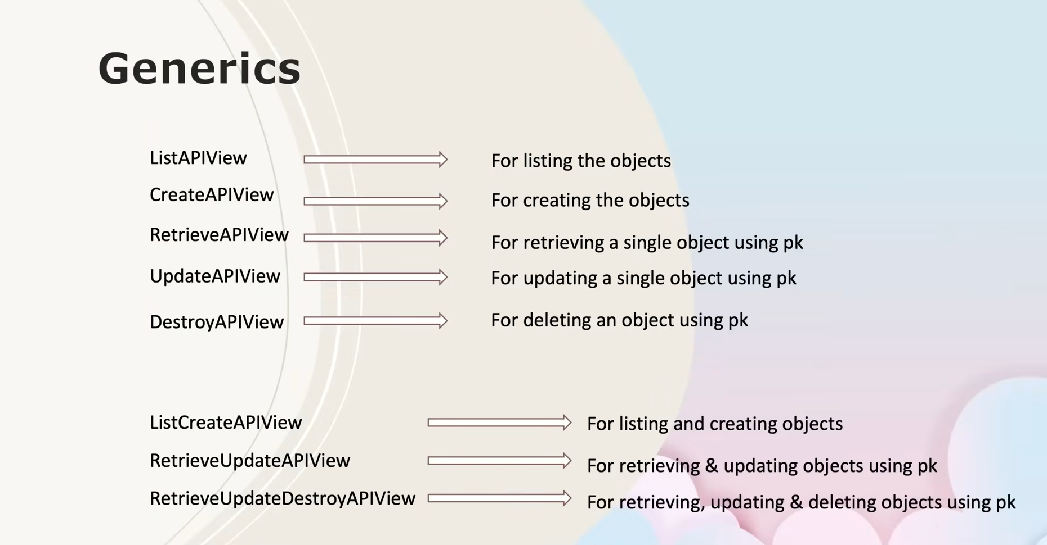

Great — **Generics** are one of the most important (and practical) parts of DRF.  
Below are **clean, exam-ready + notebook-ready notes** you can directly write ✍️

**📘 Django REST Framework – Generic Views (Generics)**

**🔹 What are Generic Views?**

**Generic Views** in Django REST Framework are **pre-built class-based views** that combine:

* GenericAPIView
* One or more **mixins**

👉 They help us **write less code** while still supporting **CRUD operations**.

Instead of manually defining get(), post(), put(), delete(), DRF already provides these.

**🔹 Why Generic Views are Used**

* Reduce boilerplate code
* Cleaner & readable APIs
* Faster development
* Industry-standard practice
* Easier to maintain

**🔹 Generic View Classes (Single Responsibility)**

**1️⃣ ListAPIView**

* **Purpose:** List all objects
* **HTTP Method:** GET
* **Use Case:** Get all records

class StudentList(ListAPIView):

queryset = Student.objects.all()

serializer_class = StudentSerializer

**2️⃣ CreateAPIView**

* **Purpose:** Create a new object
* **HTTP Method:** POST
* **Use Case:** Insert new record

class StudentCreate(CreateAPIView):

queryset = Student.objects.all()

serializer_class = StudentSerializer

**3️⃣ RetrieveAPIView**

* **Purpose:** Retrieve a single object using pk
* **HTTP Method:** GET
* **URL:** /students/<pk>/

class StudentDetail(RetrieveAPIView):

queryset = Student.objects.all()

serializer_class = StudentSerializer

**4️⃣ UpdateAPIView**

* **Purpose:** Update a single object using pk
* **HTTP Methods:** PUT, PATCH

class StudentUpdate(UpdateAPIView):

queryset = Student.objects.all()

serializer_class = StudentSerializer

**5️⃣ DestroyAPIView**

* **Purpose:** Delete an object using pk
* **HTTP Method:** DELETE

class StudentDelete(DestroyAPIView):

queryset = Student.objects.all()

serializer_class = StudentSerializer

**🔹 Combined Generic Views (Most Used)**

**6️⃣ ListCreateAPIView**

* **GET:** List all objects
* **POST:** Create new object

class StudentListCreate(ListCreateAPIView):

queryset = Student.objects.all()

serializer_class = StudentSerializer

**7️⃣ RetrieveUpdateAPIView**

* **GET:** Retrieve one object
* **PUT/PATCH:** Update object

class StudentRetrieveUpdate(RetrieveUpdateAPIView):

queryset = Student.objects.all()

serializer_class = StudentSerializer

**8️⃣ RetrieveUpdateDestroyAPIView**

* **GET:** Retrieve
* **PUT/PATCH:** Update
* **DELETE:** Delete

class StudentRUD(RetrieveUpdateDestroyAPIView):

queryset = Student.objects.all()

serializer_class = StudentSerializer

👉 **Most commonly used in real projects**

**🔹 What is Mandatory in Generic Views?**

Every Generic View **must contain**:

queryset = Model.objects.all()

serializer_class = ModelSerializer

Without this → ❌ DRF throws an error.

**🔹 Generics vs Mixins vs Function-Based Views**

| **Type** | **Code Size** | **Readability** | **Industry Use** |
| --- | --- | --- | --- |
| Function-Based Views | Large | Low | ❌ Rare |
| Mixins + GenericAPIView | Medium | Medium | ⚠️ Learning |
| Generic Views | Small | High | ✅ Very Common |
| ViewSets | Smallest | Highest | ⭐ Industry Standard |

**🔹 When to Use Generics?**

Use **Generic Views** when:

* You want quick CRUD APIs
* No complex custom logic required
* Clean & maintainable code is needed

**🧠 Interview Line (Very Important)**

You can say:

“Generic Views in Django REST Framework provide built-in CRUD functionality by combining GenericAPIView with mixins, allowing us to build clean and efficient APIs with minimal code.”

**📌 What Comes After Generics?**

Next natural steps:

1. ✅ Generic Views
2. 🔜 **ViewSets**
3. 🔜 **Routers**
4. 🔜 Pagination
5. 🔜 Filtering & Search

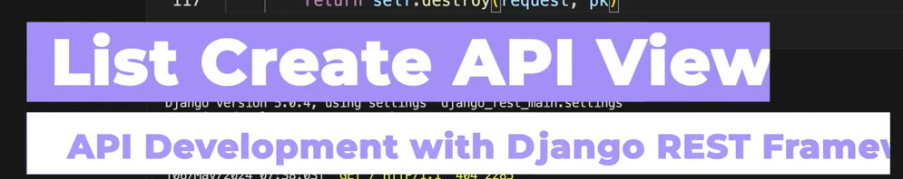

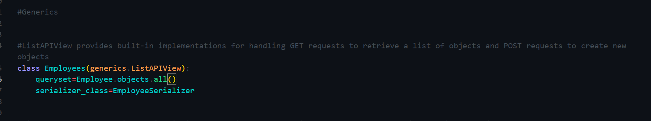

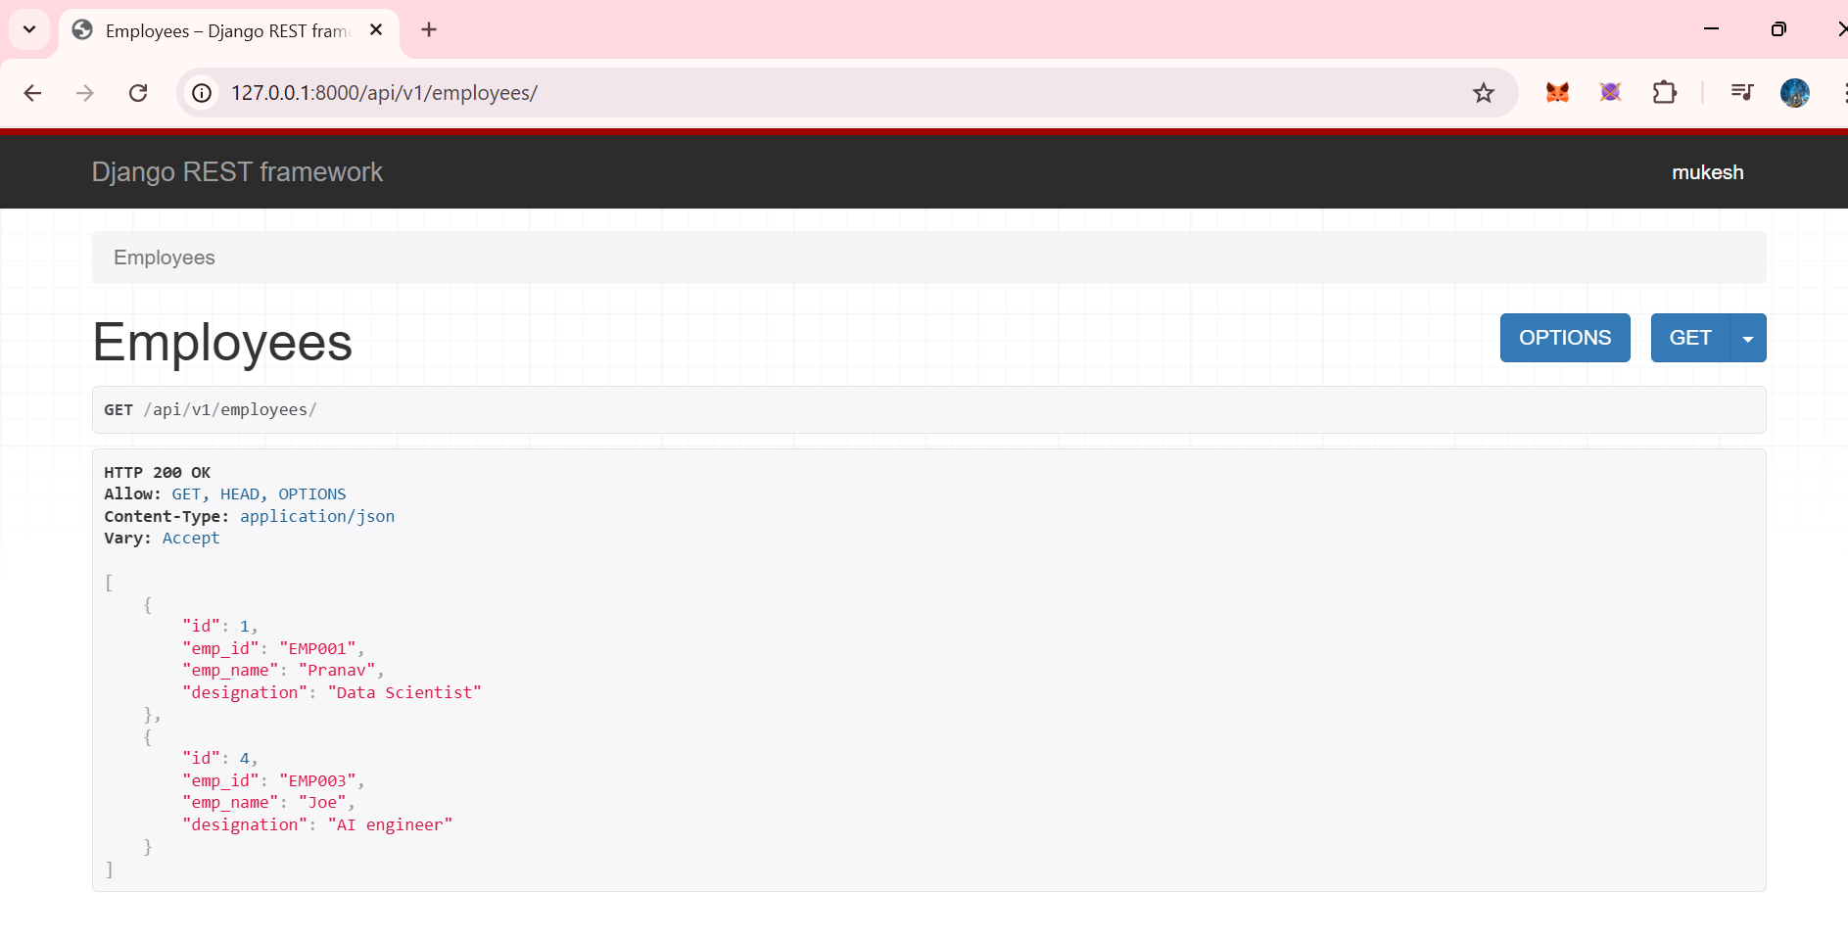

Now what if we wan to create/POST new employye..

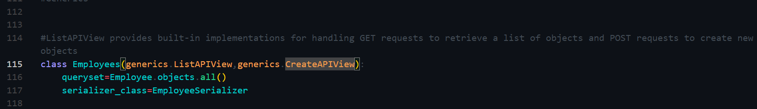

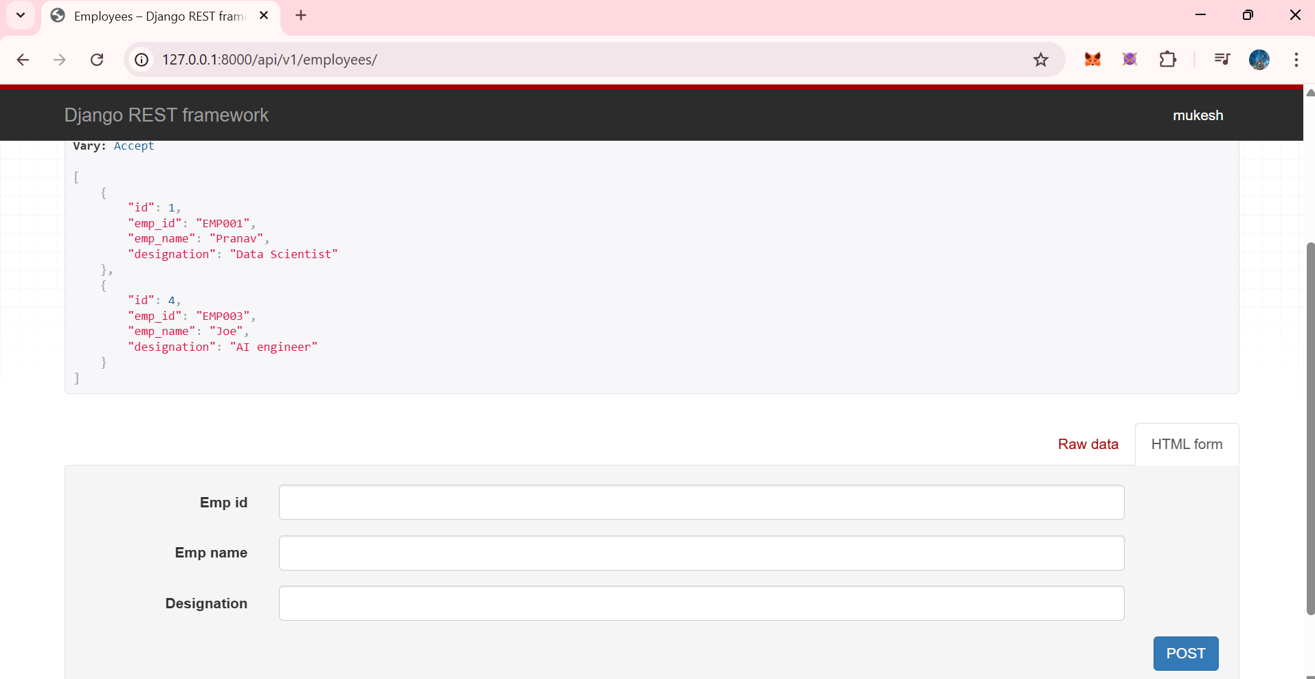

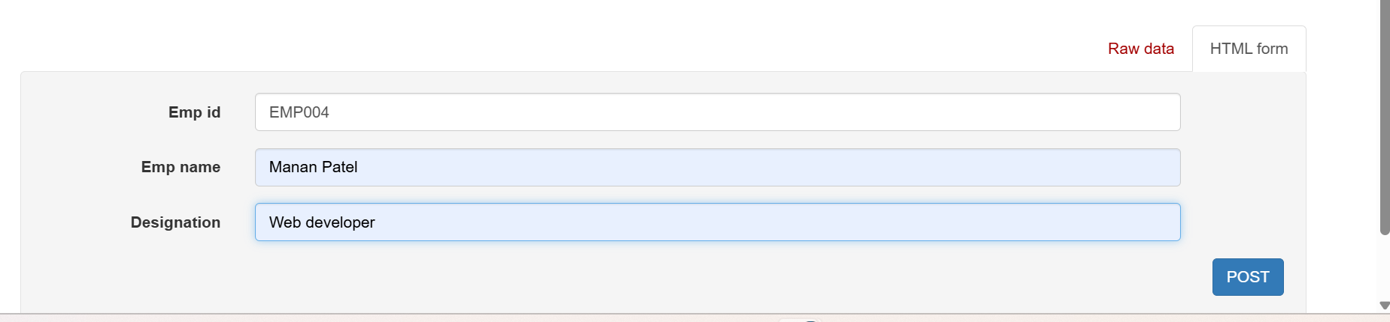

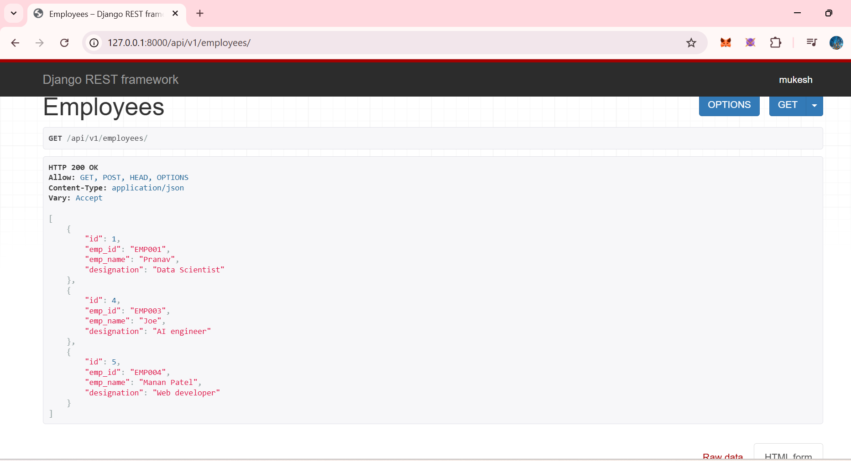

Now what if we want listcreateAPIView togethe.. wewant get and post method to work together,,

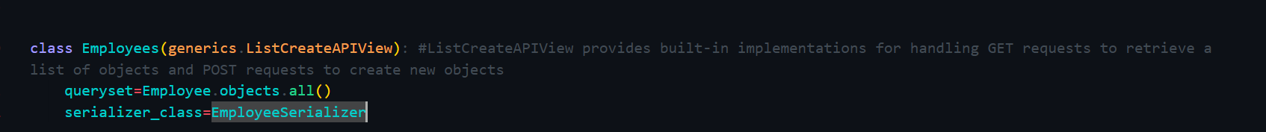

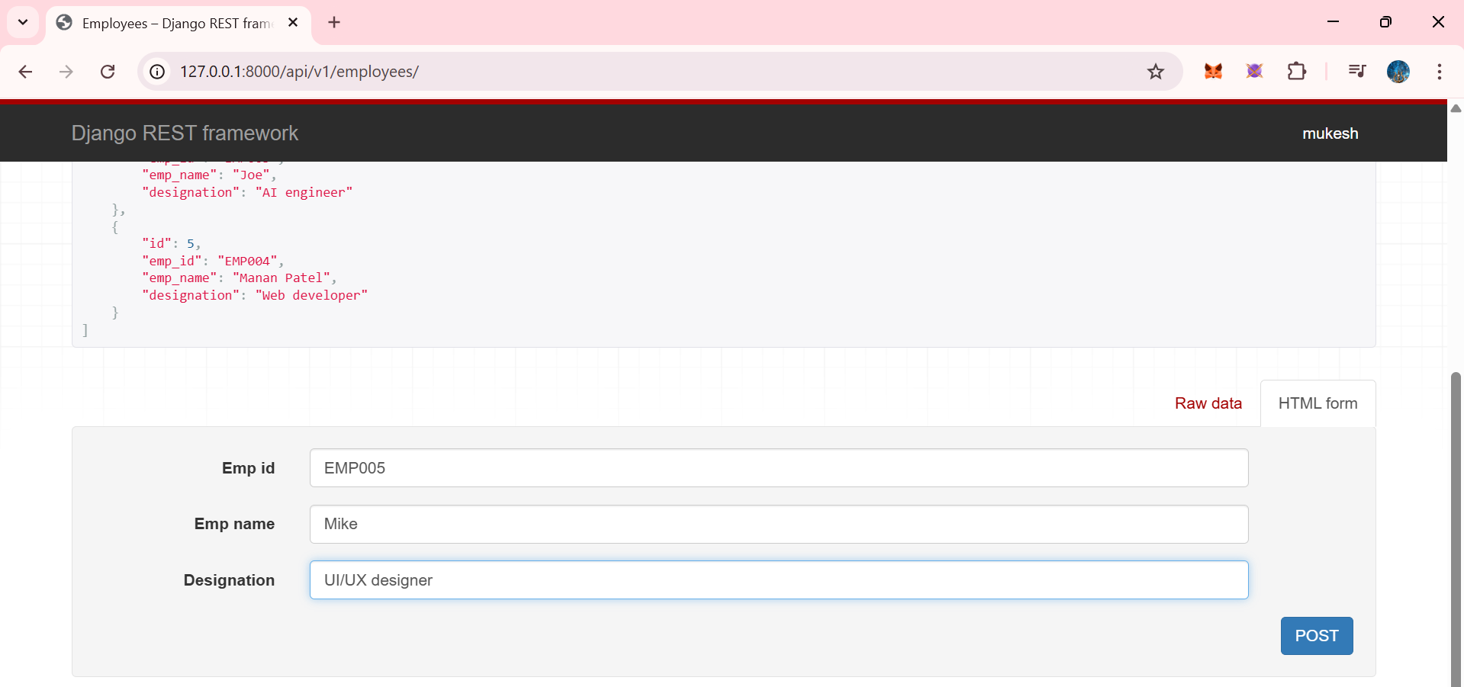

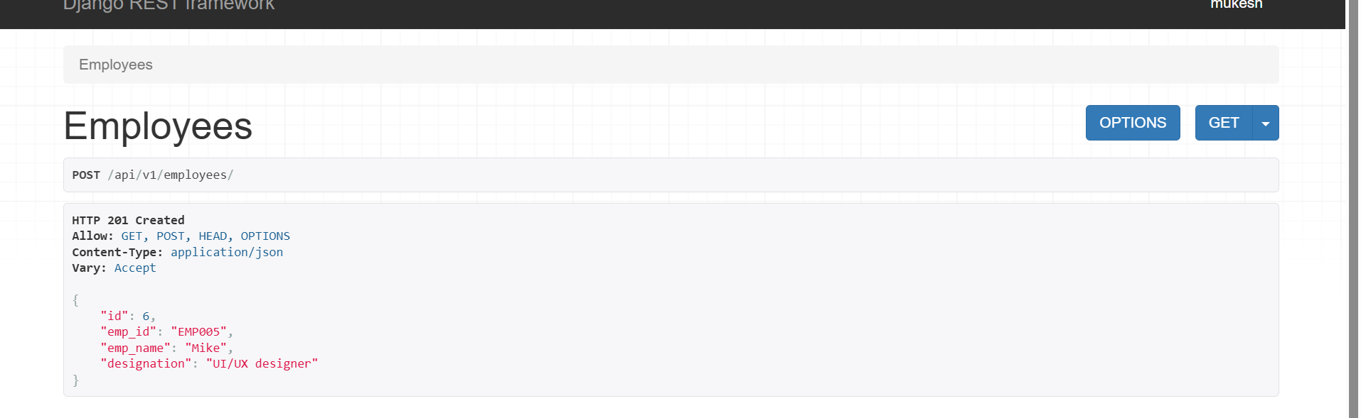

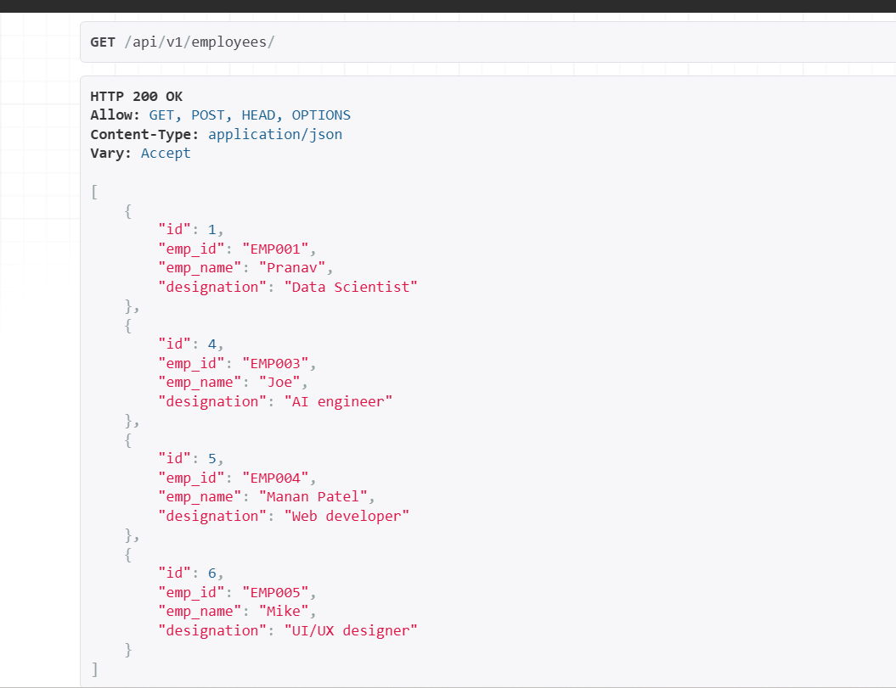

Now what if we want to retireve / get a single employee

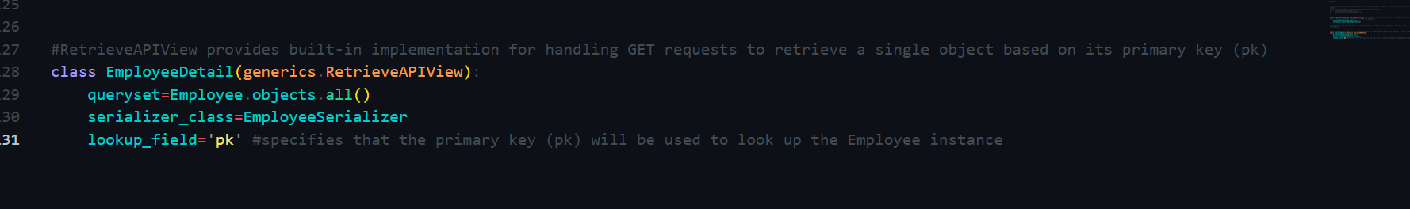

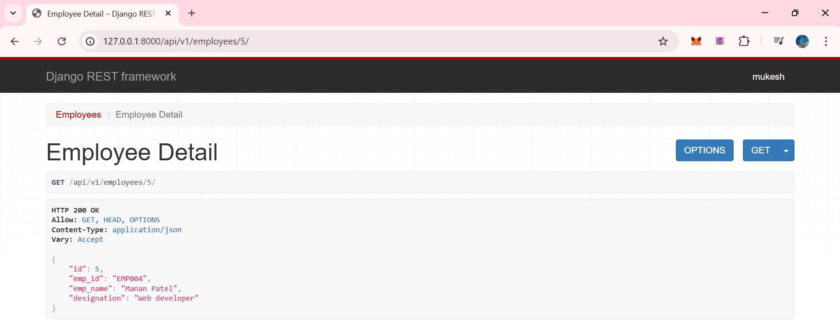

Now what if we want to update the employee id info..

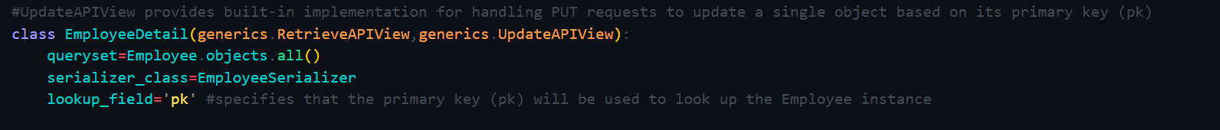

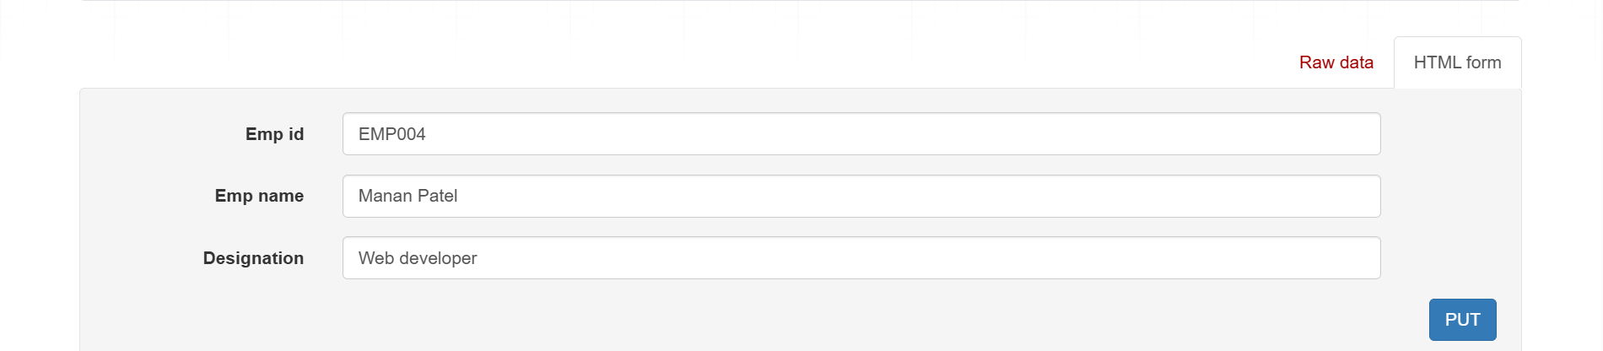

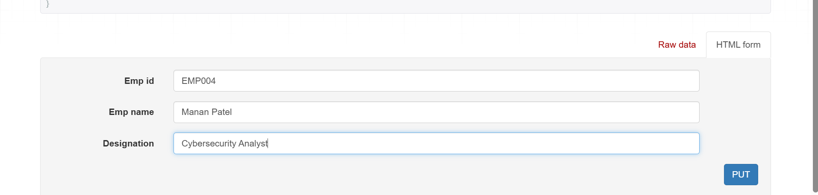

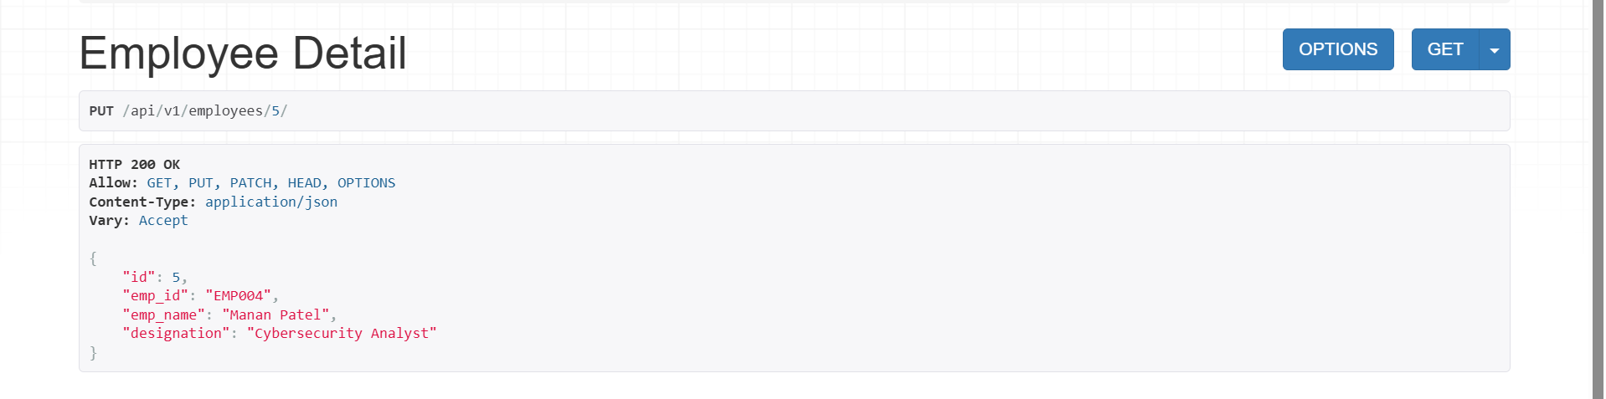

Now what if we eant to delete employee id info,

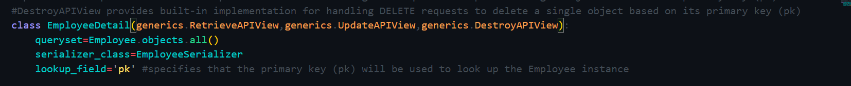

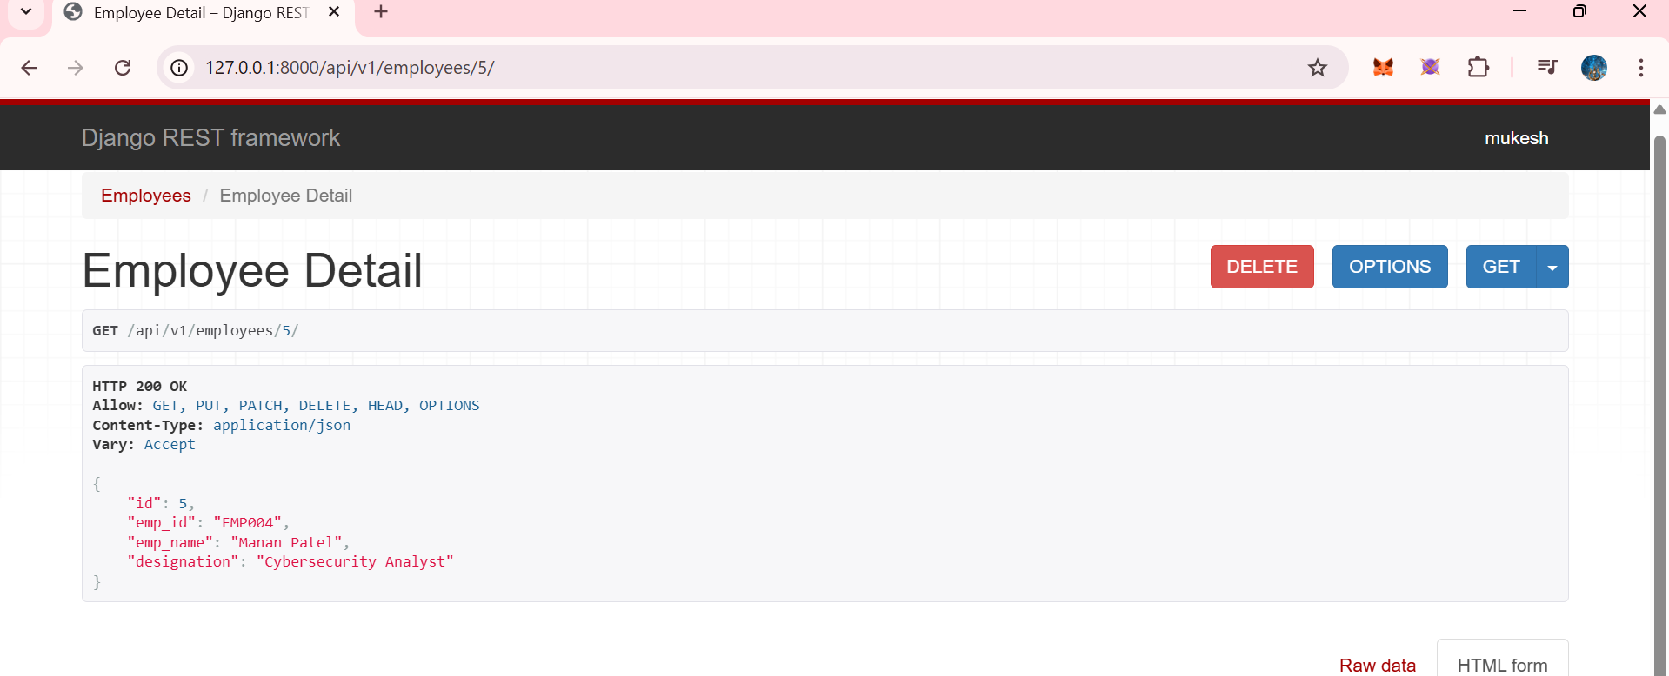

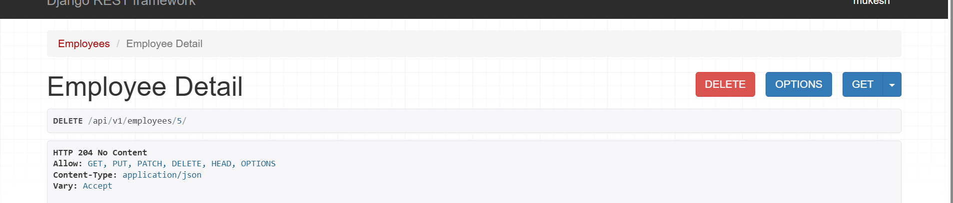

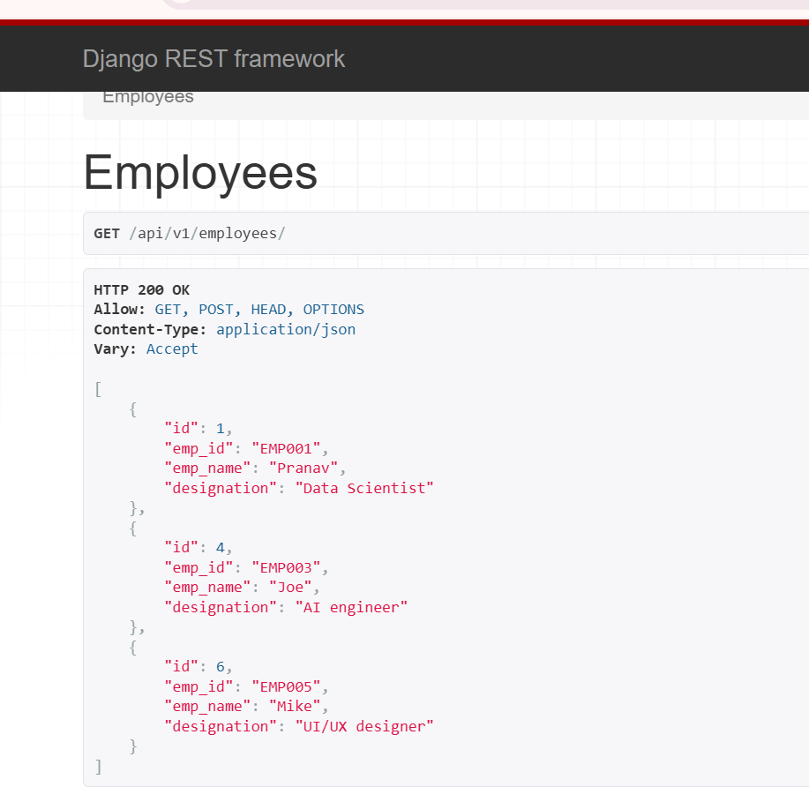

Now we want combo of retriev update and destroy..

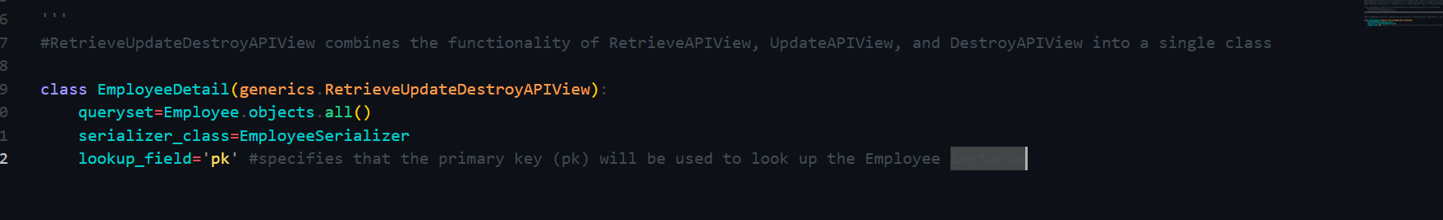

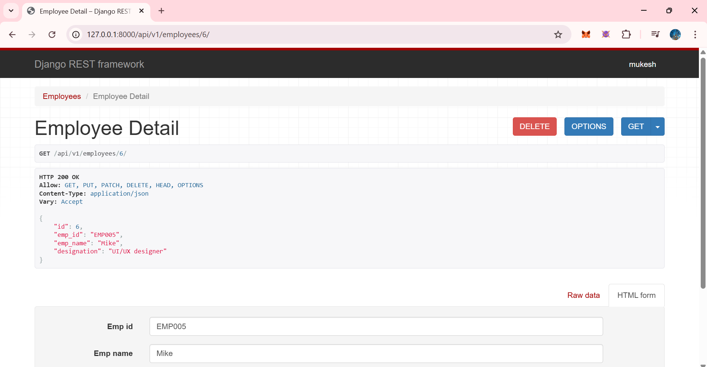

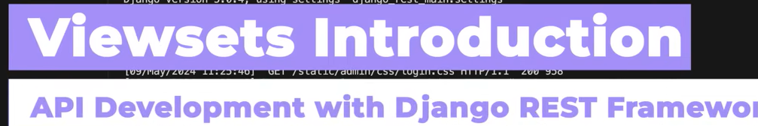

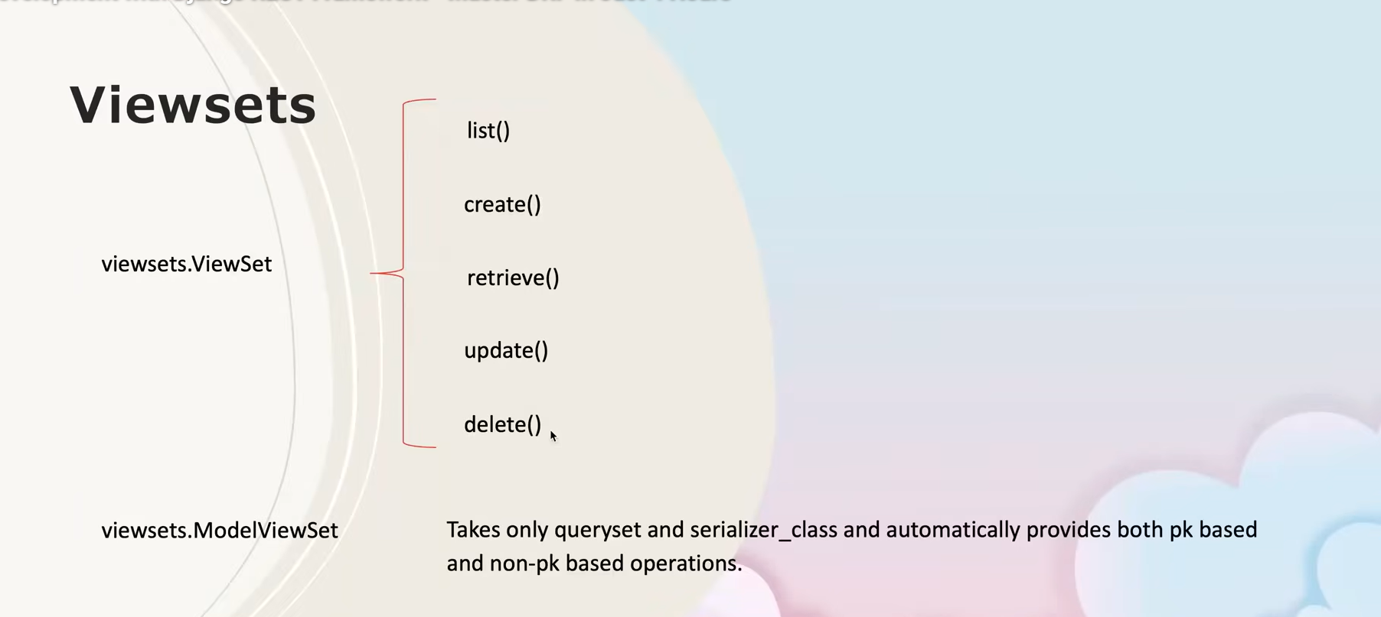

**📘 Django REST Framework – ViewSets**

**🔹 What are ViewSets?**

**ViewSets** are a higher-level abstraction in Django REST Framework that **combine all CRUD operations into a single class**.

Instead of writing:

* multiple views
* multiple URLs

👉 **one ViewSet handles everything**.

**🔹 Why ViewSets are Used?**

* Minimum code
* Clean and professional APIs
* Easy URL management using **routers**
* Widely used in **real-world / industry projects**

**🔹 CRUD Operations in ViewSets**

| **Method** | **Purpose** |
| --- | --- |
| list() | Get all objects |
| create() | Create a new object |
| retrieve() | Get a single object by pk |
| update() | Update an object |
| destroy() | Delete an object |

These methods internally map to:

| **HTTP Method** | **Action** |
| --- | --- |
| GET | list / retrieve |
| POST | create |
| PUT / PATCH | update |
| DELETE | destroy |

**🔹 Types of ViewSets**

**1️⃣ viewsets.ViewSet**

* You manually define all methods
* More control
* More code

from rest_framework import viewsets

class StudentViewSet(viewsets.ViewSet):

def list(self, request):

pass

def create(self, request):

pass

def retrieve(self, request, pk=None):

pass

🟡 Used for **custom logic APIs**

**2️⃣ viewsets.ModelViewSet ✅ (MOST IMPORTANT)**

* Automatically provides **ALL CRUD operations**
* Requires only:
  + queryset
  + serializer_class

from rest_framework import viewsets

class StudentViewSet(viewsets.ModelViewSet):

queryset = Student.objects.all()

serializer_class = StudentSerializer

✅ **Best choice for standard CRUD APIs**

**🔹 What ModelViewSet Gives Automatically**

Without writing any methods, you get:

* GET /students/ → list
* POST /students/ → create
* GET /students/{id}/ → retrieve
* PUT /students/{id}/ → update
* DELETE /students/{id}/ → delete

💡 That’s why it’s heavily used in production.

**🔹 Routers (Very Important with ViewSets)**

ViewSets work best with **routers**, which auto-generate URLs.

from rest_framework.routers import DefaultRouter

from .views import StudentViewSet

router = DefaultRouter()

router.register('students', StudentViewSet)

urlpatterns = router.urls

📌 No need to manually write:

path('students/', ...)

path('students/<int:pk>/', ...)

**🔹 ViewSets vs Generics vs Mixins**

| **Feature** | **Mixins** | **Generics** | **ViewSets** |
| --- | --- | --- | --- |
| Code Size | Medium | Small | 🔥 Smallest |
| URLs | Manual | Manual | Auto (Router) |
| Industry Use | ⚠️ Learning | ✅ Common | ⭐ Most Used |

**🔹 When to Use ViewSets?**

Use **ViewSets** when:

* CRUD APIs are required
* Standard REST behavior is needed
* Clean architecture is expected
* You want **industry-level code**

**🔹 Interview Line (VERY IMPORTANT)**

You can say:

“ViewSets in Django REST Framework allow us to handle all CRUD operations in a single class and, when combined with routers, they automatically generate RESTful URLs with minimal code.”

**🔹 Typical Learning Flow (You’re Doing It RIGHT ✅)**

1. Function-Based Views
2. Class-Based Views
3. Mixins
4. Generics
5. **ViewSets** ← you are here
6. Routers
7. Pagination & Filtering

👏 Exactly how professionals learn DRF.

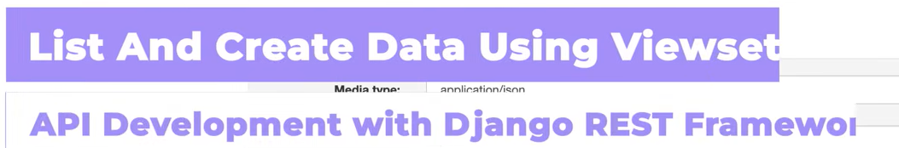

Now first of al go in urls.py

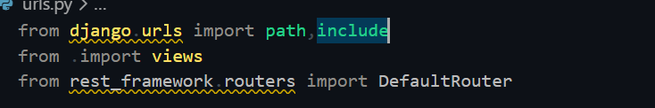

Use basename only when we use views.Viewset

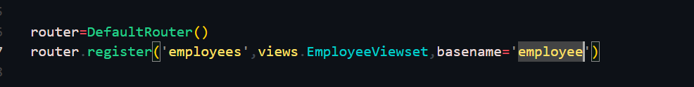

And then include path (empty) (‘ ‘)

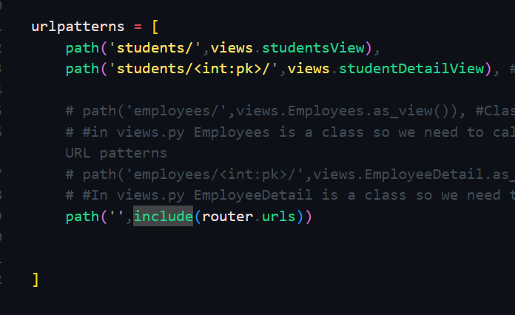

Now go in views.py and create viewsets..

Import viewsets



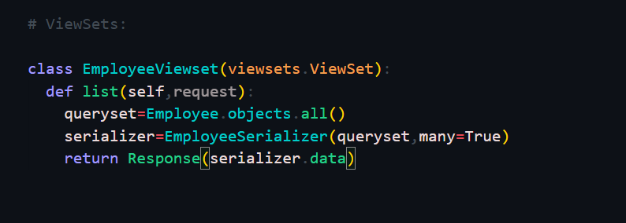

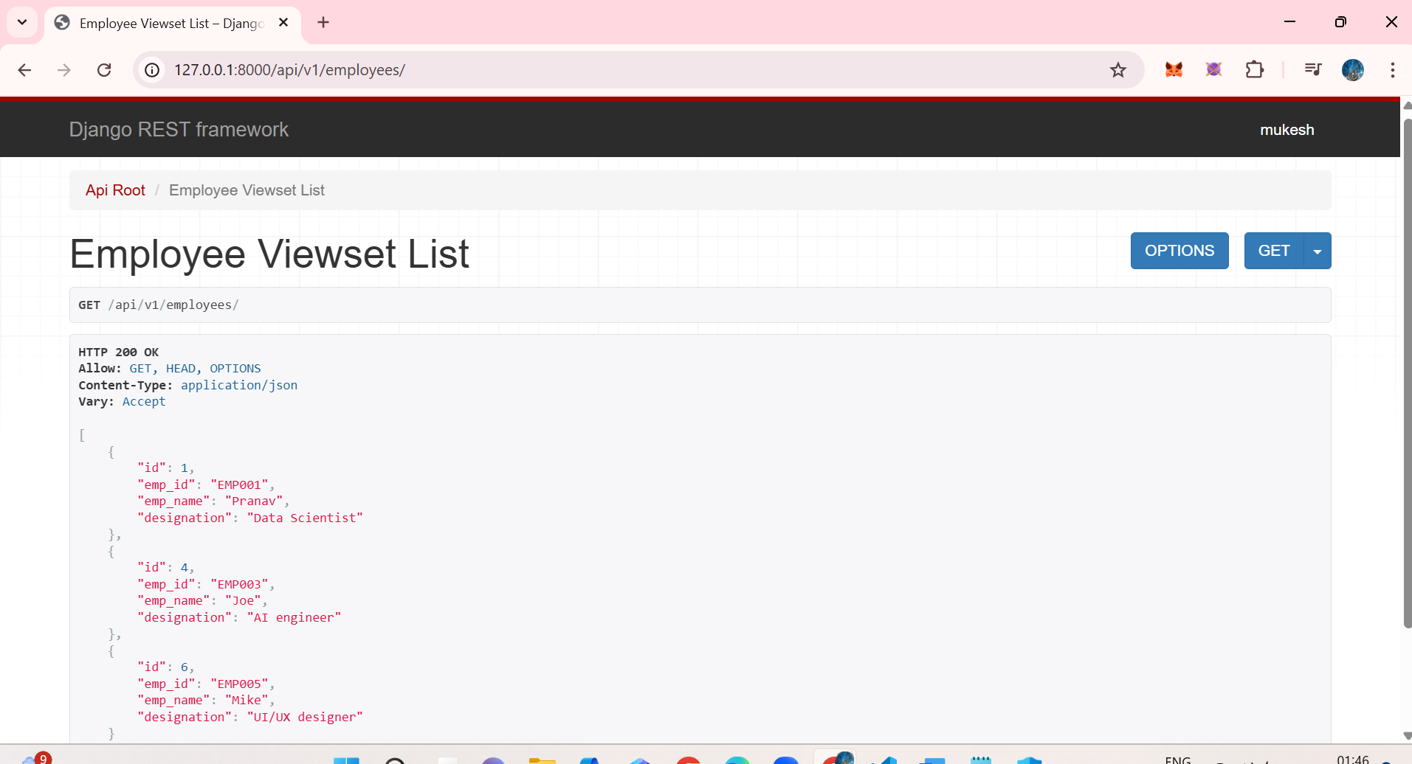

Lets create another employee

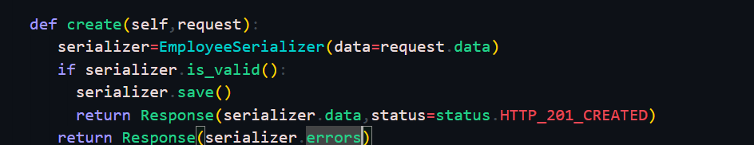

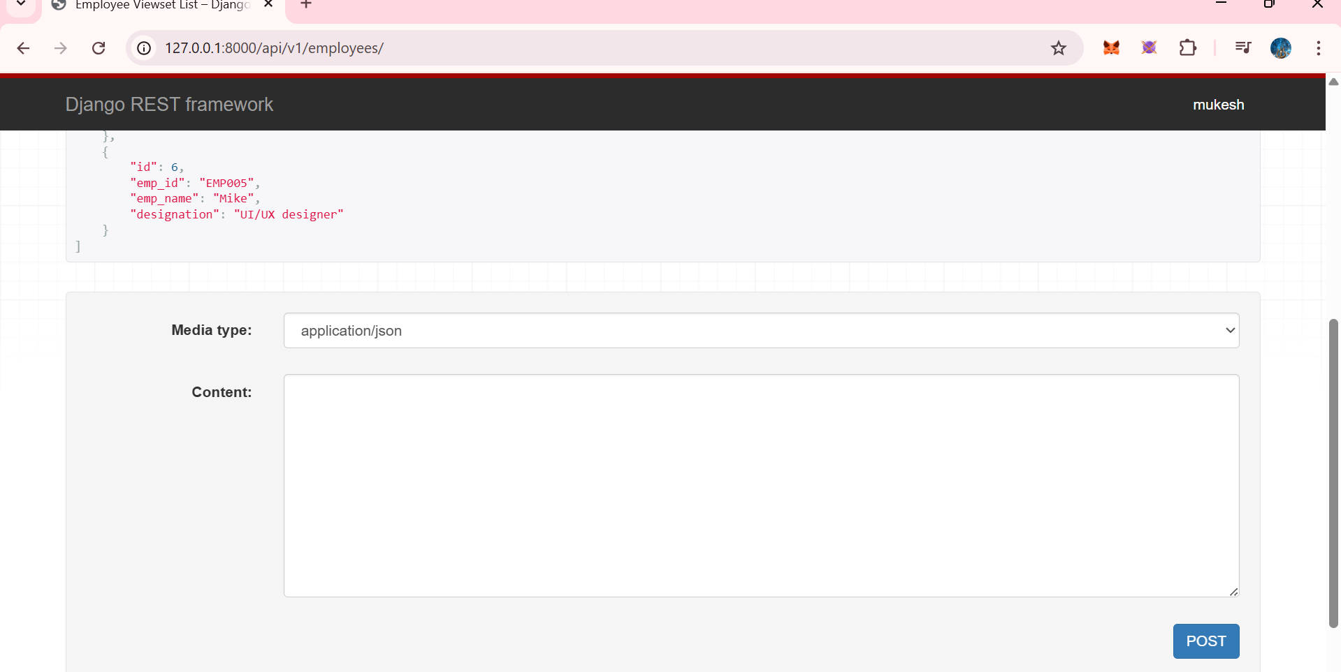

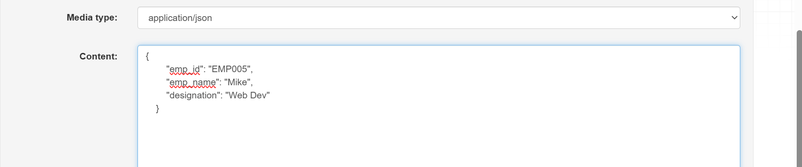

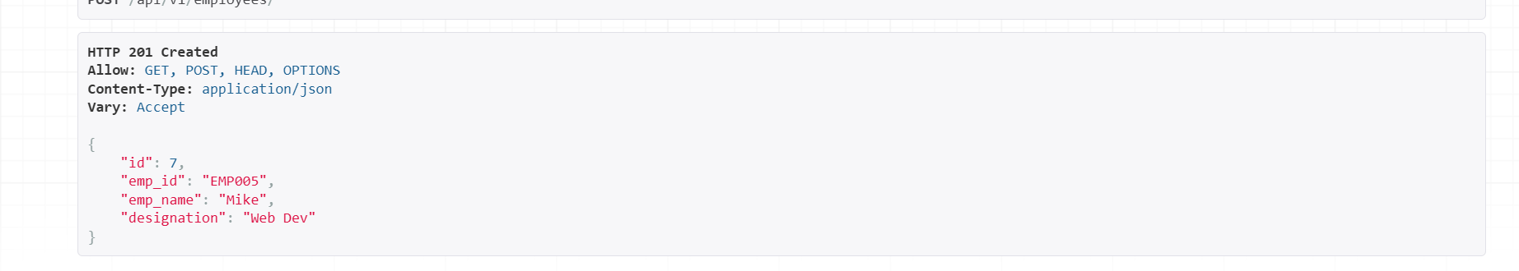

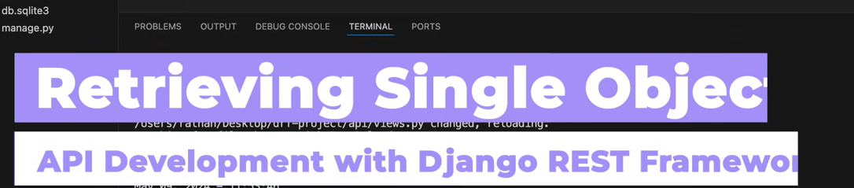

Now lets retireve a single employee



We will be writin the fucntion in the same class.. no need to create a separate class for it

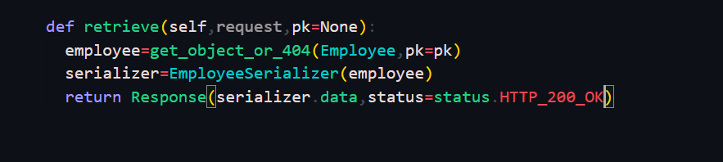

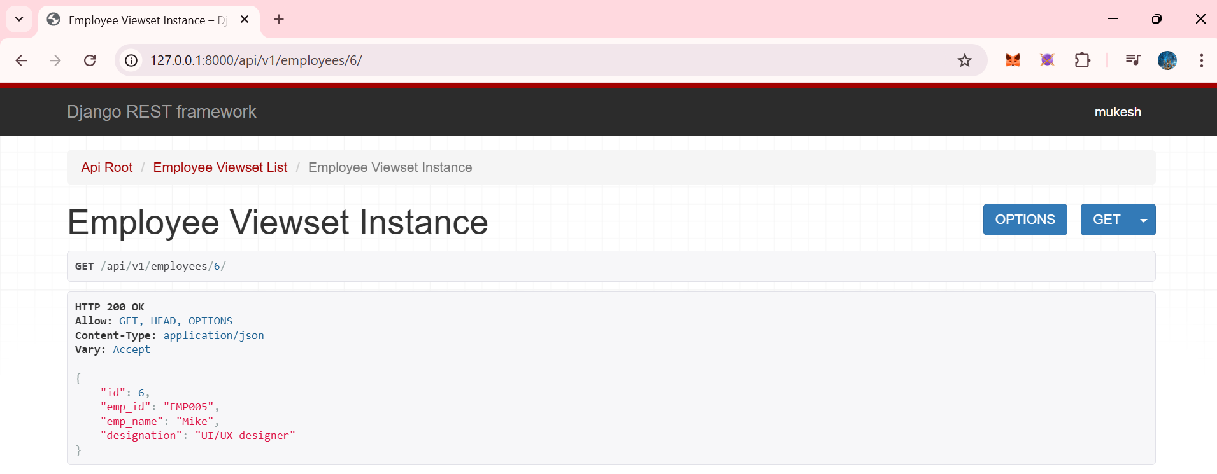

Similarly for update and delete we have,

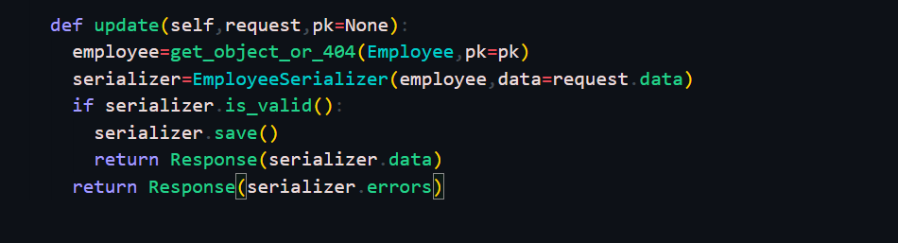

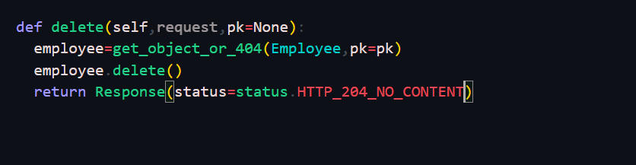

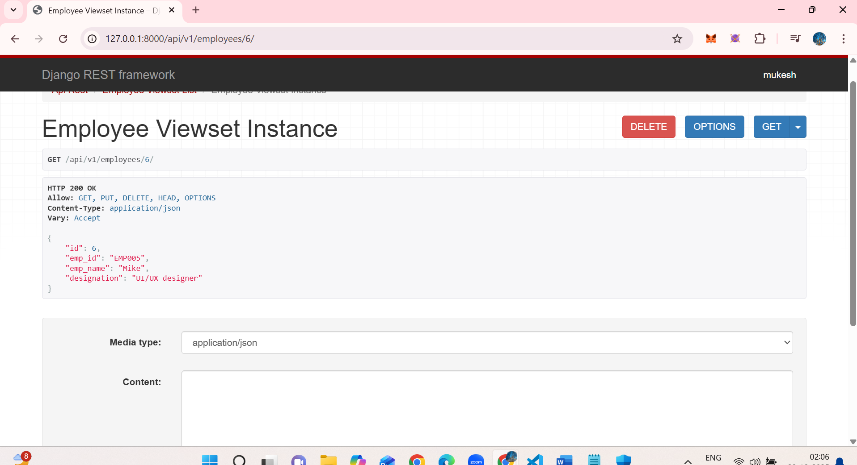

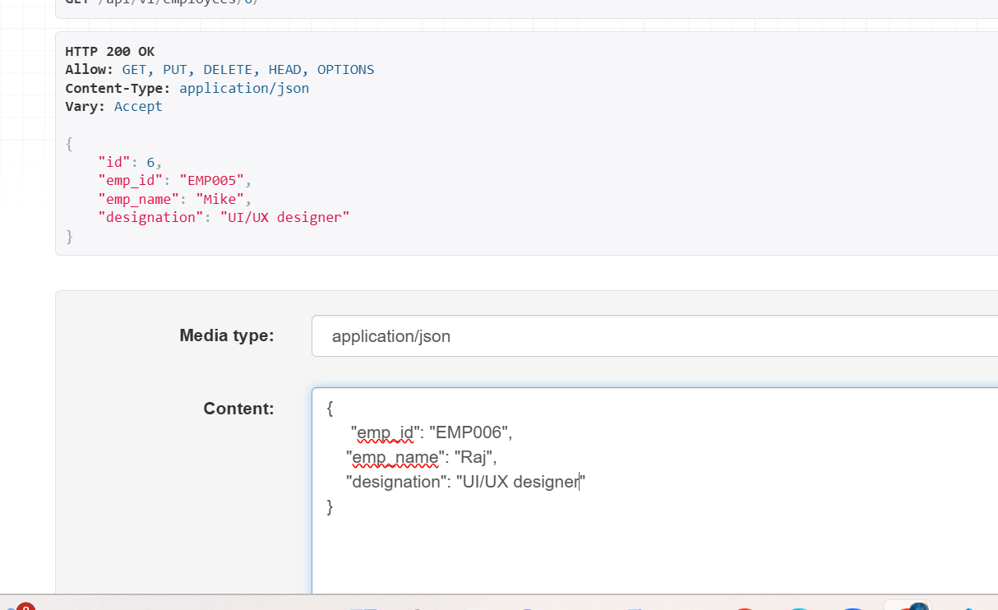

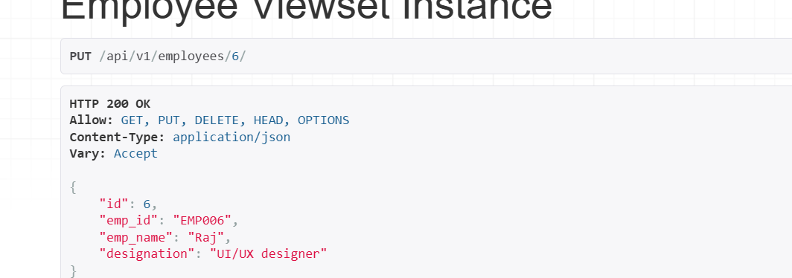

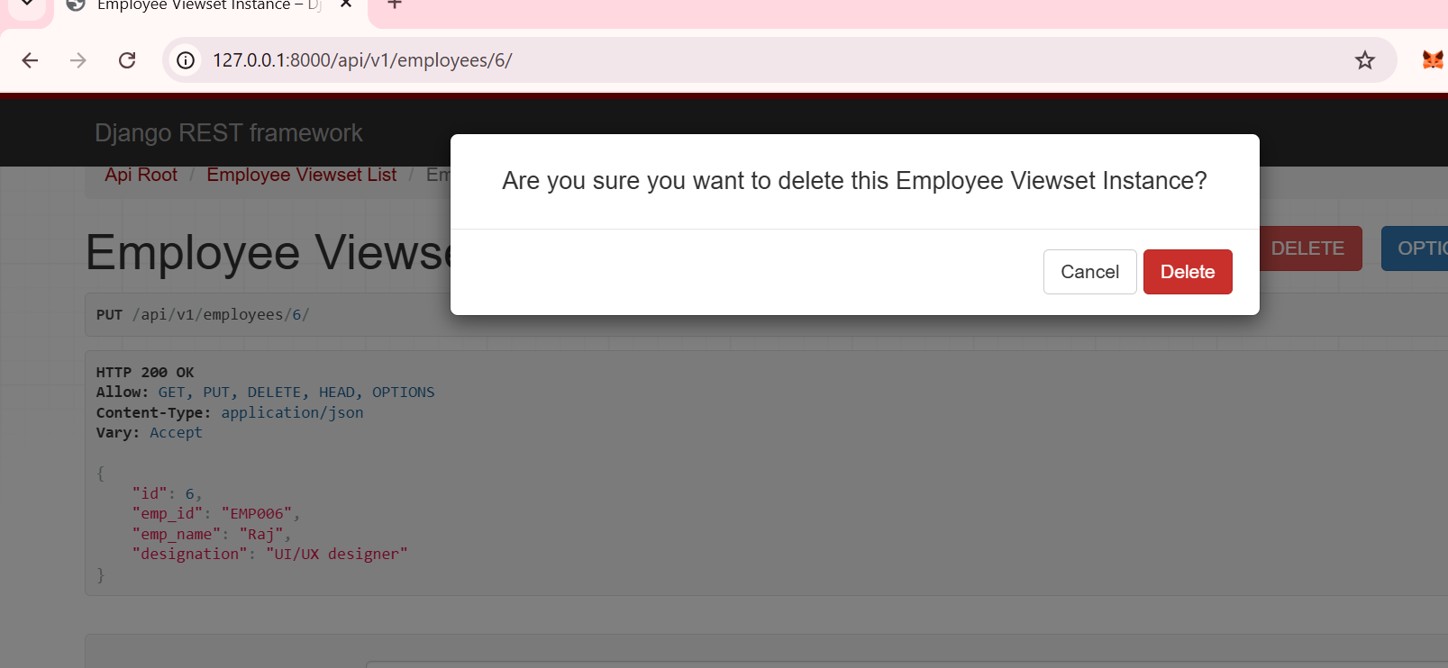

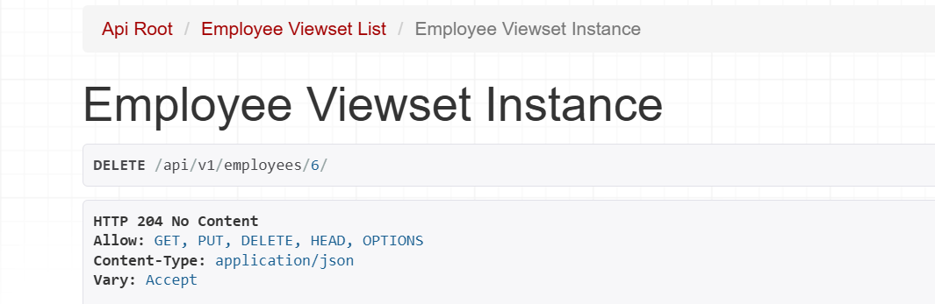

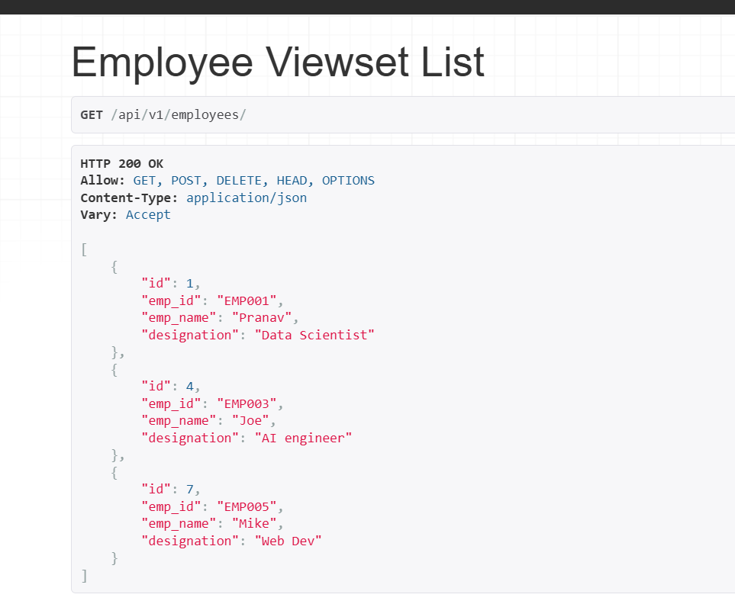

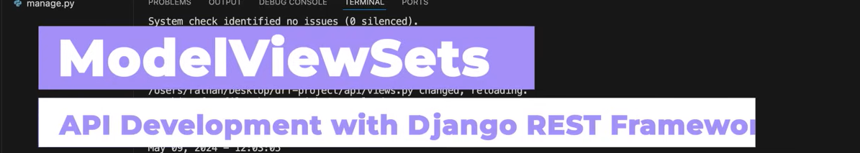

No need to manually wrtie different functions(list,retirve,update… ) and also create separate class for all data and single data… just write this only

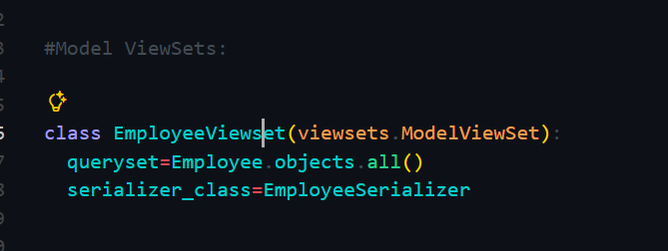

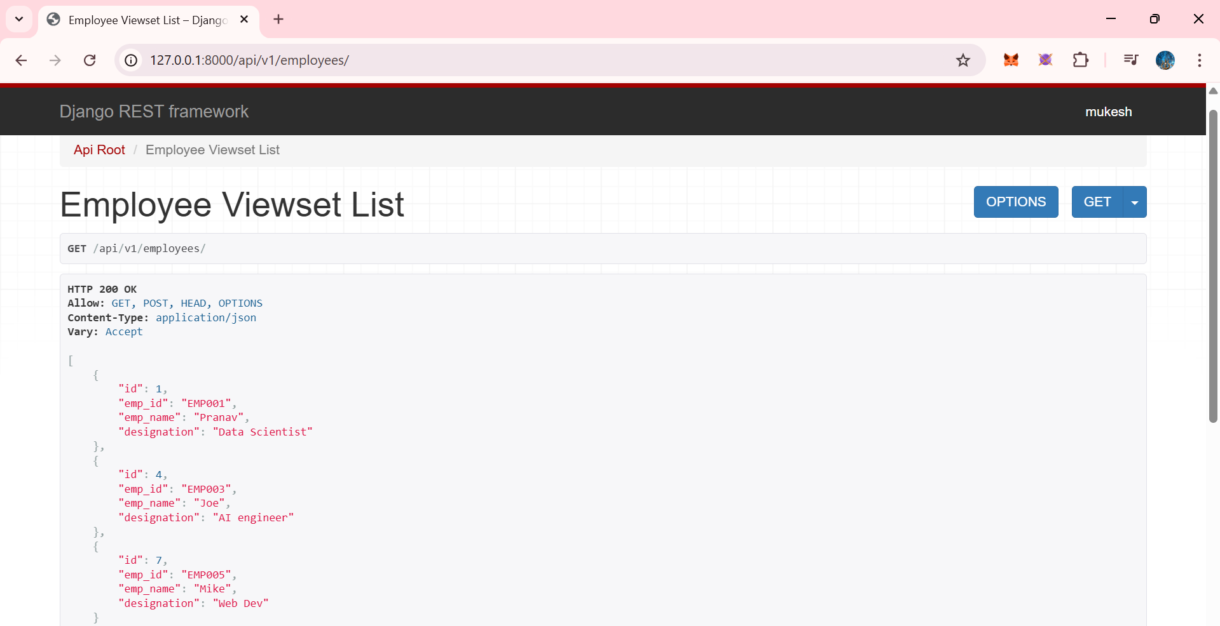

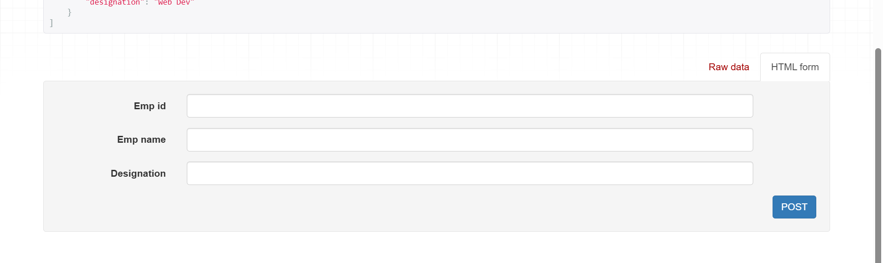

It also handles primary key based operations 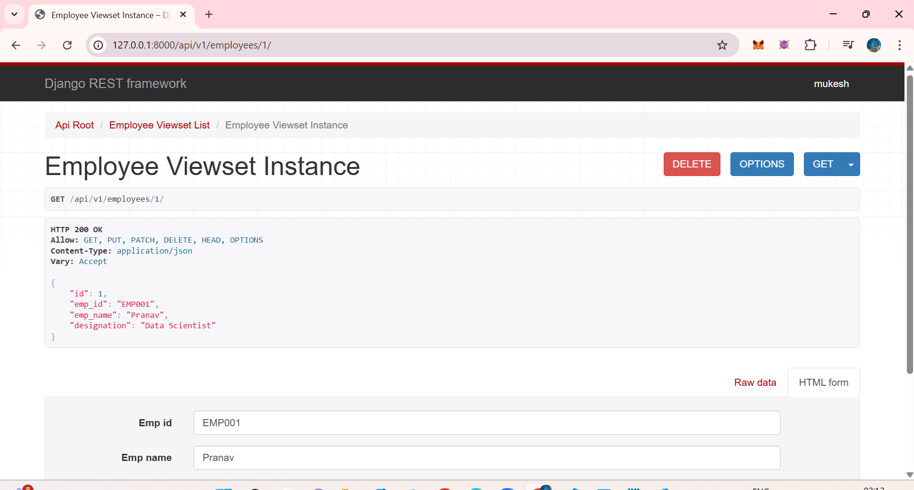

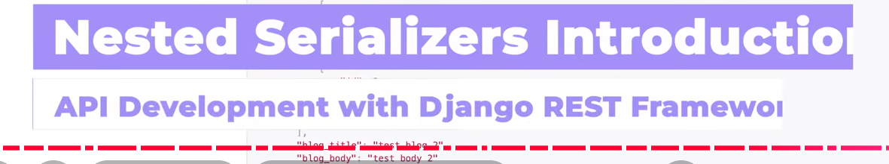

Perfect 👍  
Nested serializers are an **important and interview-relevant topic**. I’ll give you **clean, notebook-ready notes** in simple language.

**📘 Nested Serializers (Django REST Framework)**

**🔹 What is a Nested Serializer?**

A **Nested Serializer** is used when **one model is related to another model**, and you want to **include related model data inside the API response** instead of just showing IDs.

👉 In simple words:

**Serializer inside another serializer**

**🔹 Why do we need Nested Serializers?**

Without nested serializers, APIs usually return **only foreign key IDs**.

Example ❌ (without nesting):

{

"id": 1,

"name": "John",

"department": 2

}

But APIs are meant to be **user-friendly**, so we want:

Example ✅ (with nesting):

{

"id": 1,

"name": "John",

"department": {

"id": 2,

"name": "IT"

}

}

👉 This is where **Nested Serializers** are used.

**🔹 When to use Nested Serializers?**

Use nested serializers when:

* Models have **ForeignKey**
* **One-to-One**
* **Many-to-Many** relationships
* You want **detailed related data** in one API call

**🔹 Example Scenario (Easy to Understand)**

**Models**

class Department(models.Model):

name = models.CharField(max_length=100)

class Employee(models.Model):

name = models.CharField(max_length=100)

department = models.ForeignKey(Department, on_delete=models.CASCADE)

**🔹 Step 1: Create Serializer for Child Model**

class DepartmentSerializer(serializers.ModelSerializer):

class Meta:

model = Department

fields = '__all__'

**🔹 Step 2: Use it inside Parent Serializer (Nested)**

class EmployeeSerializer(serializers.ModelSerializer):

department = DepartmentSerializer() # 👈 nested serializer

class Meta:

model = Employee

fields = '__all__'

**🔹 API Response (Result)**

{

"id": 1,

"name": "John",

"department": {

"id": 2,

"name": "IT"

}

}

✔ Clean  
✔ Readable  
✔ Professional API

**🔹 Read-only Nested Serializer**

Sometimes you want:

* Read nested data
* But NOT allow create/update through it

department = DepartmentSerializer(read_only=True)

✔ Very common in real projects

**🔹 Nested Serializer for Multiple Objects (Many=True)**

Example: One Department → Many Employees

class DepartmentSerializer(serializers.ModelSerializer):

employees = EmployeeSerializer(many=True)

class Meta:

model = Department

fields = '__all__'

**🔹 Important Interview Point ⚠️**

Nested serializers are **great for reading data**,  
but **writing (POST/PUT)** becomes complex.

So in real projects:

* Often use nested serializers for **GET**
* Use IDs for **POST / PUT**

**🔹 Advantages**

✔ Clean API responses  
✔ Fewer API calls  
✔ Better frontend experience

**🔹 Disadvantages**

❌ Slower for large data  
❌ Complex create/update logic  
❌ Over-fetching data if not careful

**🔹 Best Practice (Industry)**

* Use nested serializers **only when needed**
* Avoid deep nesting (2–3 levels max)
* Prefer flat responses for performance

**🔹 One-line Definition (Notebook / Exam)**

**Nested serializers allow embedding one serializer inside another to represent related model data in a single API response.**

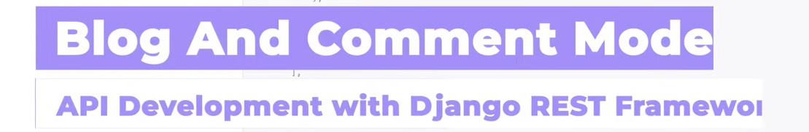

Lets create a new app blog model



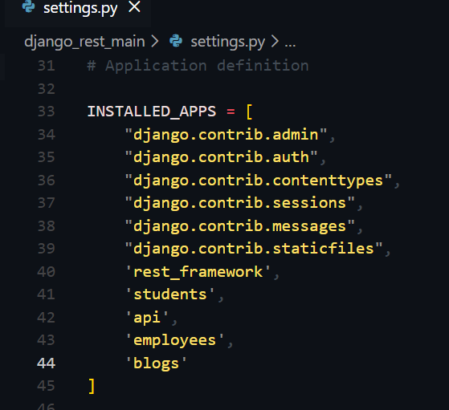

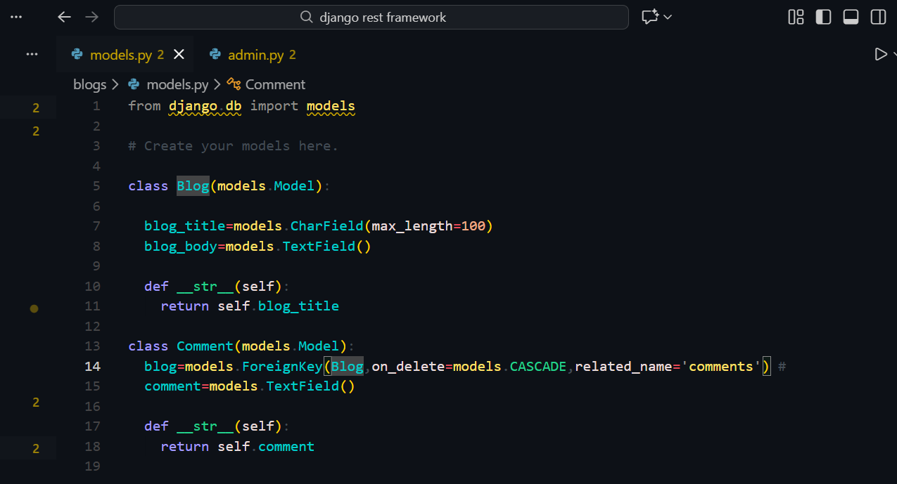

Perfect timing — this is the **exact place where Nested Serializers make sense** 👍  
I’ll explain this **short, sweet, and concept-focused**, just like notebook notes.

**🧩 What this code is doing (Big Picture)**

You created **two related models**:

* **Blog** → Parent
* **Comment** → Child (many comments belong to one blog)

This is a **one-to-many relationship**.

**📘 Blog Model (Parent)**

class Blog(models.Model):

blog_title = models.CharField(max_length=100)

blog_body = models.TextField()

def __str__(self):

return self.blog_title

**Meaning:**

* Each **Blog** has:
  + a title
  + a body
* __str__ helps show the blog title nicely in admin & shell

✅ One blog = one row in blogs table

**💬 Comment Model (Child)**

class Comment(models.Model):

blog = models.ForeignKey(

Blog,

on_delete=models.CASCADE,

related_name='comments'

)

comment = models.TextField()

def __str__(self):

return self.comment

**Meaning:**

* Each **Comment**:
  + belongs to **one Blog**
  + cannot exist without a blog
* ForeignKey creates a **relationship**
* on_delete=models.CASCADE:
  + If a blog is deleted → its comments are deleted automatically
* related_name='comments':
  + Lets you access comments like:
  + blog.comments.all()

✅ One blog → many comments  
✅ Many comments → one blog

**🔗 Why this is important for Nested Serialization**

Because of this relationship:

related_name = 'comments'

You can now return **this kind of API response**:

{

"blog_title": "My First Blog",

"blog_body": "This is blog content",

"comments": [

{"comment": "Nice post!"},

{"comment": "Very helpful"}

]

}

👉 This is called **Nested Serialization**  
👉 Blog serializer contains **Comment serializer inside it**

**📝 One-line notebook definition**

**Nested Serializer** is used when one model has a relationship with another model, and we want to include related data (child objects) inside the parent API response.

**🎯 Why this is taught now**

Because you already know:

* Models ✅
* Serializers ✅
* Relationships (ForeignKey) ✅

Now you’re learning how to:

* **Return related data in a single API call**
* Build **real-world APIs** (blogs, posts, comments, reviews, orders)

**💡 Real-world analogy**

* Blog = YouTube Video
* Comment = YouTube Comment

When you open a video, you **see comments inside it**  
➡️ That’s nested data

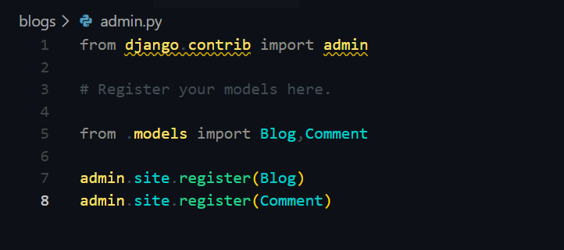

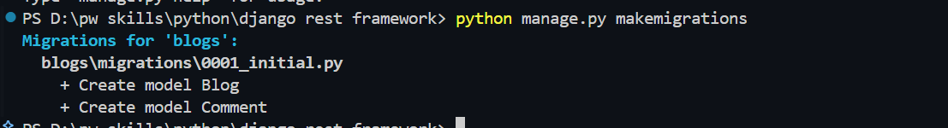

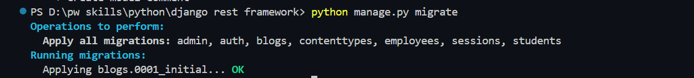

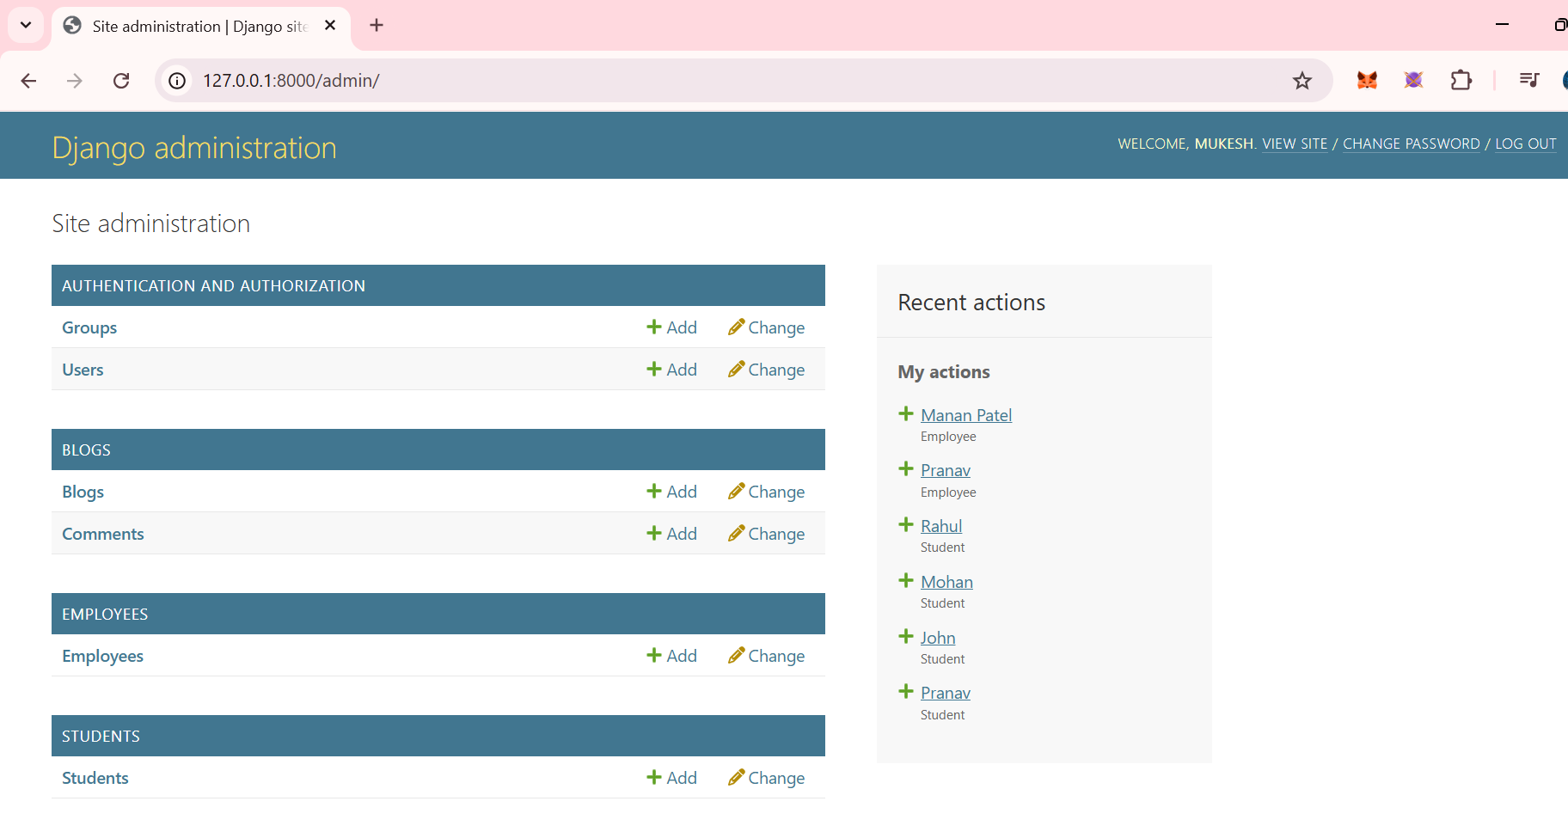

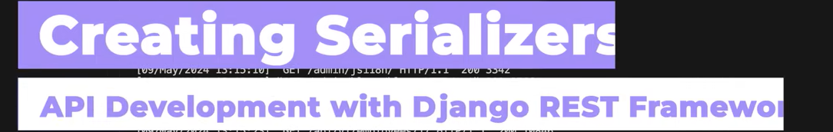

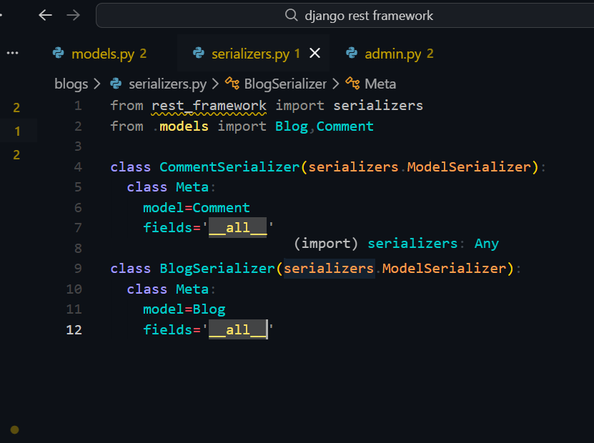

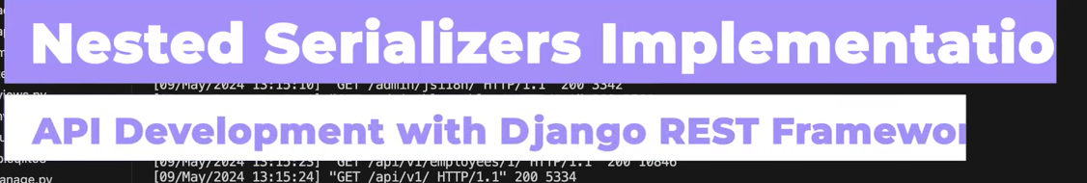

Now first of all go in apis->urls.py to add path to Views and then create views in views.py

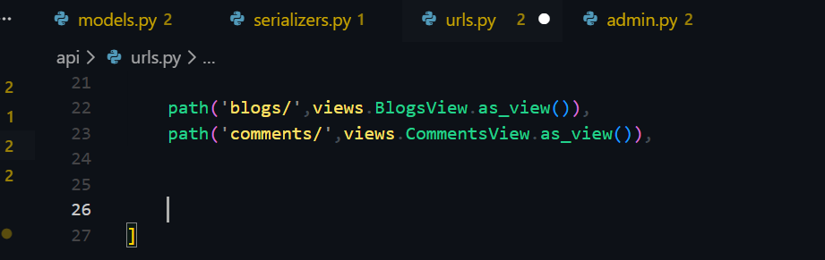

Now go in api->views.py

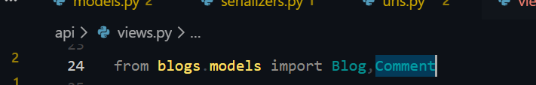



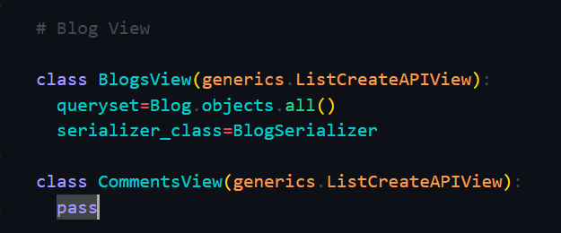

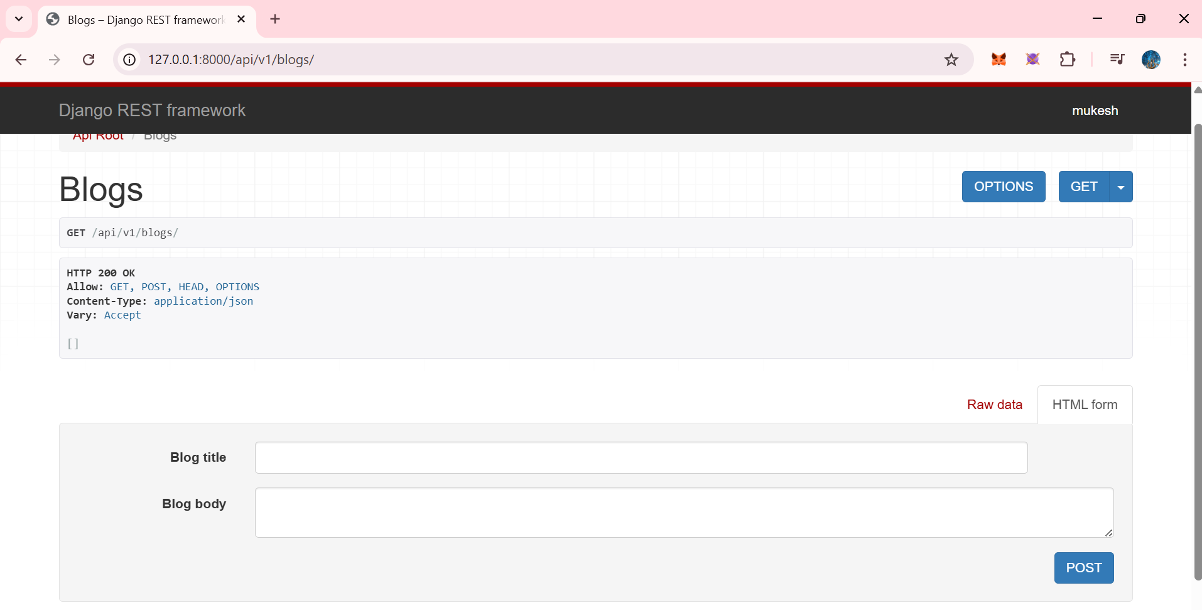

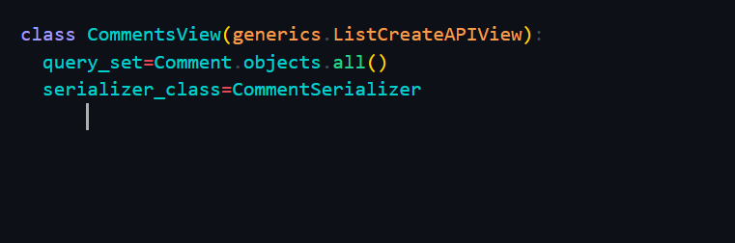

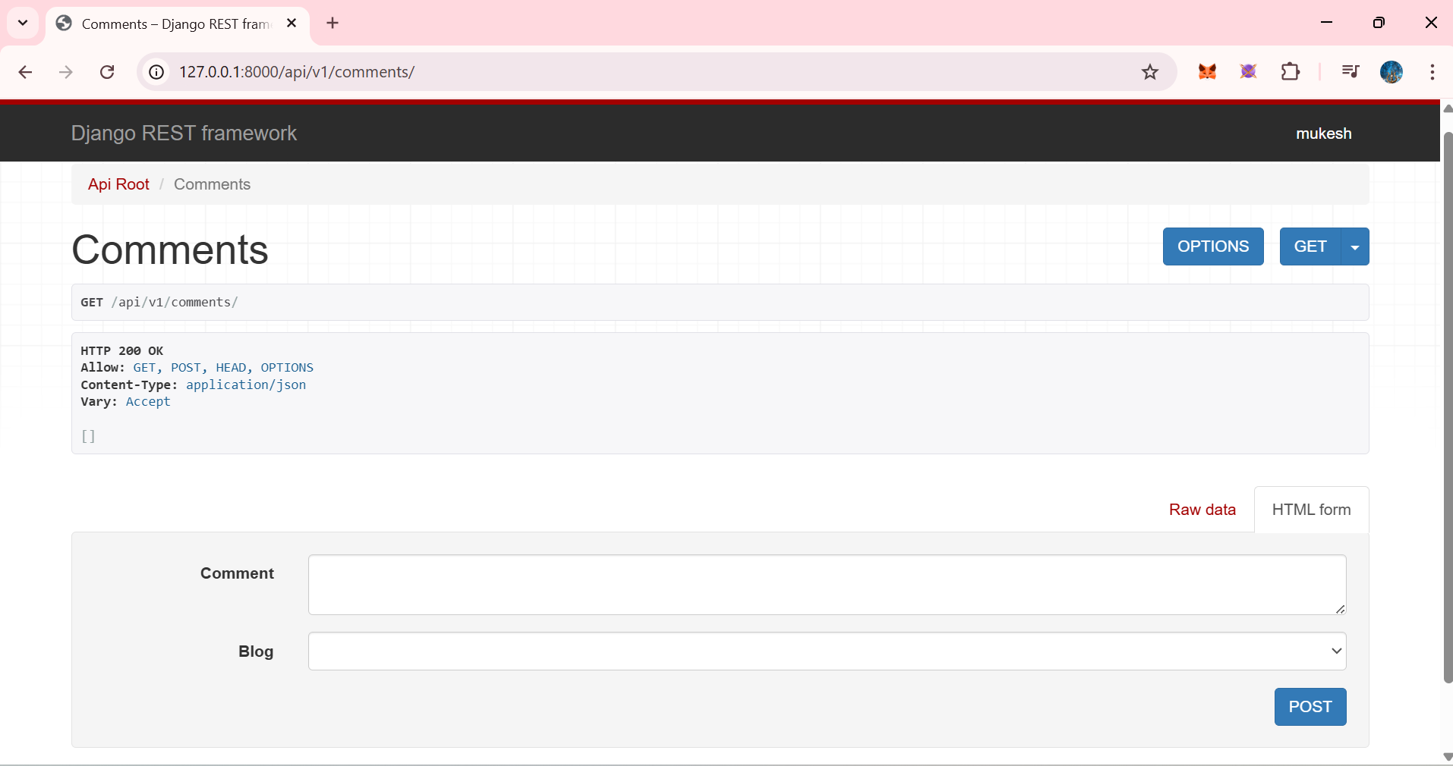

Now lets adds some data in it

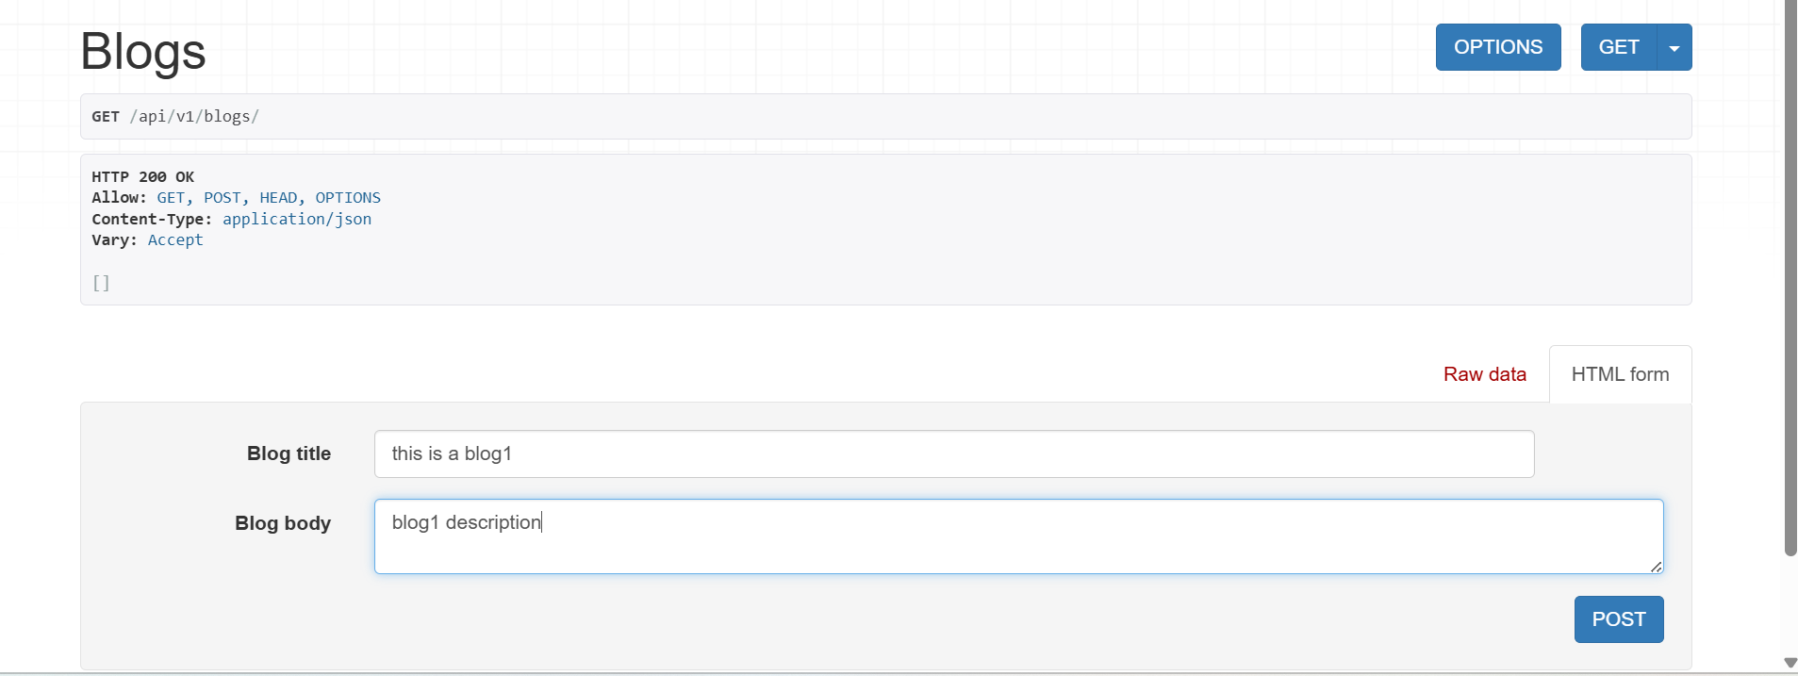

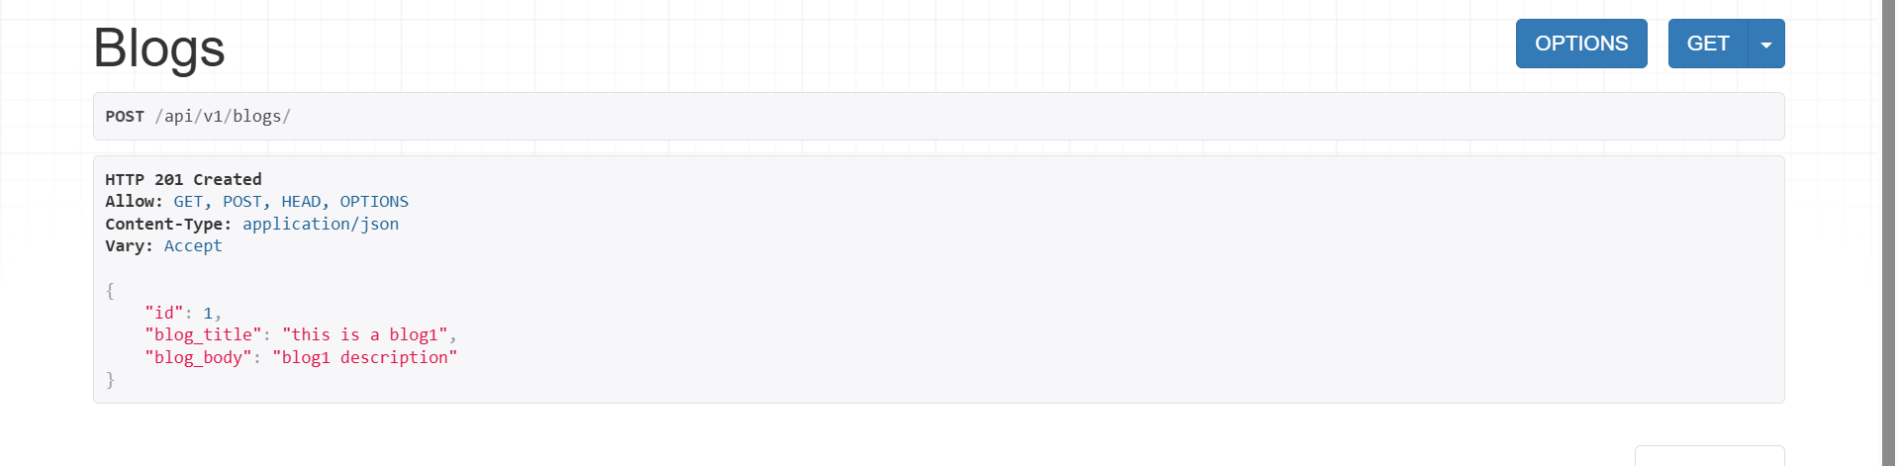

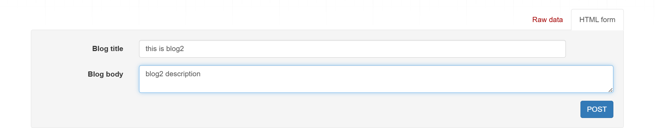

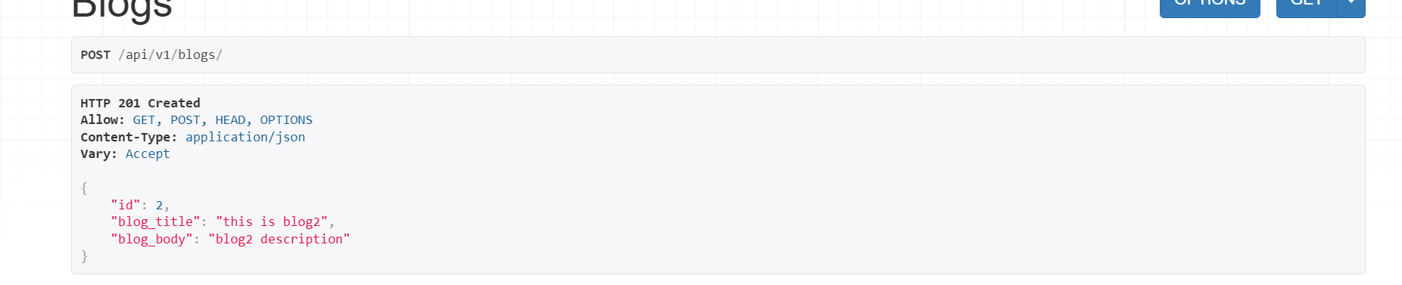

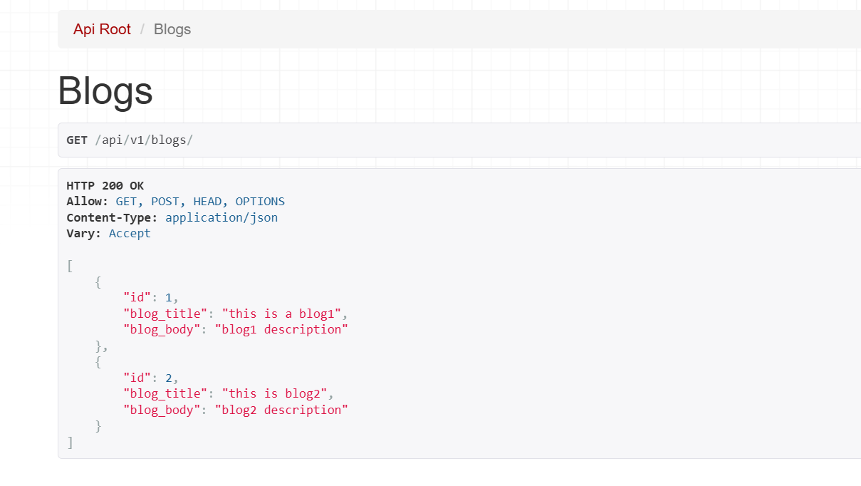

Now lets ass some comments

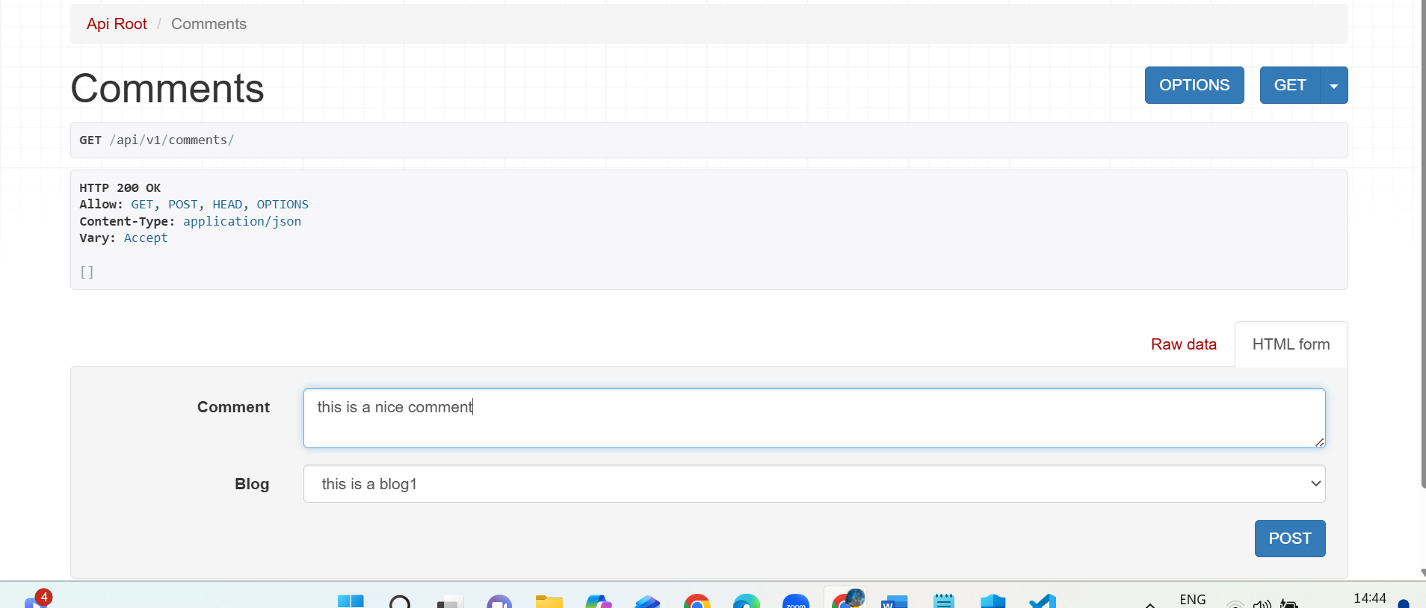

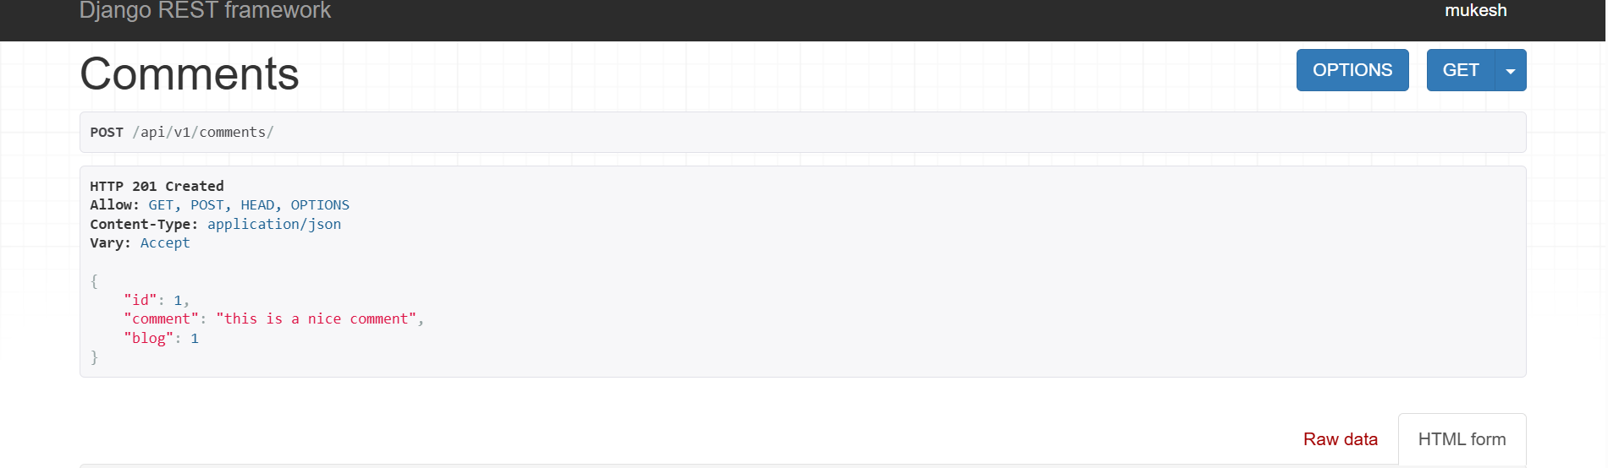

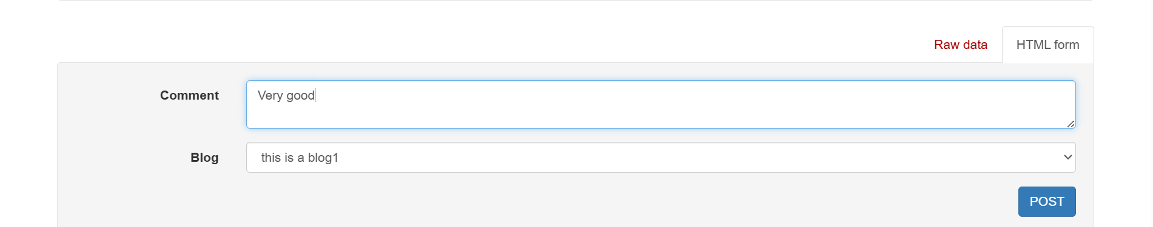

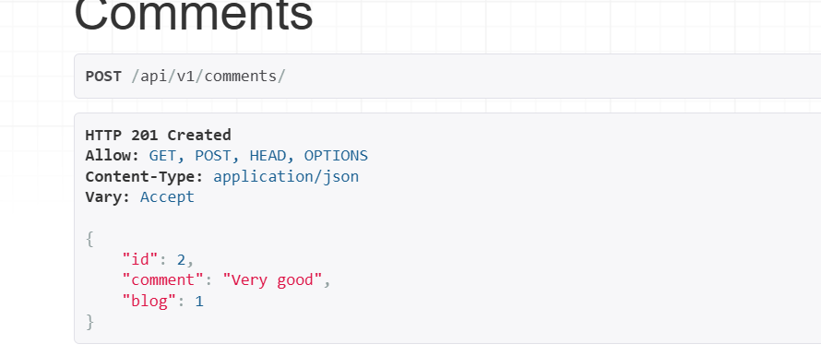

Thus we now have 2 commwnts for blog1,

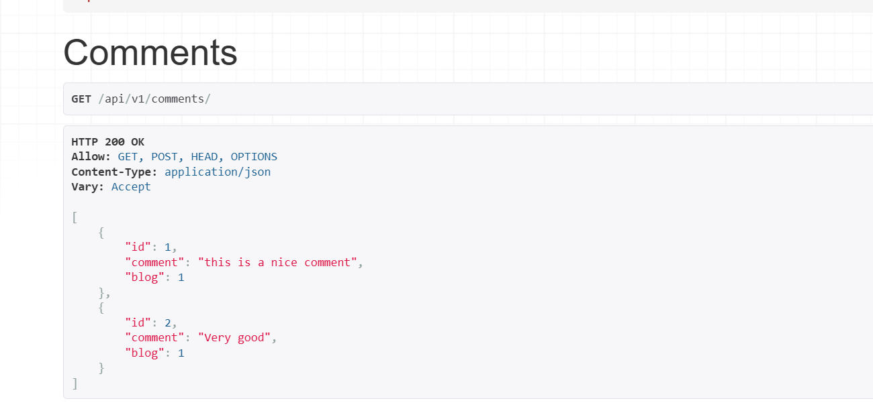

Now notice that still commeths are not visible in blogs 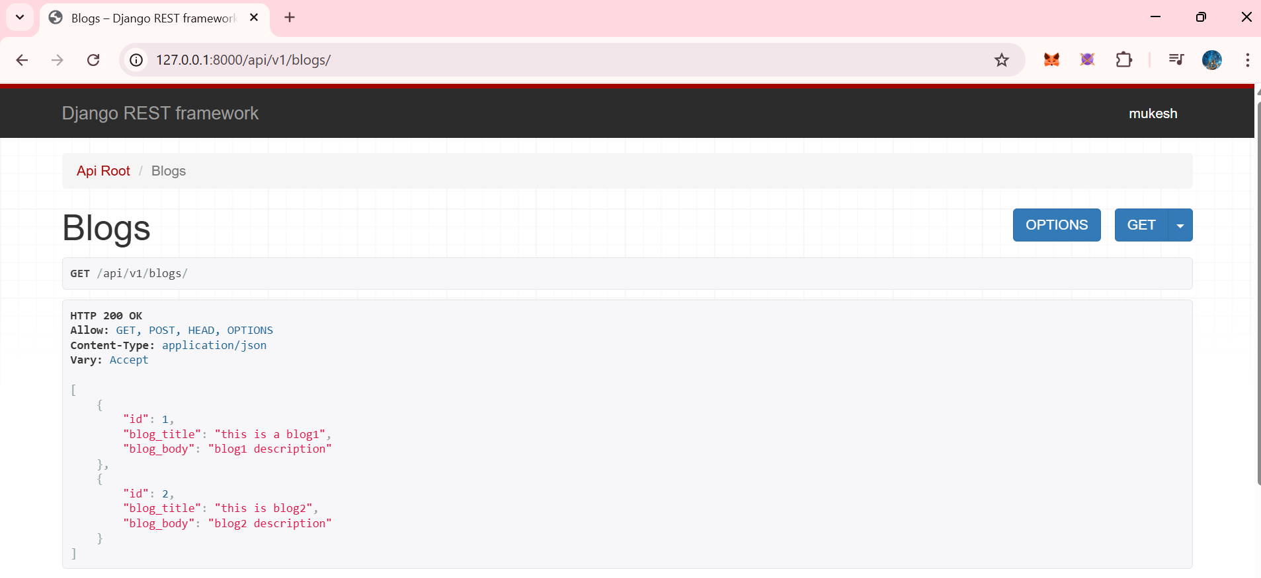

So we will now use nested serializers

#alwaysremebr whaterver "related_name" you gave in comments in models.py only use that name only here as well

See refer models.py.. and see the related_name.. here it is (‘comments’)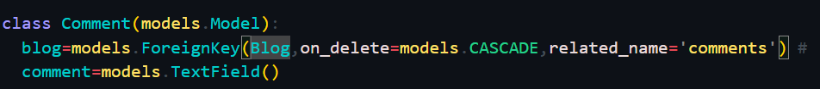

Use that only in nested serializer

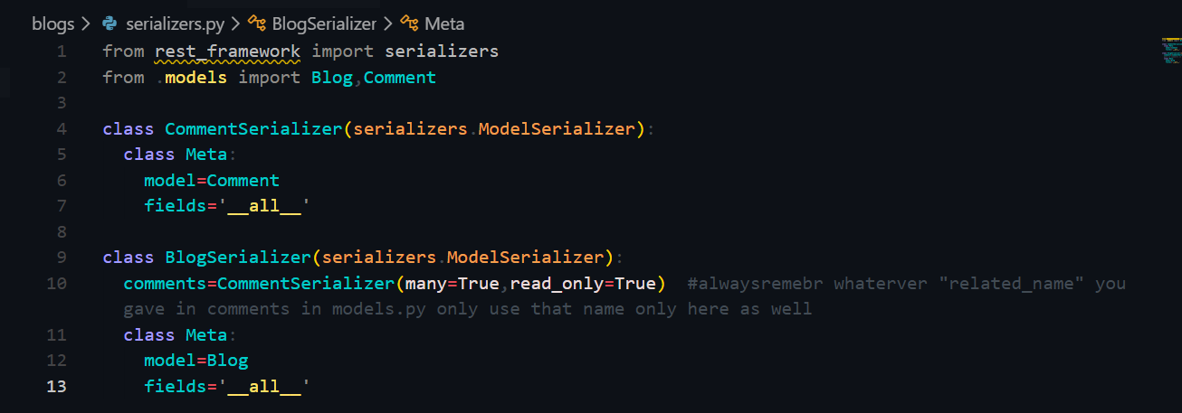

Now you see commnerts are visible for blog1

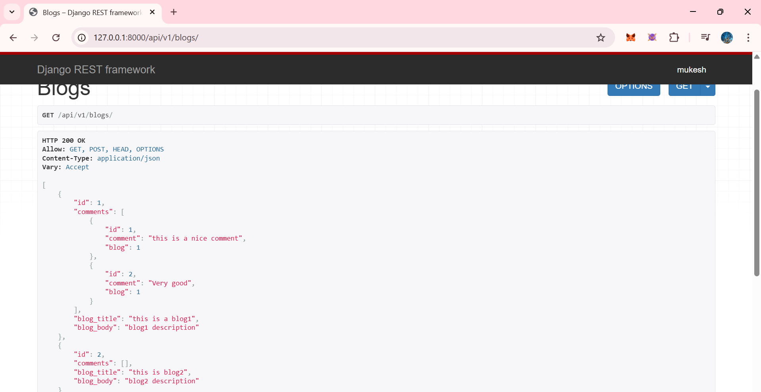

Now lets add some new commnts in blog2

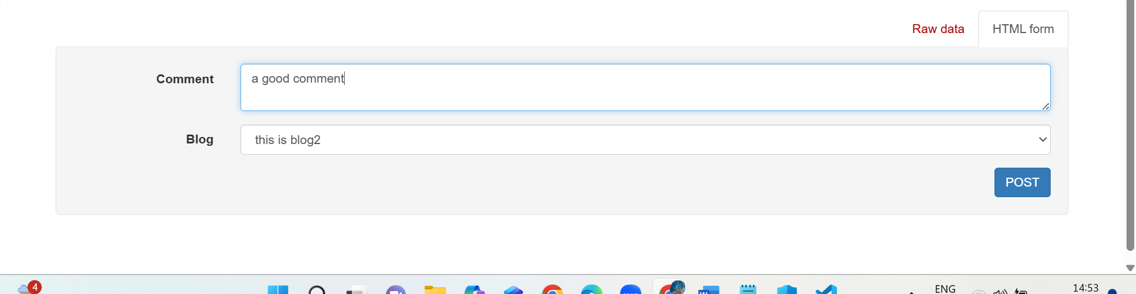

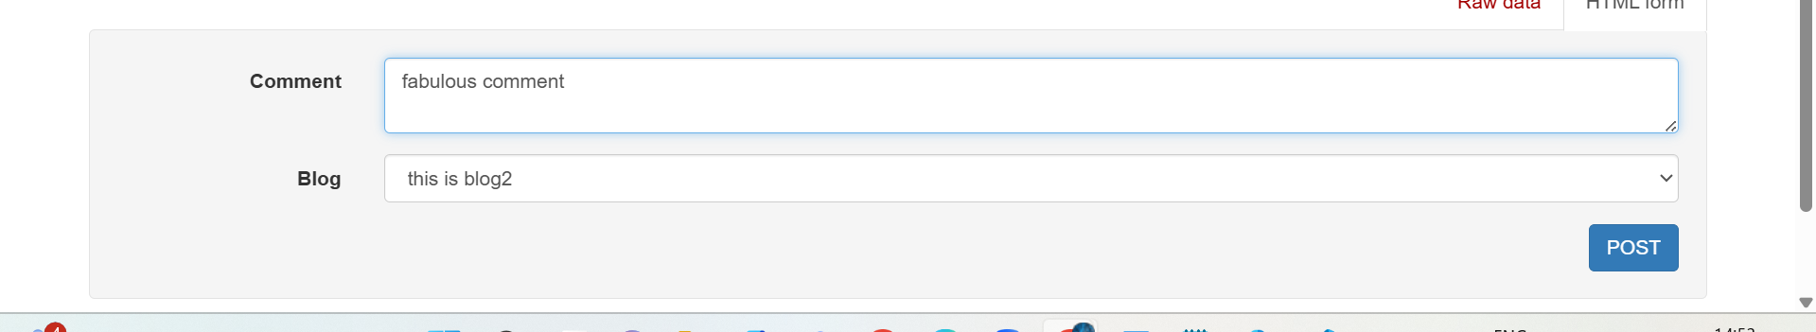

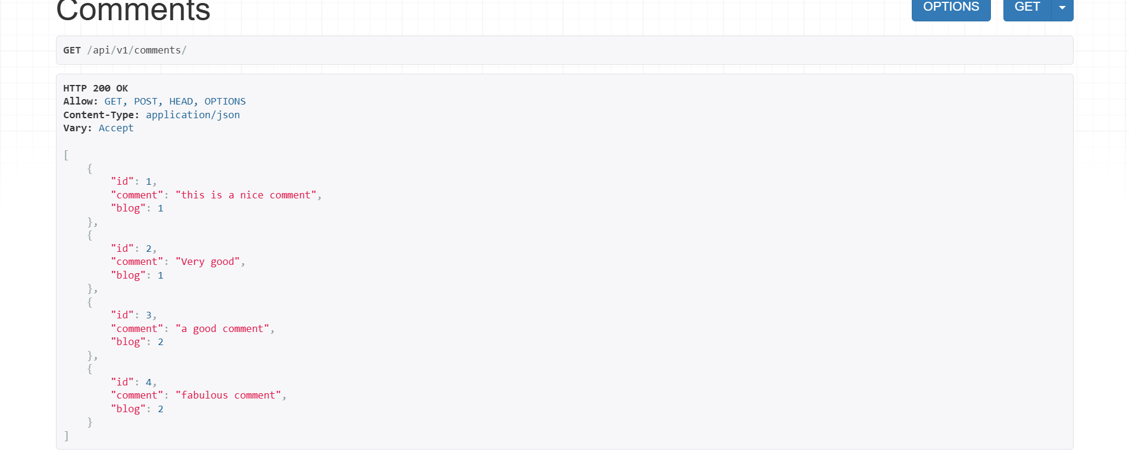

Now go in blogs and see whther commens are visible or not

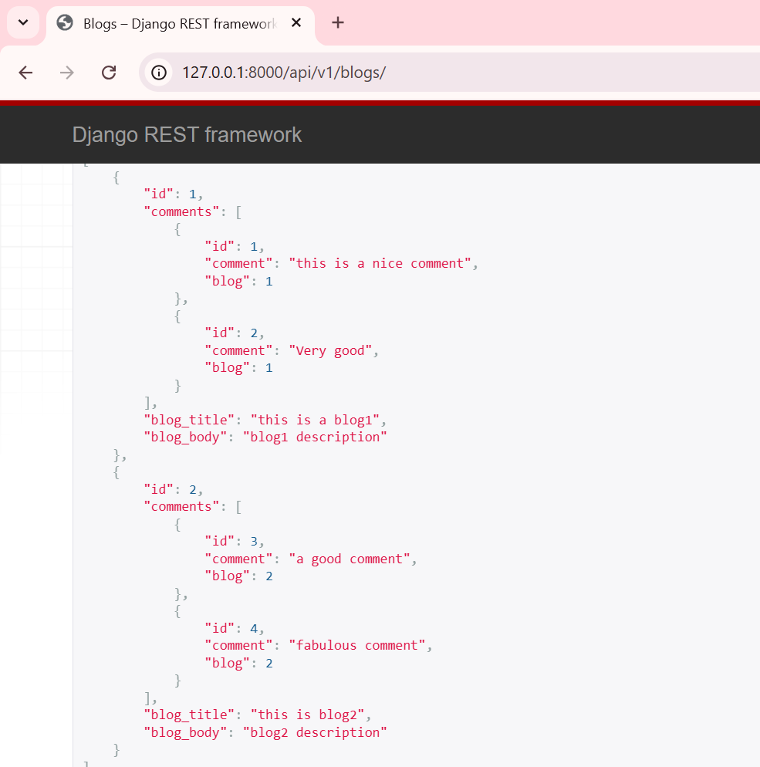

Now go in jsonviewer to see this json resposne

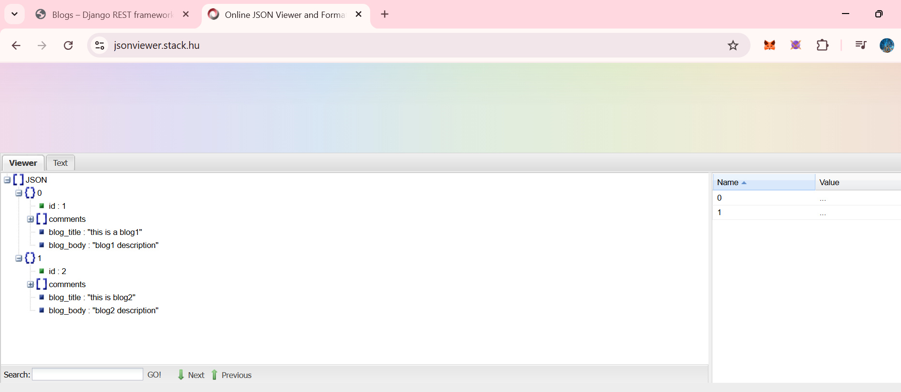

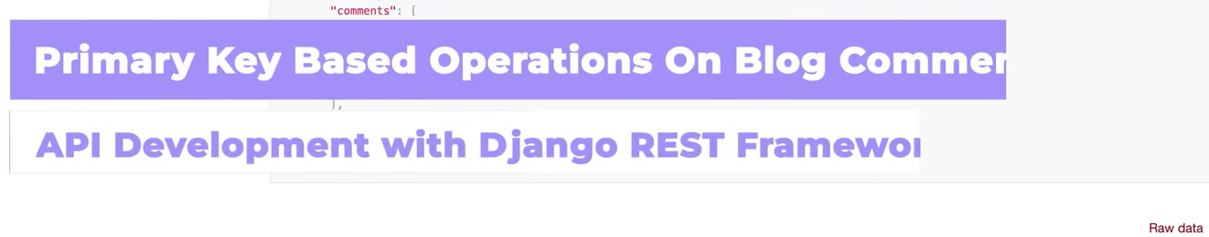

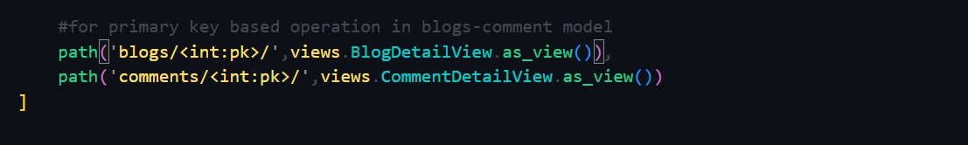

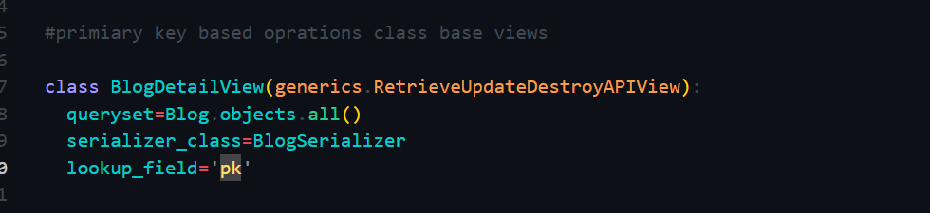

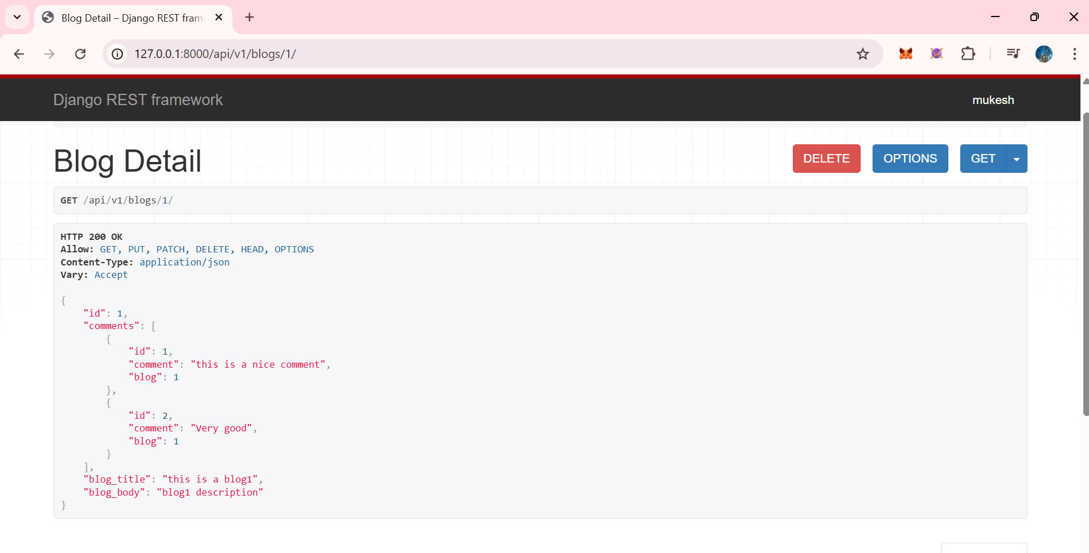

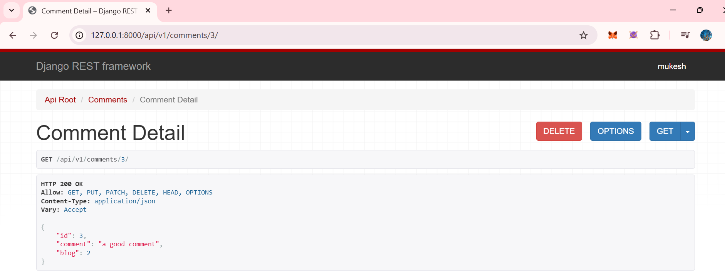

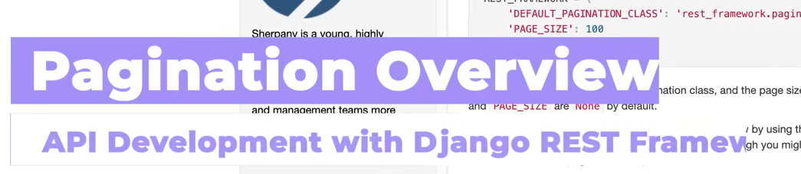

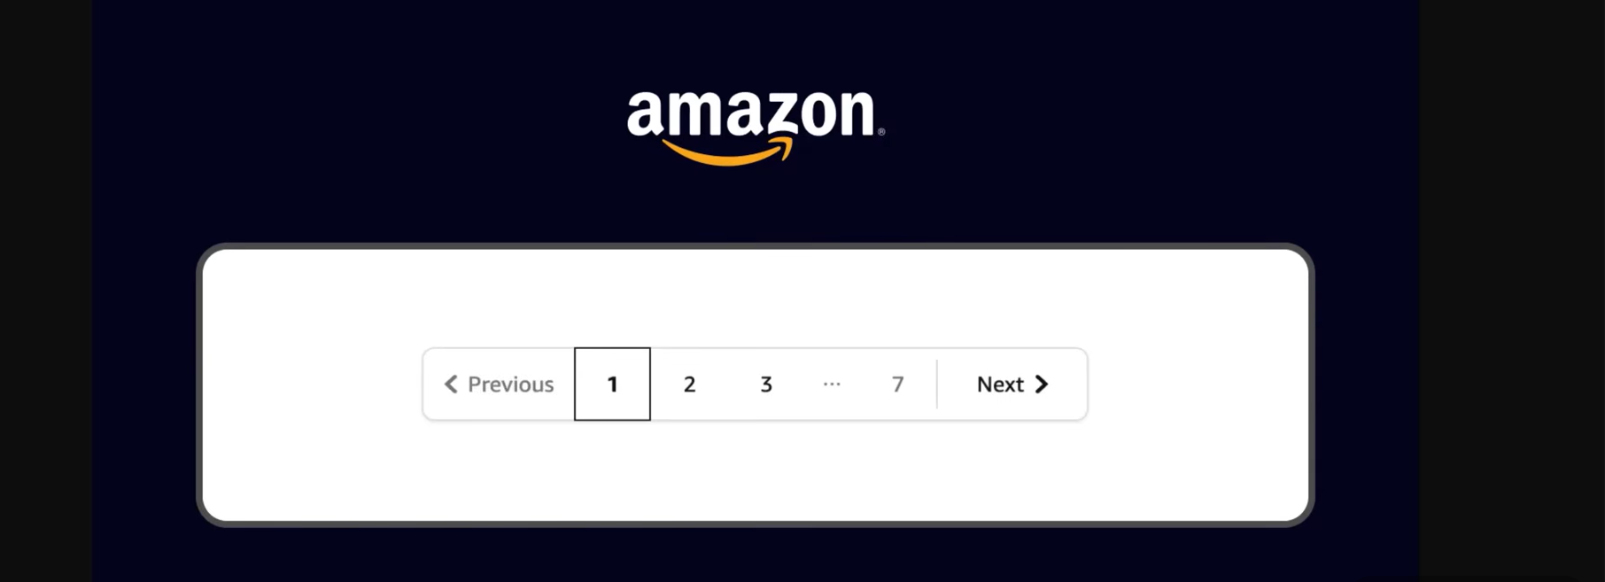

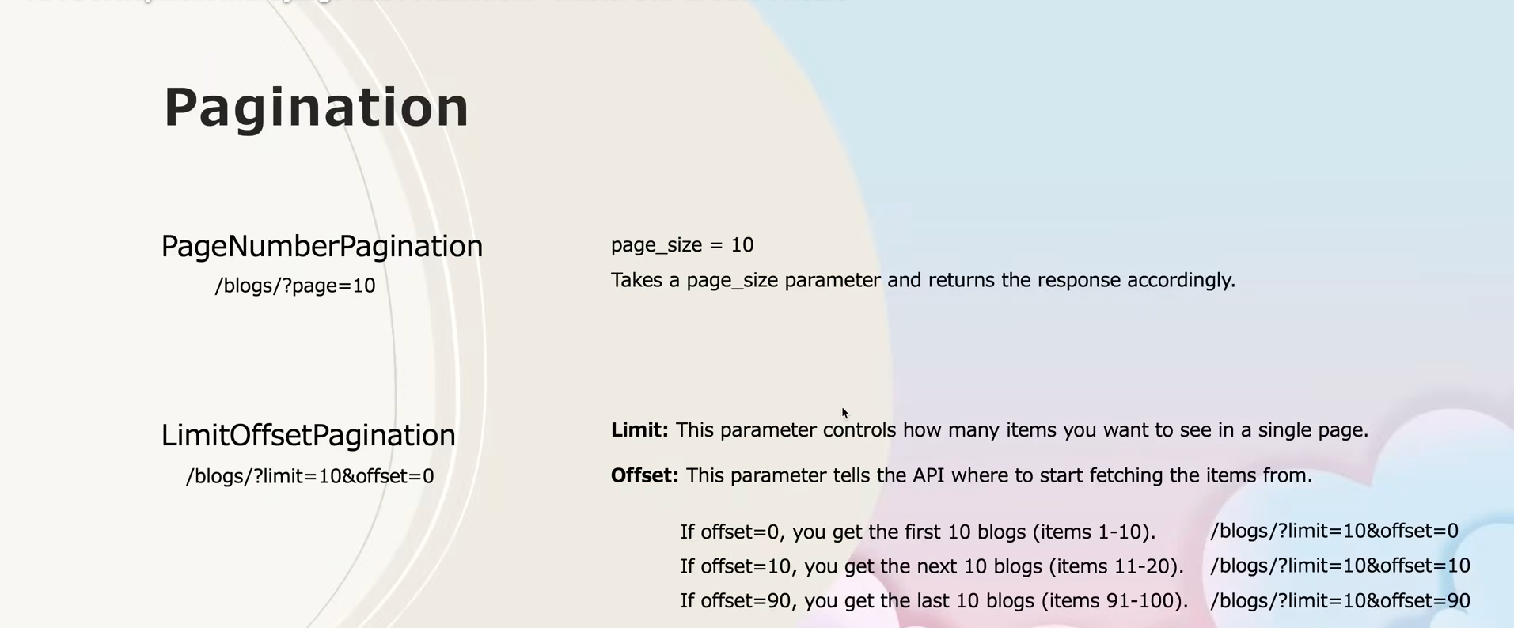

Great 👍 Let’s make **clean, exam-ready + interview-ready notes** for **Pagination in Django REST Framework**, with a few **extra clarifications and additions** (as you asked).

**📌 Pagination in Django REST Framework (DRF)**

**🔹 What is Pagination?**

**Pagination** means **splitting large datasets into smaller pages** instead of returning all records at once.

Example (real life):  
👉 Amazon / Google shows **10–20 items per page**, not thousands at once.

**❓ Why Pagination is Important**

* 🚀 Faster API responses
* 💾 Less server load
* 📱 Better frontend performance
* 👀 Easy navigation for users

**🔹 Pagination in DRF**

Django REST Framework provides **built-in pagination classes**.

**Two most commonly used:**

1. **PageNumberPagination**
2. **LimitOffsetPagination**

**1️⃣ PageNumberPagination**

**📖 Concept**

* Data is divided into **pages**
* Client requests a specific page number

**📌 Example URL**

/api/v1/blogs/?page=1

/api/v1/blogs/?page=2

**📌 How it works**

* page_size = 10
* Page 1 → items 1–10
* Page 2 → items 11–20

**🔧 Settings (Global Configuration)**

REST_FRAMEWORK = {

'DEFAULT_PAGINATION_CLASS':

'rest_framework.pagination.PageNumberPagination',

'PAGE_SIZE': 10,

}

**📤 API Response Format**

{

"count": 100,

"next": "http://127.0.0.1:8000/api/v1/blogs/?page=2",

"previous": null,

"results": [

{ "id": 1, "blog_title": "Post 1" },

{ "id": 2, "blog_title": "Post 2" }

]

}

**✅ When to use PageNumberPagination**

* Blog listings
* Products
* Simple UI with page numbers

**2️⃣ LimitOffsetPagination**

**📖 Concept**

Client controls:

* **limit** → how many records
* **offset** → from where to start

**📌 Example URLs**

/blogs/?limit=10&offset=0 → first 10 items

/blogs/?limit=10&offset=10 → next 10 items

/blogs/?limit=10&offset=90 → last 10 items

**🔧 Settings**

REST_FRAMEWORK = {

'DEFAULT_PAGINATION_CLASS':

'rest_framework.pagination.LimitOffsetPagination',

'PAGE_SIZE': 10,

}

**📤 Response Format**

{

"count": 100,

"next": "/blogs/?limit=10&offset=10",

"previous": null,

"results": [...]

}

**✅ When to use LimitOffsetPagination**

* Infinite scrolling (Instagram, Twitter)
* Mobile apps
* Advanced frontend control

**🔹 Custom Pagination (Important Addition ⭐)**

You can **create your own pagination class**.

**Example**

from rest_framework.pagination import PageNumberPagination

class BlogPagination(PageNumberPagination):

page_size = 5

page_size_query_param = 'page_size'

max_page_size = 20

**Use it in a View**

class BlogsView(generics.ListAPIView):

queryset = Blog.objects.all()

serializer_class = BlogSerializer

pagination_class = BlogPagination

**🔹 Pagination vs No Pagination**

| **Without Pagination** | **With Pagination** |
| --- | --- |
| Slow API | Fast API |
| Large payload | Small payload |
| Poor UX | Better UX |
| High memory | Optimized |

**🔹 Very Important Interview Point ⭐**

Pagination is **always applied on List APIs**, not on **Retrieve APIs (pk-based)**.

✔ /blogs/ → pagination  
❌ /blogs/1/ → no pagination

**🔹 One-Line Definitions (Exam Friendly)**

* **Pagination**: Technique to divide large datasets into smaller pages.
* **PageNumberPagination**: Pagination using page numbers.
* **LimitOffsetPagination**: Pagination using limit and offset.
* **PAGE_SIZE**: Number of records per page.

**🔹 What You Should Say in Daily Scrum**

“Today I learned pagination in Django REST Framework, including PageNumberPagination and LimitOffsetPagination, and how to configure it globally and per view.”

**🔹 What’s Next After Pagination?**

➡️ **Filtering**  
➡️ **Searching**  
➡️ **Ordering**

(You’re almost at the **advanced DRF level** 🔥)

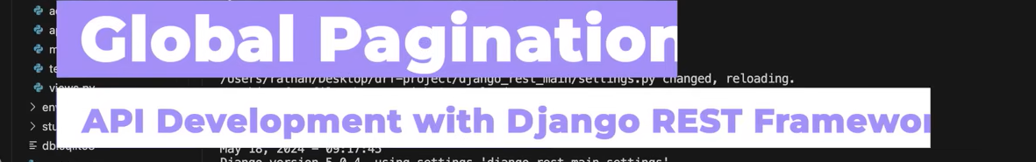

Lets add some random blogs first

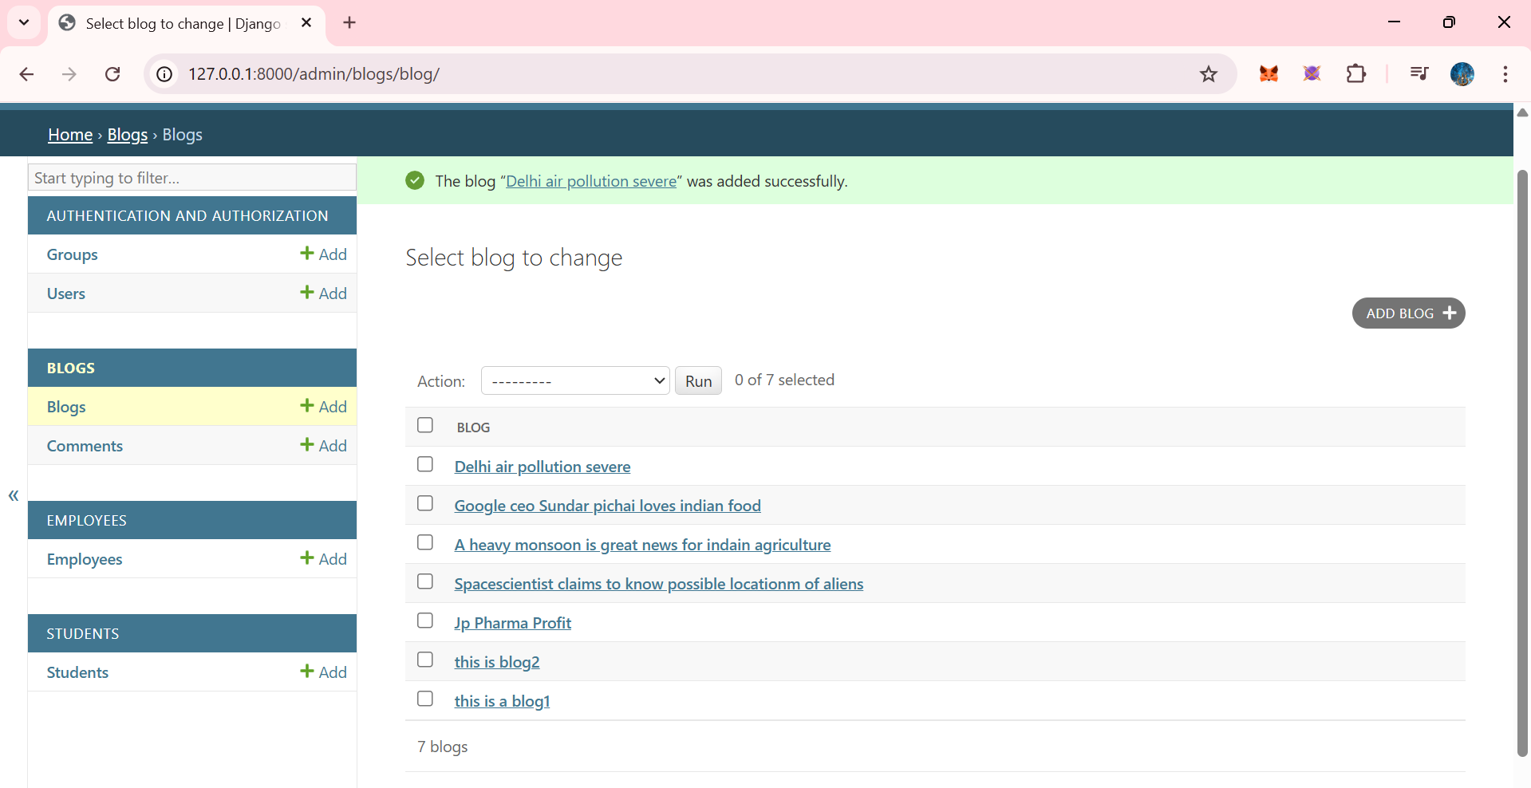

Go in settings.py and ADD

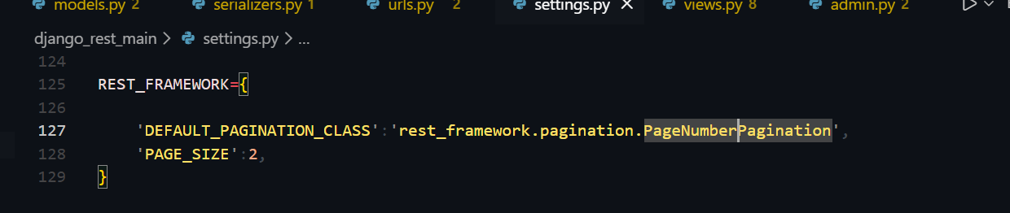

WE CAN SEE HERE NEXT,PREVOUS AND PAGE NUMBERS TOO…currenltu we are at page 1 and we can see only 2 plogs per page as we had set page_size=2

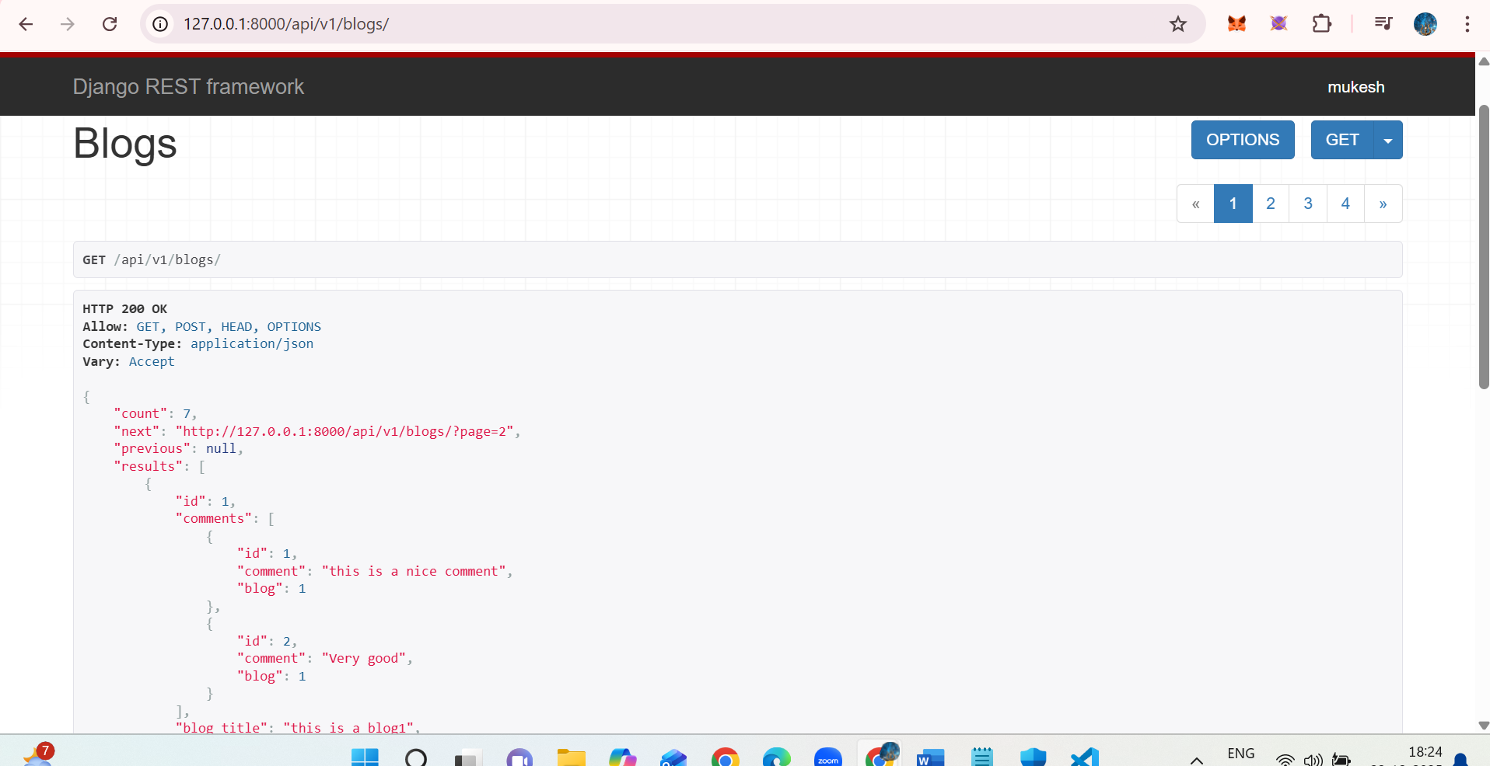

2 blogs (blog1 and blog2 ) per page as we can see here..

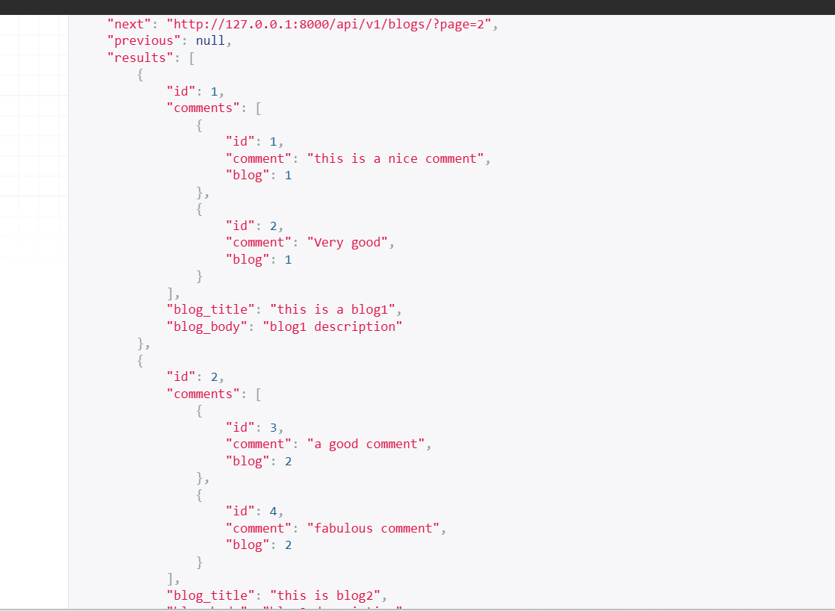

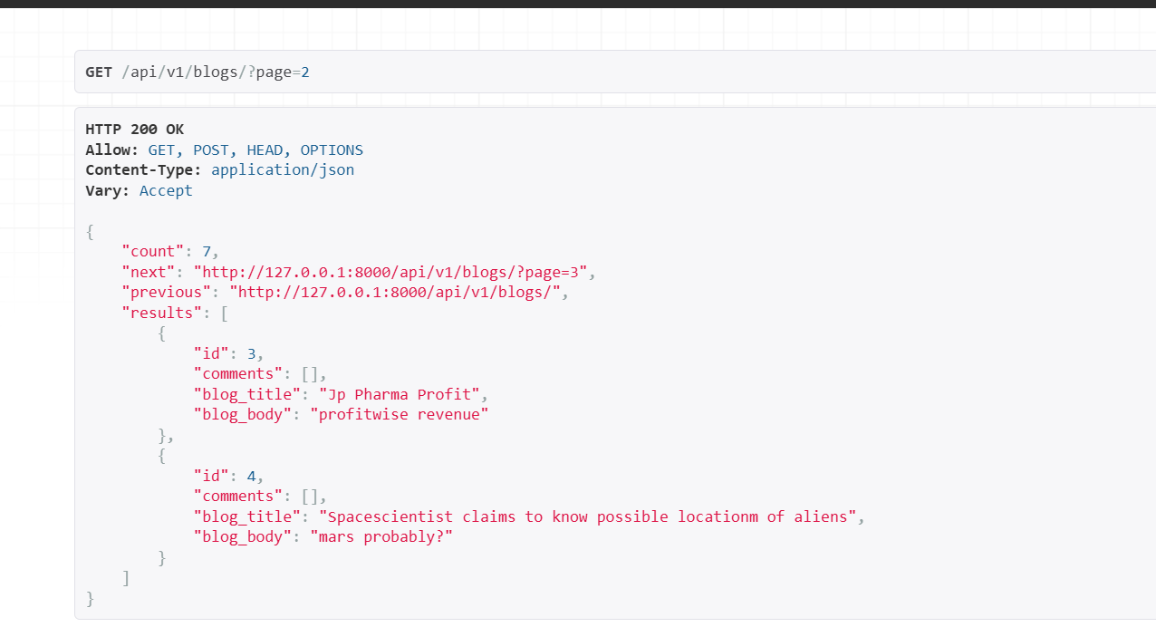

Now lets add some employees in employee table

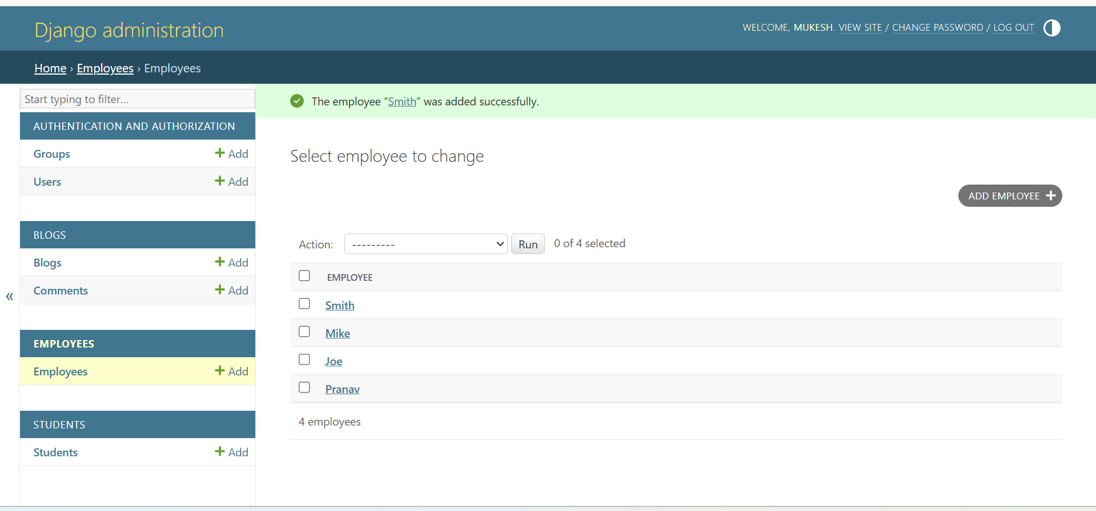

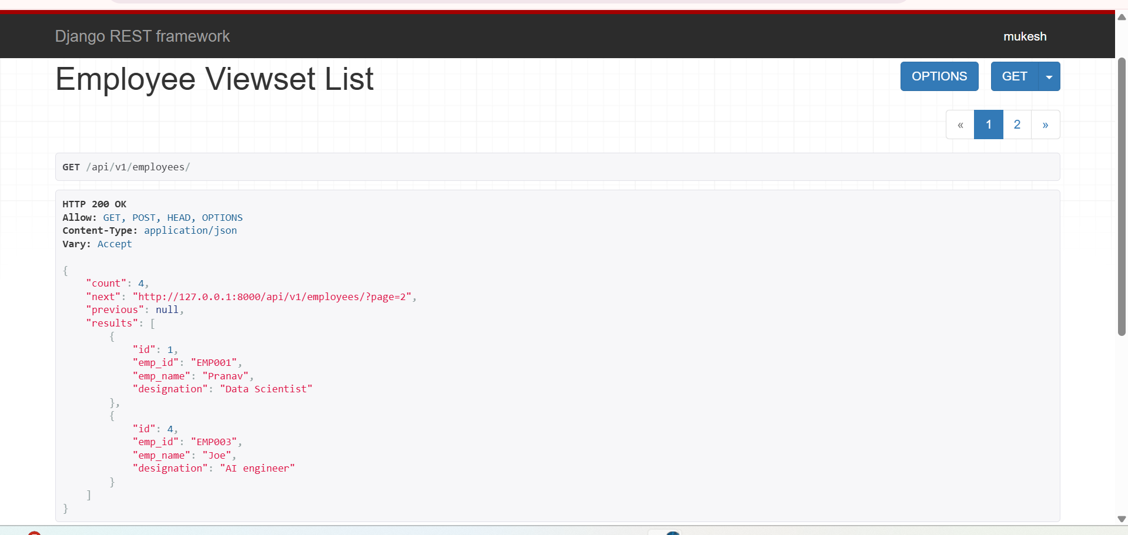

Now instead of pagenumberpagination . lets do LimitOffsetPagiantion

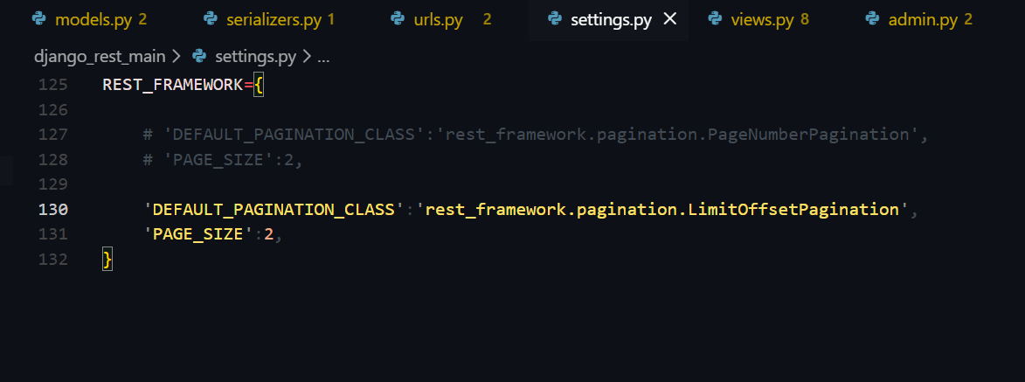

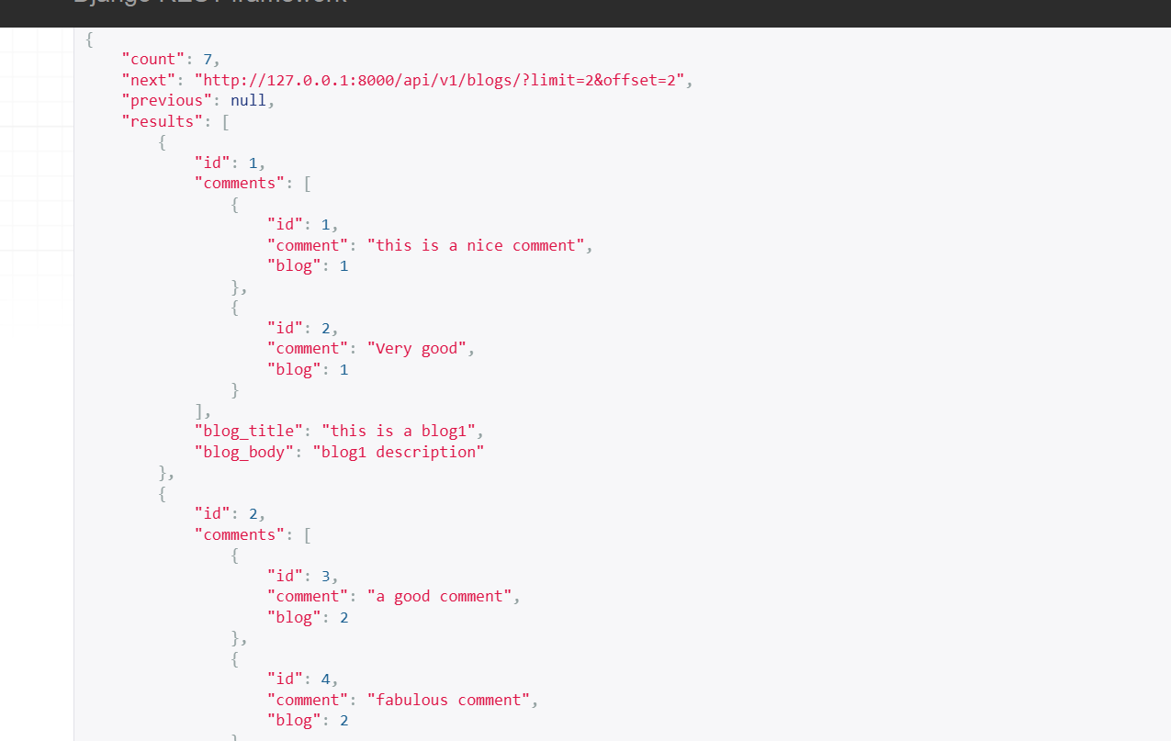

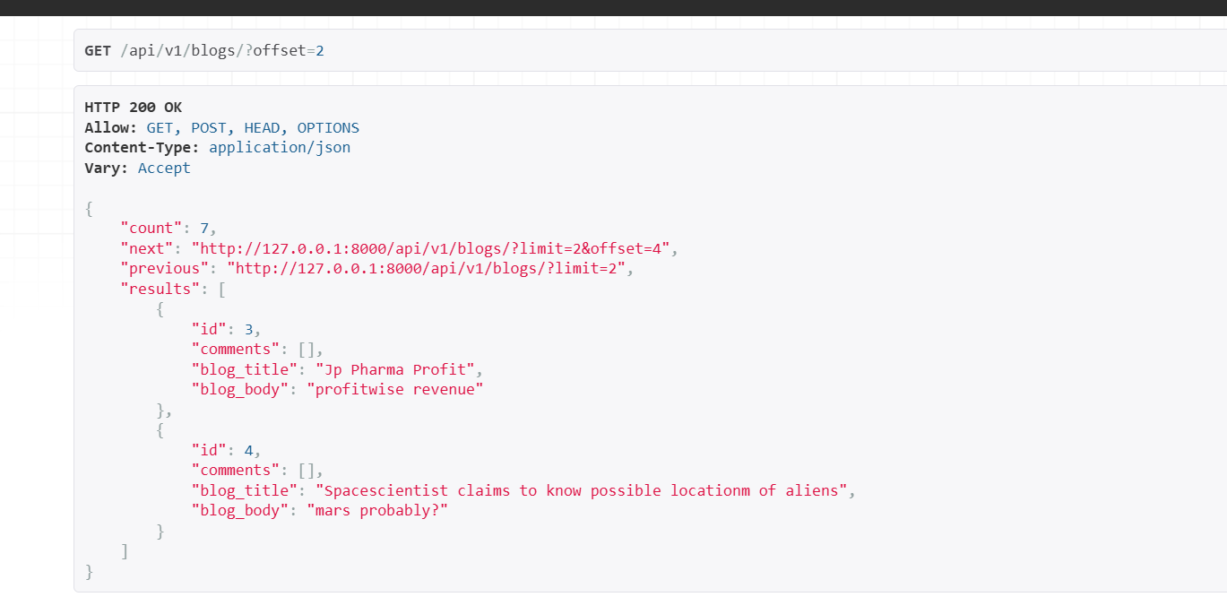

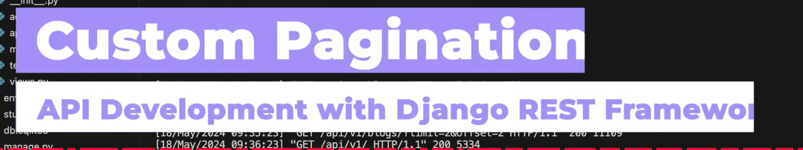

Noe we will set custom paginaiton for the class Employee

Let the default global paginaiton be limitoffset pagaintion and let the paginaion for employyes be pagenumberpagination..

Letgs create paginations.py in api folder

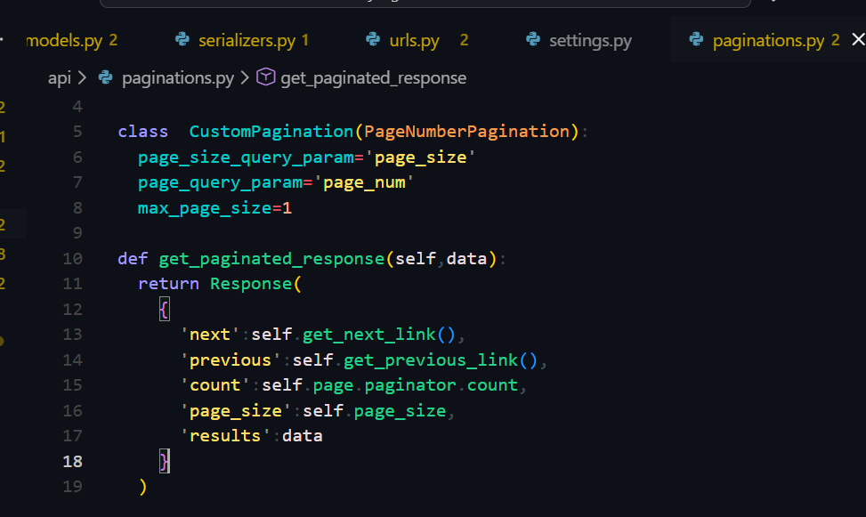

Perfect, this is **custom pagination** in DRF. I’ll explain it **line-by-line**, simple and notebook-ready 👍

**1️⃣ Imports**

from rest_framework.pagination import PageNumberPagination

from rest_framework.response import Response

* **PageNumberPagination** → Built-in DRF pagination class (page=1, page=2, etc.)
* **Response** → Used to return a custom JSON response format

**2️⃣ Creating a Custom Pagination Class**

class CustomPagination(PageNumberPagination):

* You are **extending (inheriting)** DRF’s PageNumberPagination
* This allows you to **customize how pagination behaves and looks**

**3️⃣ Pagination Configuration**

page_size_query_param = 'page_size'

➡ Allows the client to control page size via URL

Example:

/blogs/?page_size=5

page_query_param = 'page_num'

➡ Changes default page parameter from page to page_num

Example:

/blogs/?page_num=2

(Default is /blogs/?page=2)

max_page_size = 1

➡ Maximum number of records per page  
Even if client requests more, it will not exceed **1**

Example:

/blogs/?page_size=10 ❌

Actual size returned → 1 ✅

**4️⃣ Custom Response Structure**

def get_paginated_response(self, data):

* This method **overrides DRF’s default pagination response**
* data → serialized data for the current page

**Custom JSON Response**

return Response(

{

'next': self.get_next_link(),

'previous': self.get_previous_link(),

'count': self.page.paginator.count,

'page_size': self.page_size,

'results': data

}

)

**🔍 Field-by-field explanation**

| **Key** | **Meaning** |
| --- | --- |
| next | URL for the next page |
| previous | URL for the previous page |
| count | Total number of records in DB |
| page_size | Number of records per page |
| results | Actual paginated data |

**6️⃣ How to Use This Pagination in a View**

**Option 1: Per View**

class BlogsView(generics.ListAPIView):

queryset = Blog.objects.all()

serializer_class = BlogSerializer

pagination_class = CustomPagination

**Option 2: Global (settings.py)**

REST_FRAMEWORK = {

'DEFAULT_PAGINATION_CLASS': 'path.to.CustomPagination',

}

**7️⃣ Example API Usage**

/api/v1/blogs/?page_num=1&page_size=1

**Sample Response**

{

"next": "http://127.0.0.1:8000/api/v1/blogs/?page_num=2",

"previous": null,

"count": 10,

"page_size": 1,

"results": [

{

"id": 1,

"title": "First Blog"

}

]

}

**📝 Notebook Definition (Write This)**

**Custom Pagination** in DRF is created by extending PageNumberPagination to control page size, page number parameter, and response format according to API requirements.

Now go in views.py in api folder



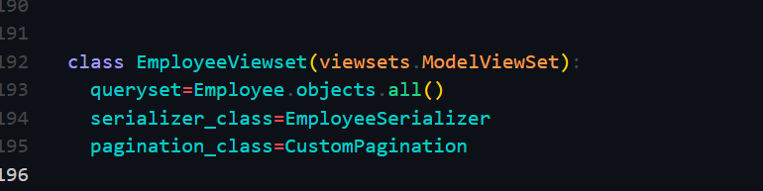

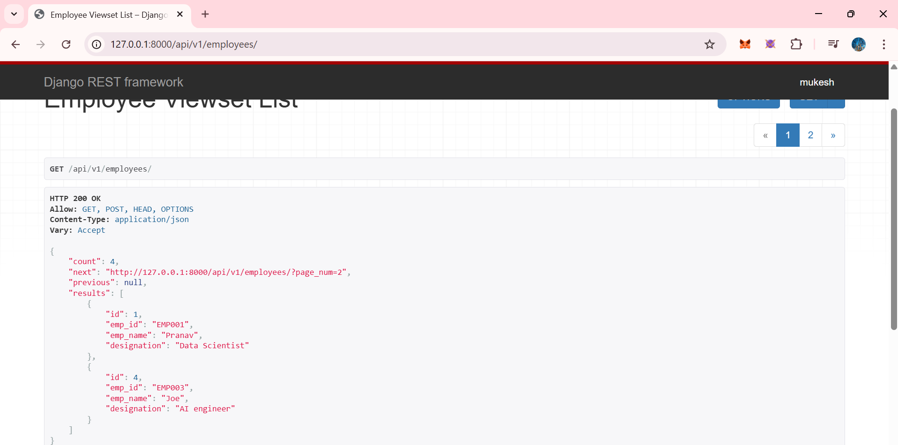

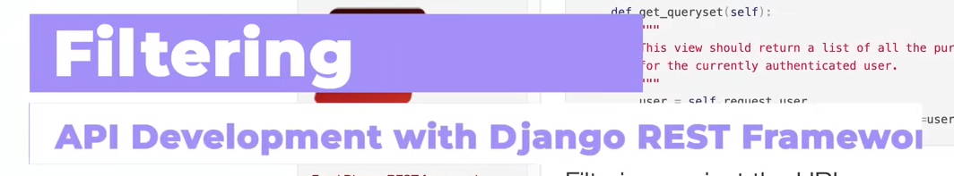

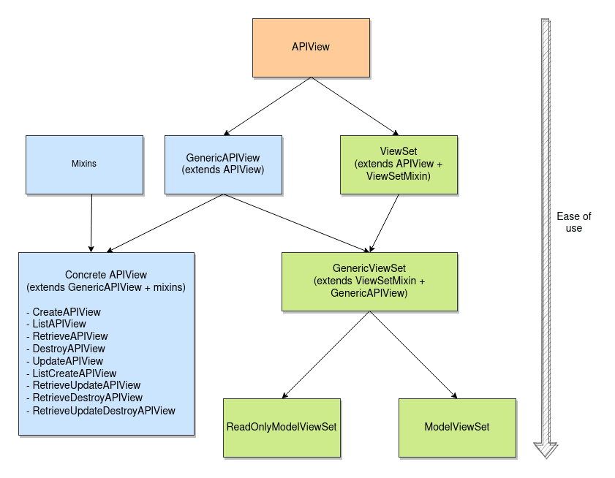

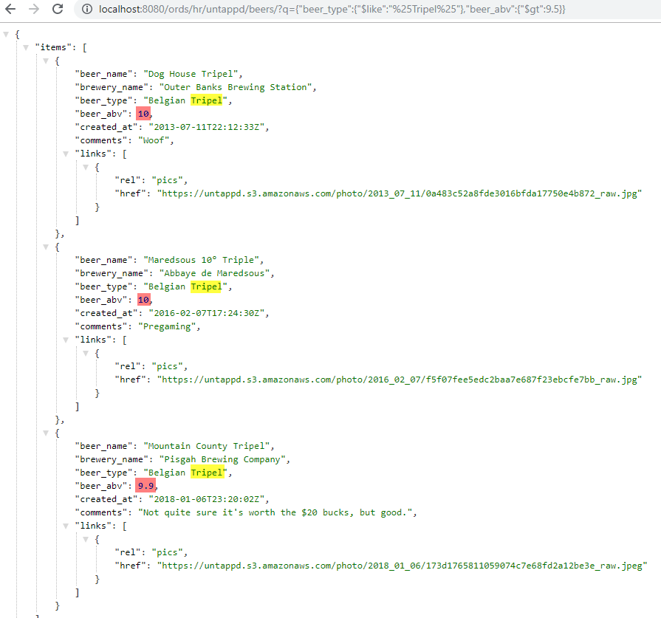

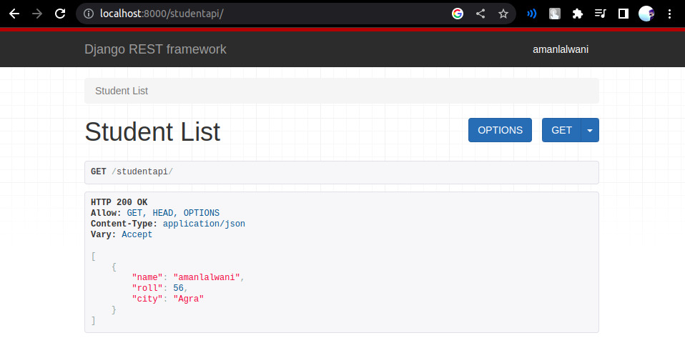

Perfect 👍  
Now let’s lock **Filtering in Django REST Framework (DRF)** in a **clean, notebook-ready way**, aligned with what your instructor will teach.

**📌 Filtering in Django REST Framework (DRF)**

**🔹 What is Filtering?**

**Filtering** means **returning only specific records from the database based on conditions** provided by the client.

Instead of returning *all data*, the API returns **only what the user asks for**.

**Example:**

GET /api/v1/employees/?department=IT

➡️ Returns only employees from the IT department.

**🔹 Why Filtering is Important**

* Reduces **unnecessary data transfer**
* Improves **performance**
* Makes APIs **client-friendly**
* Essential for **real-world production APIs**

**🔹 Types of Filtering in DRF**

**1️⃣ Manual Filtering (using queryset)**

**2️⃣ Built-in Filtering (filter_backends)**

**3️⃣ django-filter (Professional & recommended)**

**1️⃣ Manual Filtering (Basic – for learning)**

def get_queryset(self):

department = self.request.query_params.get('department')

if department:

return Employee.objects.filter(department=department)

return Employee.objects.all()

**🔎 URL:**

/employees/?department=HR

✔️ Simple  
❌ Not scalable  
❌ More code

**2️⃣ Built-in DRF Filtering (filter_backends)**

**Step 1: Enable filtering in view / viewset**

from rest_framework import filters

class EmployeeViewset(viewsets.ModelViewSet):

queryset = Employee.objects.all()

serializer_class = EmployeeSerializer

filter_backends = [filters.SearchFilter]

search_fields = ['name', 'department']

**🔎 URL:**

/employees/?search=john

✔️ Easy  
✔️ Built-in  
❌ Limited control

**3️⃣ django-filter (🔥 Industry Standard)**

This is **what you should remember for interviews & projects**.

**🔹 Step 1: Install django-filter**

pip install django-filter

**🔹 Step 2: Add to settings.py**

INSTALLED_APPS = [

...

'django_filters',

]

REST_FRAMEWORK = {

'DEFAULT_FILTER_BACKENDS': [

'django_filters.rest_framework.DjangoFilterBackend'

]

}

**🔹 Step 3: Use django-filter in ViewSet**

from django_filters.rest_framework import DjangoFilterBackend

class EmployeeViewset(viewsets.ModelViewSet):

queryset = Employee.objects.all()

serializer_class = EmployeeSerializer

filter_backends = [DjangoFilterBackend]

filterset_fields = ['department', 'age']

**🔎 URLs You Can Use**

/employees/?department=IT

/employees/?age=25

/employees/?department=IT&age=25

✔️ Clean  
✔️ Powerful  
✔️ Production-ready

**🔹 Filtering vs Search vs Pagination**

| **Feature** | **Purpose** |
| --- | --- |
| Filtering | Exact match (department=IT) |
| Search | Partial match (search=john) |
| Pagination | Controls number of results |

✔️ They **work together**, not instead of each other.

**🔹 Typical Real-World API Example**

/employees/?department=IT&search=raj&page=2&page_size=5

➡️ IT employees  
➡️ Name contains “raj”  
➡️ Page 2  
➡️ 5 results per page

🔥 **THIS is how real APIs look**

**🧠 Interview-Ready One-Liner**

**Filtering in DRF allows clients to retrieve specific subsets of data using query parameters, improving performance and usability of REST APIs.**

**✅ What You Should Write in Your Notes**

✔ Definition  
✔ Why filtering is needed  
✔ django-filter steps  
✔ Example URLs  
✔ Difference between filtering & search